KARPAGA VINAYAGA COLLEGE OF ENGINEERING & TECHNOLOGY
DEPARTMENT OF BIOTECHNOLOGY
BT2353 BIOPROCESS ENGINEERING
Course Notes

UNIT-1
ANALYSIS OF STIRRED TANK REACTOR

  - STIRRED TANK REACTOR- NON IDEALITY:
I.1.1 Ideal flow reactors:
There are two different flow patterns. They are mixed flow or stirred tank reactor and plug flow reactor.
- Ideal Mixed Flow Reactors:
In an ideal mixed flow the concentrations of the reactor will be uniform throughout the reactor and the concentration does not change with respect to position but it changes with time. Concentration of the exit stream is equal to concentration of mixture inside the reactor. Thorough mixing is required for ideal flow reactor.

Fig 1.1.1 a. Ideal Mixed Flow Reactor

b) Ideal Plug Flow Reactors:
[Plug flow, slug flow, piston flow, ideal tubular and mixed flow reactor]
It is characterized by fact that the flow of fluid through the reactor is orderly with no element of fluid overtaking or mixing with any other element ahead or behind. There may be lateral mixing of fluid in a plug flow reactor. There may be no mixing or diffusion along the flow path.
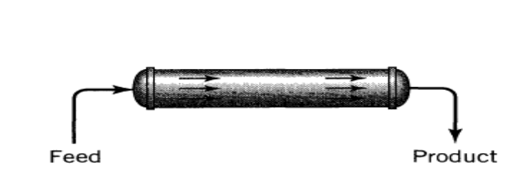
Fig 1.1.1 b. Plug flow reactor

1.1.2 Non-Ideal Reactors:
Reactors which deviate from conditions of ideality of perfect mixing, CSTR or completely non mixing are called non-ideal reactors.
Reasons for non-ideality in reactors is caused by
- Creation of stagnant region.
- Short circuiting.
- Channeling of fluids.
- Recirculation of fluids.
- Bypassing of fluids.
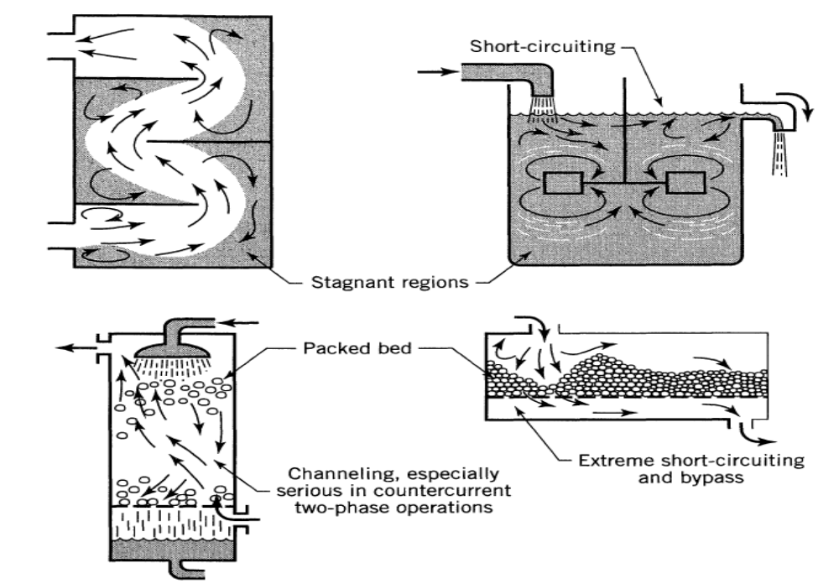
Fig 1.1.2 Non ideal flow patterns which may exist in process equipment.

Real equipment always deviates from the ideality because of the following contacting or flow patterns
1. The RTD or residence time distribution of material which is flowing through the
vessel.
2. The state of aggregation of the flowing material, its tendency to clump and for a
group of molecules to move about together
3. The earliness and lateness of mixing of material in the vessel.
1.2 The Residence Time Distribution, RTD
Residence time is the time it takes for a fluid element to pass through the reactor.
Age is the time since the element entered the reactor.
Residual life time + Age = Residence time
Or
Time spent by a fluid particle to pass through the reactor from the point of entry to the point of exit.
The distribution of these times for the stream of fluid leaving the vessel is called the exit age distribution E, or the residence time distribution RTD of fluid. E has the units of time-l.

It is represented by

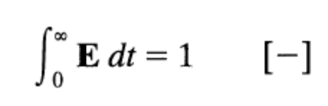
RTD is studied by E- curve method

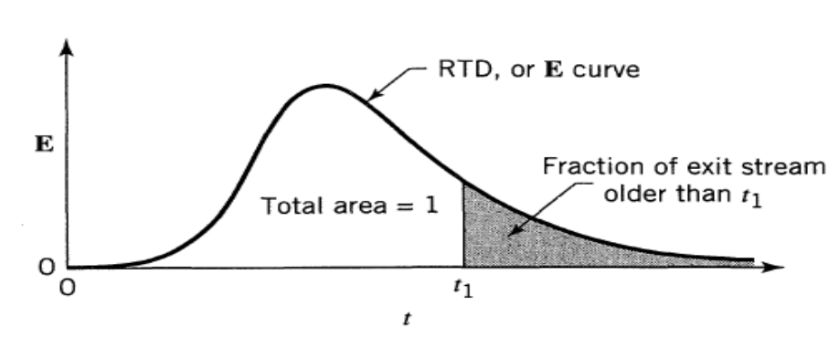
Fig 1.2 The exit age distribution curve E for fluid flowing through a vessel; also called the residence
time distribution, or RTD.
the fraction

The fraction younger than age t, is
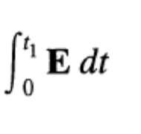
The fraction of material older than t,, shown as the shaded area in Fig. 1.2

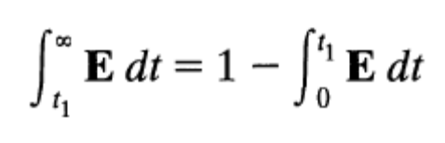
  - Experimental Methods to study RTD or E

Stimulus response techniques were used to study the exit age distribution ( RTD).

Stimulus It is a tracer input into the fluid entering time in reactor

Response It is a time taken by the reactor to leave the vessel.

1.3.1 Different types of stimulus technique:

1. Pulse input
2. Step input
3. Cyclic input
4. Random input
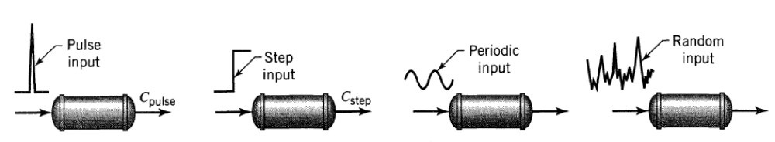
Fig 1.3.1 Various ways of studying the flow pattern in vessel time distribution, or RTD.
the fraction

      - The Pulse Experiment

Let us find the E curve for a vessel of volume V m3 through which flows v m3/s of fluid. For this instantaneously introduce M units of tracer (kg or moles) into the fluid entering the vessel, and record the concentration-time of tracer leaving the vessel. This is the C,,,,, curve. From the material balance for the vessel
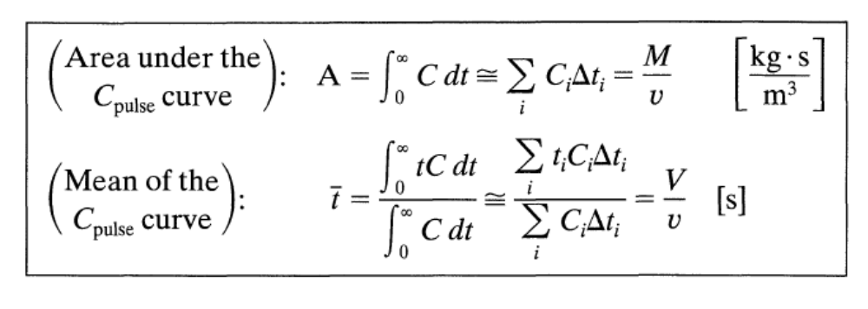
To find the E curve from the C,,,,, curve simply change the concentration scale such that the area under the curve is unity. Thus, simply divide the concentration readings by Mlv,

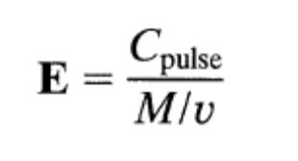
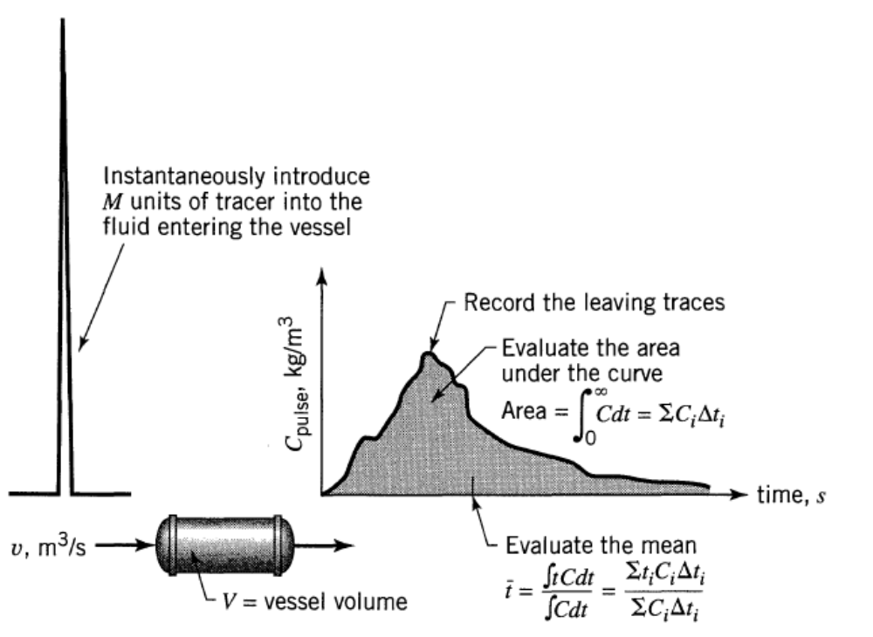
Fig 1.3.1.1 a. The useful information obtainable from the pulse tracer experiment.

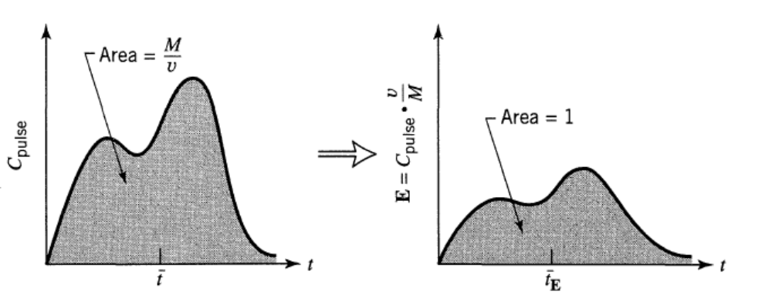
Fig 1.3.1.1 b. Transforming an experimental C,,,,, curve into an E curve.

Another RTD function E,. Here time is measured in terms of mean residence time.

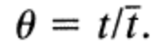
Where t= Total time
t =mean time
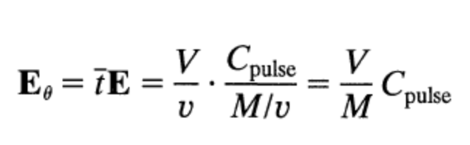

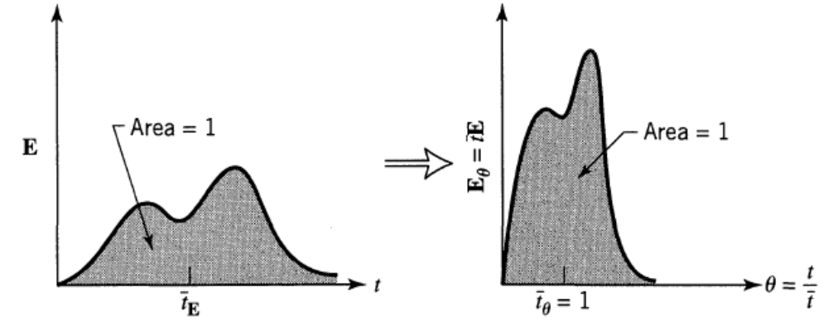
Fig 1.3.1.1 c Transforming an E curve into an E, curve.

      - The Step Experiment
Consider u m3/s of fluid flowing through a vessel of volume V. Now at time t = 0 switch from ordinary fluid to fluid with tracer of concentration C,,, =[kg or mol/m³l ] , and measure the outlet tracer concentration C_{step} versus t, as shown in fig 1.3.1.2 a
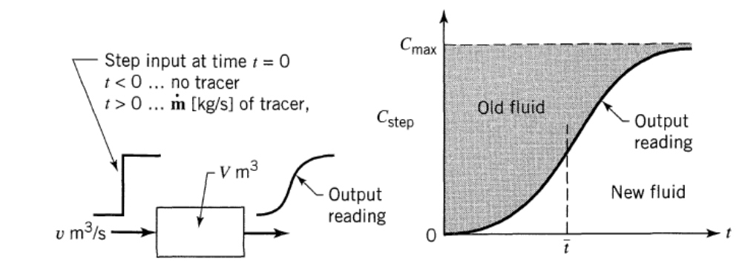

Fig 1.3.1.2.a Information obtainable from a step tracer experiment

A material balance relates the different measured quantities of the output curve of a step input

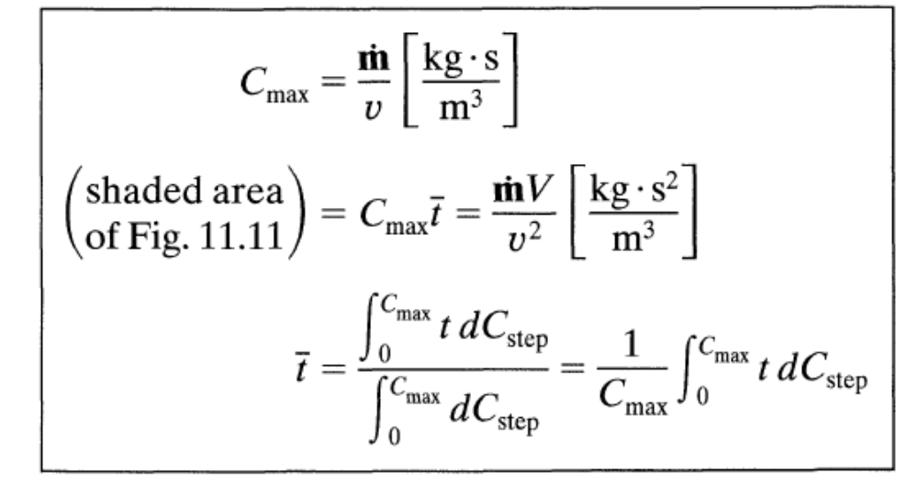

where m [kgls] is the flow rate of tracer in the entering fluid. The dimensionless form of the CStep curve is called the F curve. It is found by having the tracer concentration rise from zero to unity, as shown in Fig. 1.3.1.2 .b

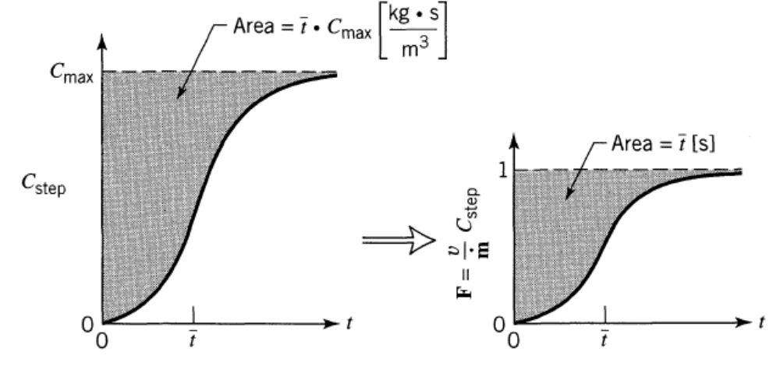

Fig 1.3.1.2.b Transforming an experimental C,,,, curve to an F curve

where m [kgls] is the flow rate of tracer in the entering fluid.The dimensionless form of the C_{Step} curve is called the F curve. It is found by having the tracer concentration rise from zero to unity.

1.3.2 Relationship between the F and E Curves

To relate E with F imagine a steady flow of white fluid. Then at time t = 0 switch to red and record the rising concentration of red fluid in the exit stream, the F curve. At any time t > 0 red fluid and only red fluid in the exit stream is younger than age t. Therefore
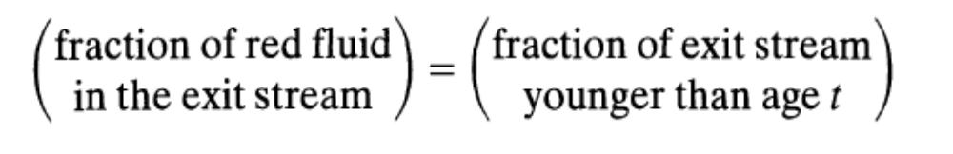
But the first term is simply the F value, while the second is given by
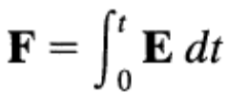
and on differentiating

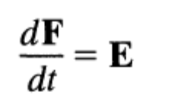
In graphical form this relationship is shown in Fig. 1.3.2 These relationships show how stimulus-response experiments, using either step or pulse inputs can conveniently give the RTD and mean flow rate of fluid in the vessel. We should remember that these relationships only hold for closed vessels. When this boundary condition is not met, then the Cpulse and E curves differ.
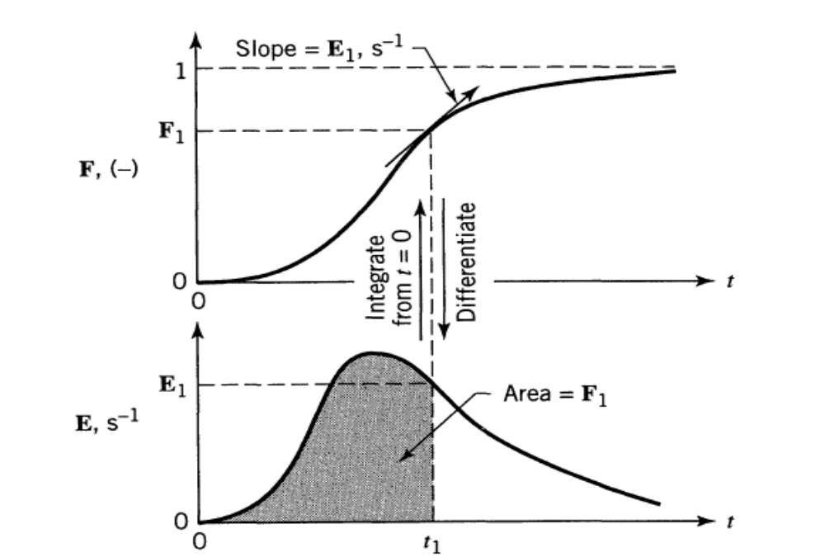
Fig 1.3.2.a Relationship between the E and F
curves.

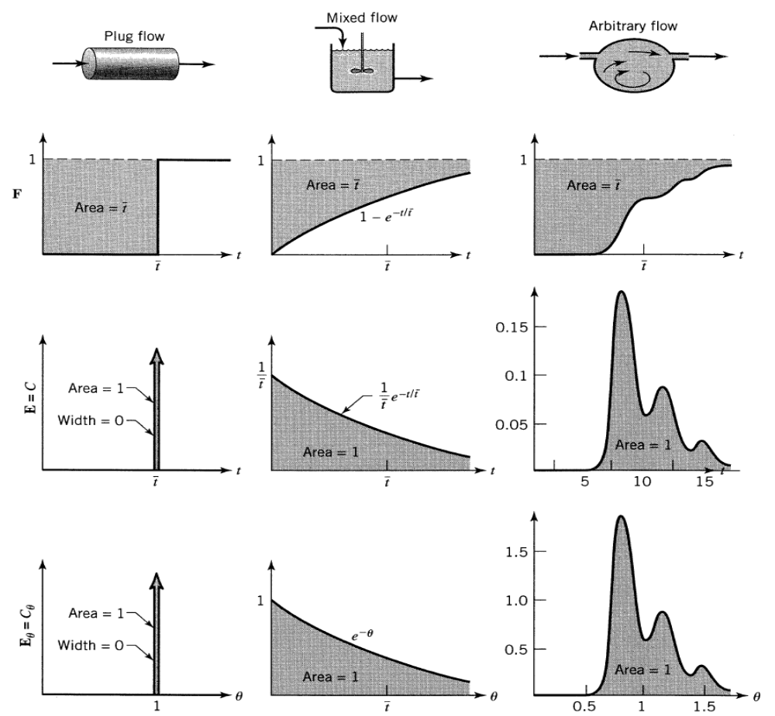
Fig 1.3.2.b Properties of the E and F curves for various flows. Curves are drawn in terms of
ordinary and dimensionless time units.

At any time these curves are related as follows:
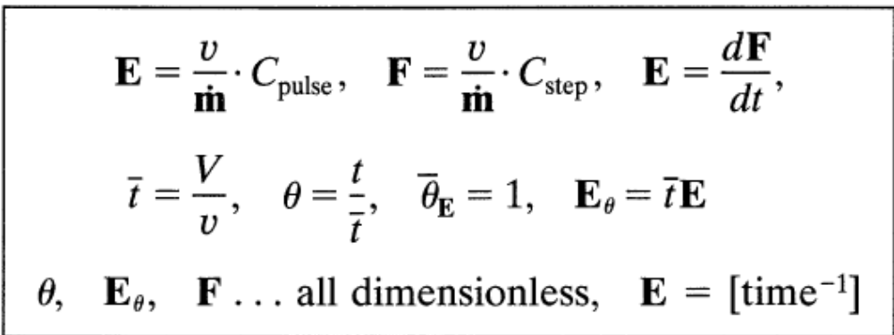
Problem 1:
The concentration readings in given Table represent a continuous response to a pulse input into a closed vessel which is to be used as a chemical reactor. Calculate the mean residence time of fluid in the vessel t, and tabulate and plot the exit age distribution E.

Time t, min | Tracer Output Concentration, C_{pulse}  gm/liter fluid
0 | 0
5 | 3
10 | 5
15 | 5
20 | 4
25 | 2
30 | 1
35 | 0
Solution:
The mean residence time,
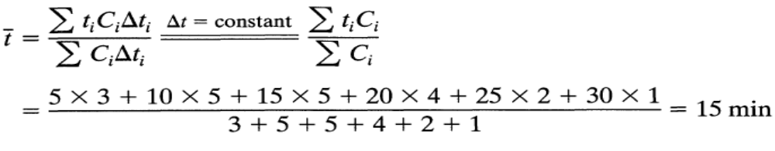
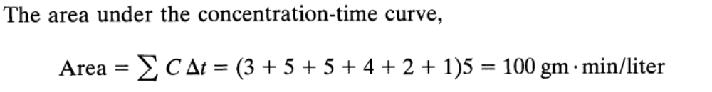
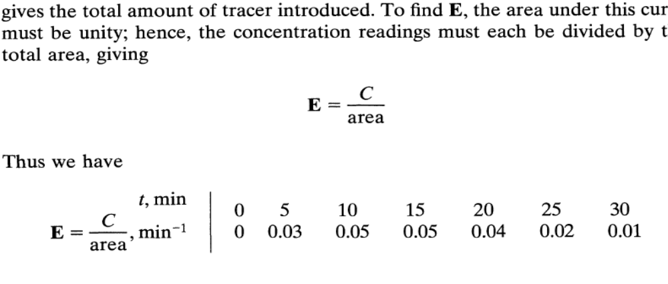
  - Model of Non- Ideal Flow

Models are useful for representing flow in real vessels, for scale up, and for diagnosing poor flow. We have different kinds of models depending on whether flow is close to plug, mixed, or somewhere in between. There are two models for non ideal flow

1. The dispersion model.
2. The tanks-in-series model.
1.4.1 Axial dispersion
Suppose an ideal pulse of tracer is introduced into the fluid entering a vessel. The pulse spreads as it passes through the vessel, and to characterize the spreading according to this model , we assume a diffusion-like process superimposed on plug flow. We call this dispersion or longitudinal dispersion to distinguish it from molecular diffusion. The dispersion coefficient D (m²/s) represents this spreading process.Thus
- large D means rapid spreading of the tracer curve
- small D means slow spreading
- D = 0 means no spreading, hence plug flow

Also D/uL is the dimensionless group characterizing the spread in the whole vessel.
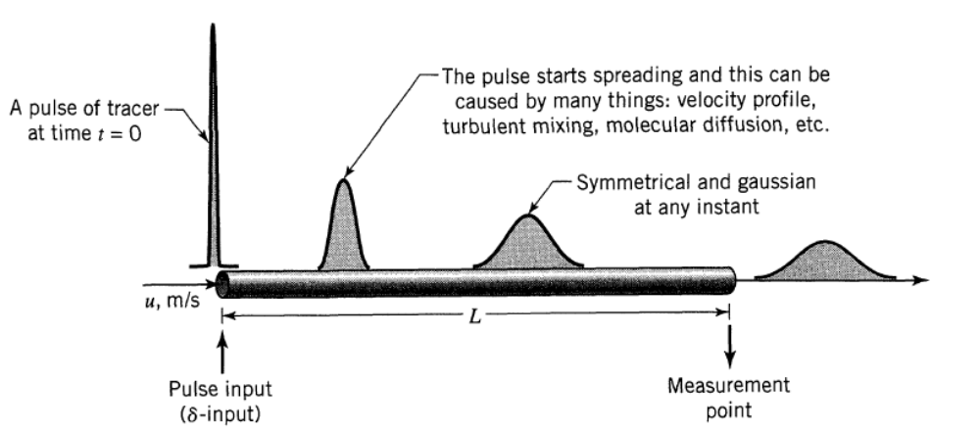
Fig 1.4.1.1 The spreading of tracer according to the dispersion model.

Evaluate D or D/uL by recording the shape of the tracer curve as it passes the exit of the vessel. In particular,

These measures, t and σ² are directly linked by theory to D and D/uL. The mean, for continuous or discrete data, is defined as
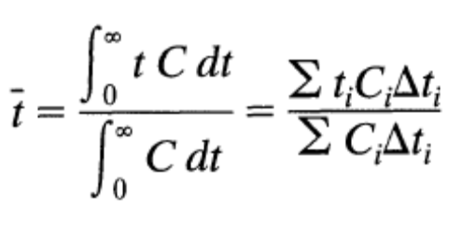
The variance is defined as
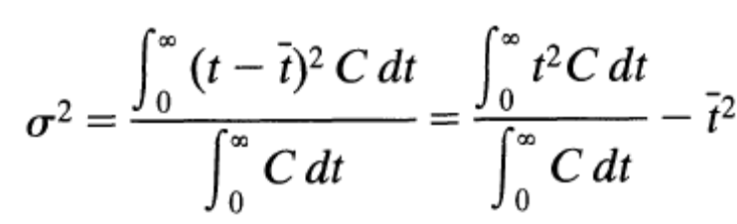
Or in discrete form

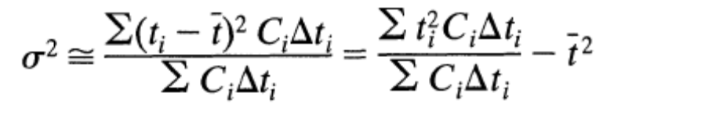
The variance represents the square of the spread of the distribution as it passes the vessel exit and has units of (time)². It is particularly useful for matching experimental curves to one of a family of theoretical curves

1.4.2 Dispersion Model
Assumption
- Plug flow of fluid with some degree of back mixing
- No stagnant regions or short circuiting of fluids.
- The fluid flow that satisfies these two assumptions are called dispersed flow model. Figure 1.4.2 shows the conditions visualized.
- Note that with varying intensities of turbulence or intermixing the predictions of this model should range from plug flow at one extreme to mixed flow at the other. As a result the reactor volume for this model will lie between those calculated for plug and mixed flow.
- Since the mixing process involves a shuffling or redistribution of material either by slippage or eddies, and since this is repeated many, many times during the flow of fluid through the vessel we can consider these disturbances to be statistical in nature, somewhat as in molecular diffusion. For molecular diffusion in the x-direction the governing differential equation is given by Fick's law:
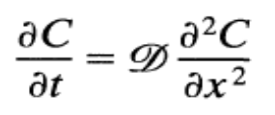

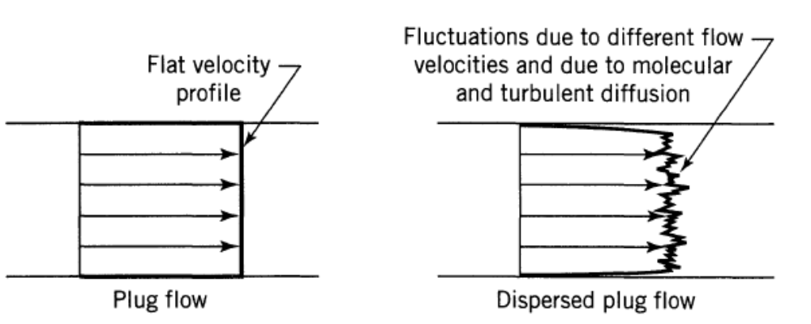
Fig 1.4.2 Representation of the dispersion Model

- Where D, the coefficient of molecular diffusion, is a parameter which uniquely characterizes the process. In an analogous manner we may consider all the contributions to intermixing of fluid flowing in the x-direction to be described by a similar form of expression, or
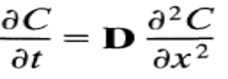
- Where D is the axial dispersion coefficient.

In dimensionless form where
The basic differential equation representing this dispersion model becomes
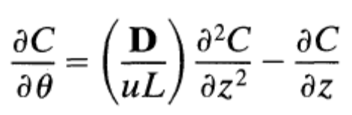
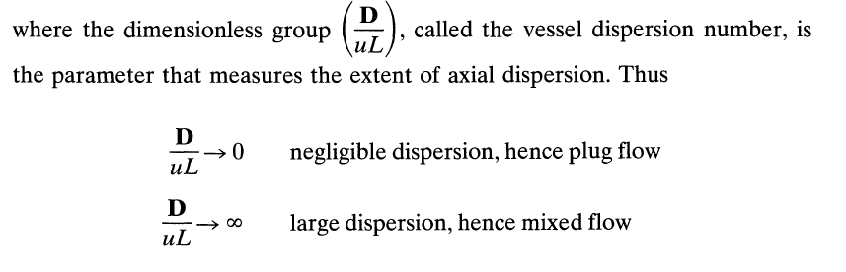
1.4.2.1 Fitting the Dispersion Model for Small Extents of Dispersion, D/uL < 0.01
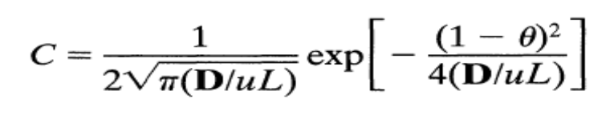
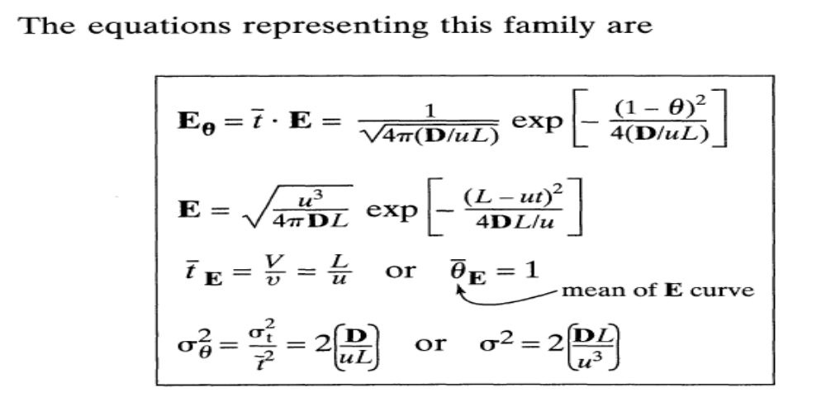
      - Fitting the Dispersion model for large extent of Dispersion , D/uL >0.01

Closed vessel: 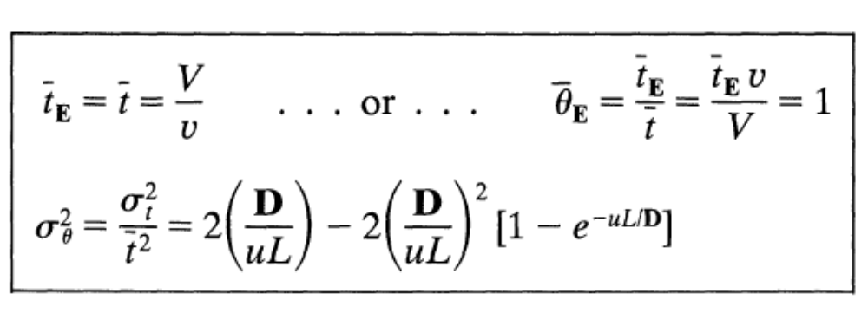

Open vessel:
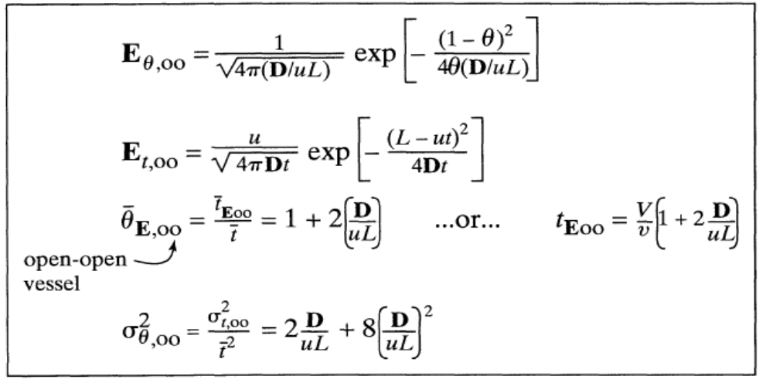

1.4.2.3 Chemical reaction and dispersion

- Our discussion has led to the measure of dispersion by a dimensionless group D/uL. Let us now see how this affects conversion in reactors.
- Consider a steady-flow chemical reactor of length L through which fluid is flowing at a constant velocity u, and in which material is mixing axially with a dispersion coefficient D. Let an nth-order reaction be occurring.

- By referring to an elementary section of reactor as shown in Fig. 1.4.2.3 , the basic material balance for any reaction component
input = output + disappearance by reaction + accumulation → 1

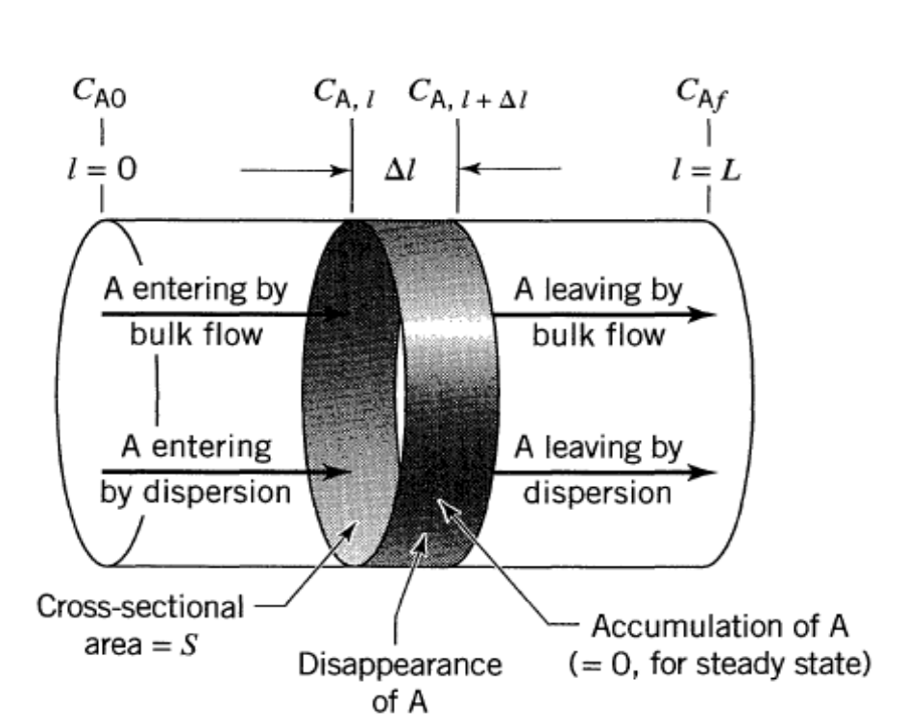
Fig 1.4.2.3 Variables for a closed vessel in which reaction and dispersion are occurring.

becomes for component A, at steady state, disappearance
→ 2

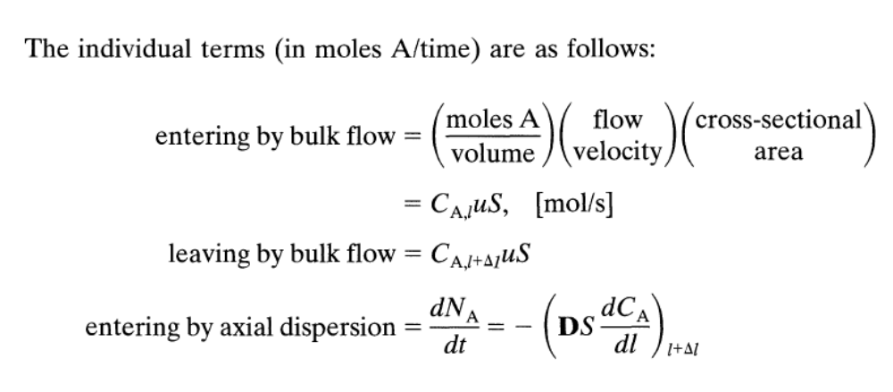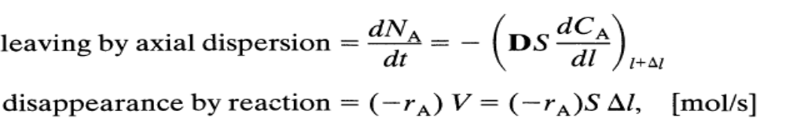
Entering all these terms into Eq. 2 and dividing by S ∆l gives

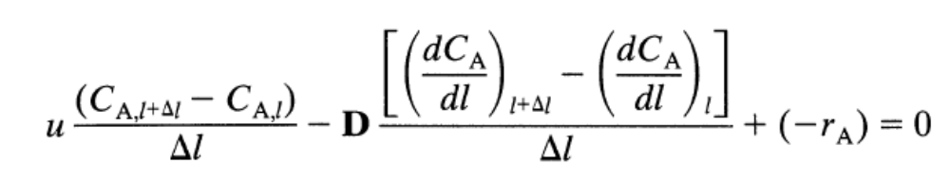
→ 3
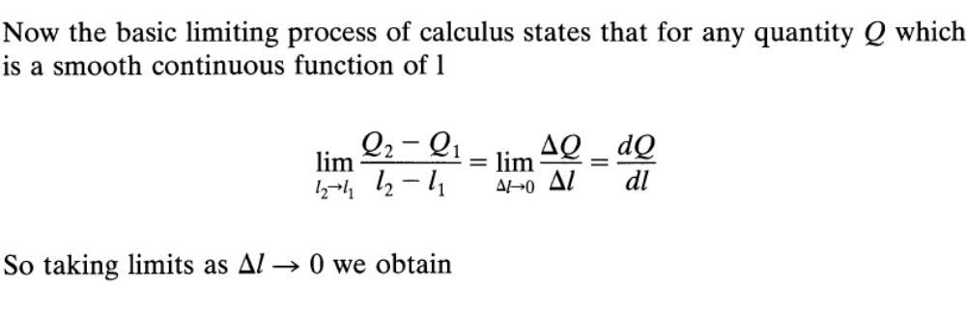
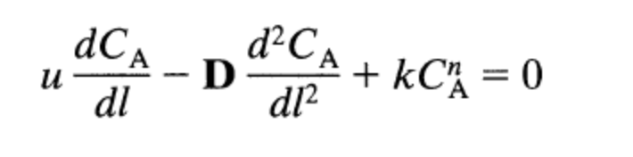
→ 4
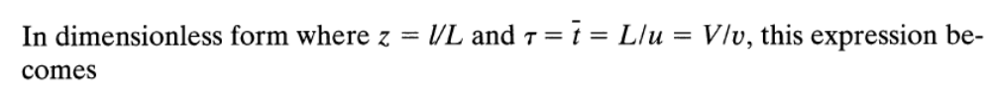
→ 5
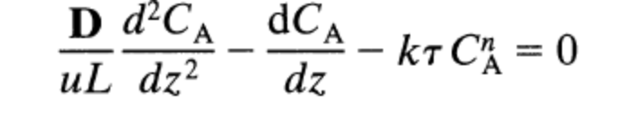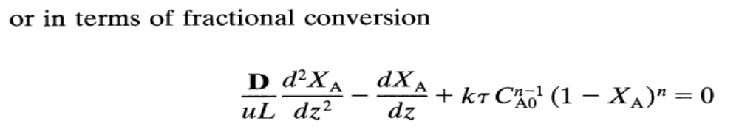
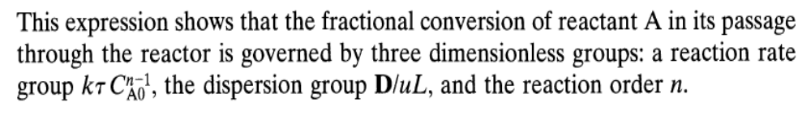
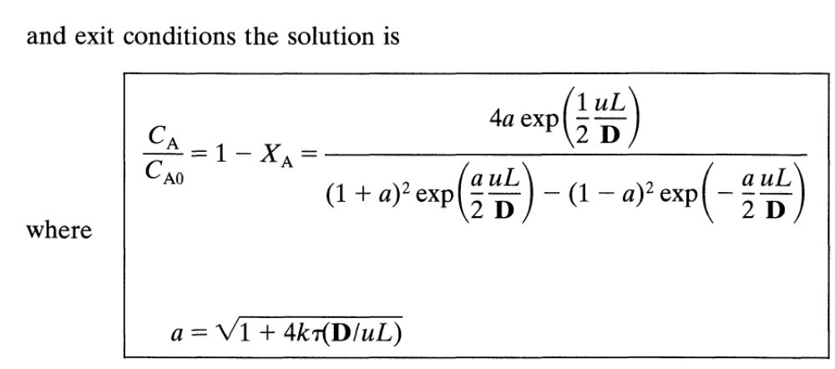

    - The Tanks-In-Series Model

- This model can be used whenever the dispersion model is used; and for not too large a deviation from plug flow both models give identical results, for all practical purposes. Which model you use depends on your mood and taste.
- The dispersion model has the advantage in that all correlations for flow in real reactors invariably use that model. On the other hand the tanks-in-series model is simple, can be used with any kinetics, and it can be extended without too much difficulty to any arrangement of compartments, with or without recycle.

- For the first tank. Consider a steady flow v m3/s of fluid into and out of the first of these ideal mixed flow units of volume V₁ At time t = 0 inject a pulse of tracer into the vessel which when evenly distributed in the vessel (and it is) has a concentration C₀
At any time t after the tracer is introduced make a material balance, thus

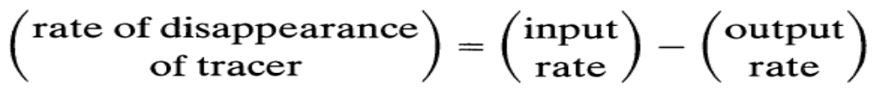

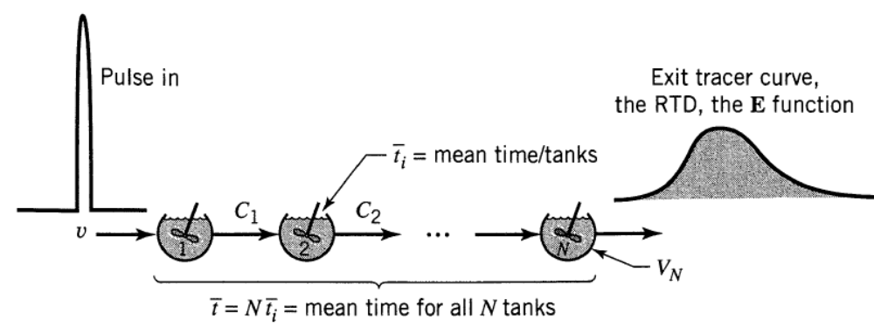
Fig 1.4.3 The tanks-in-series model.

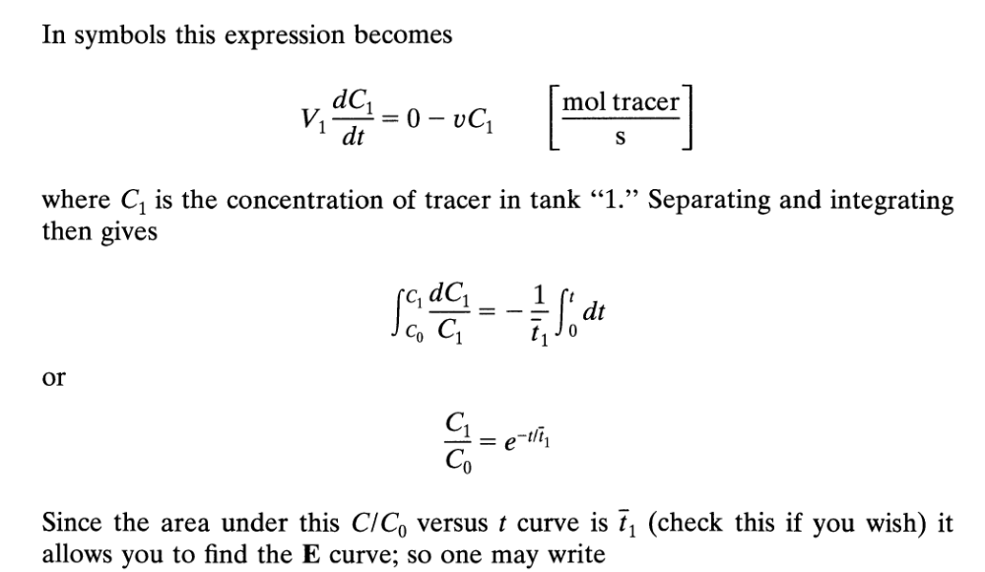
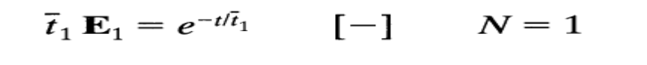
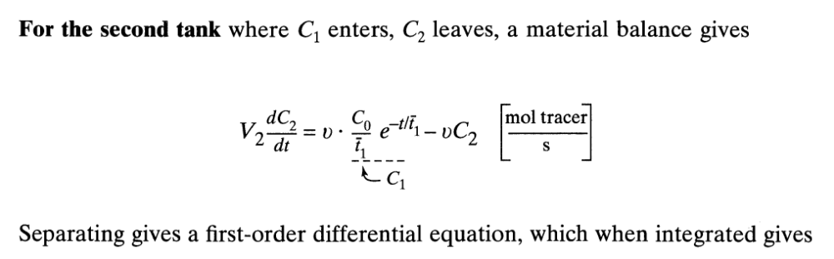
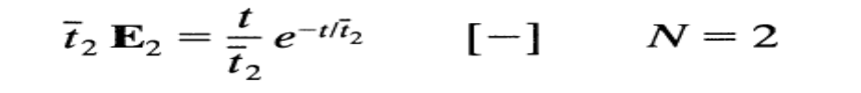
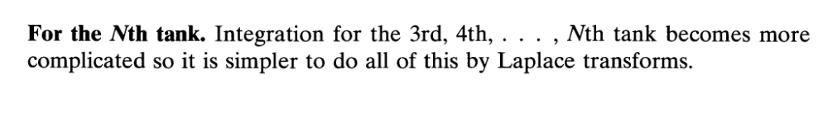
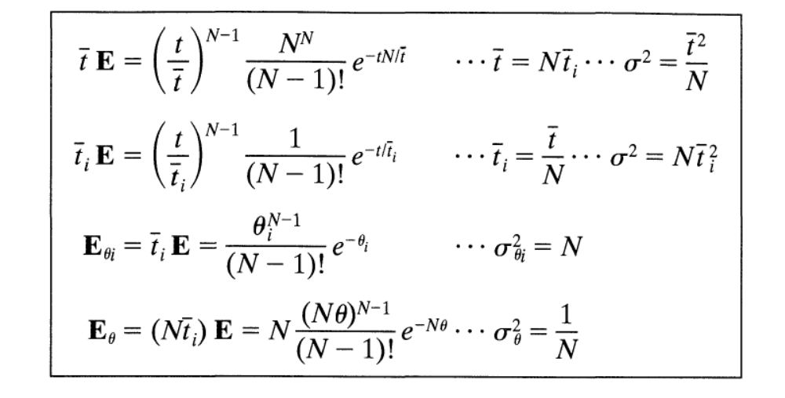
1.4.3.1 Chemical conversion 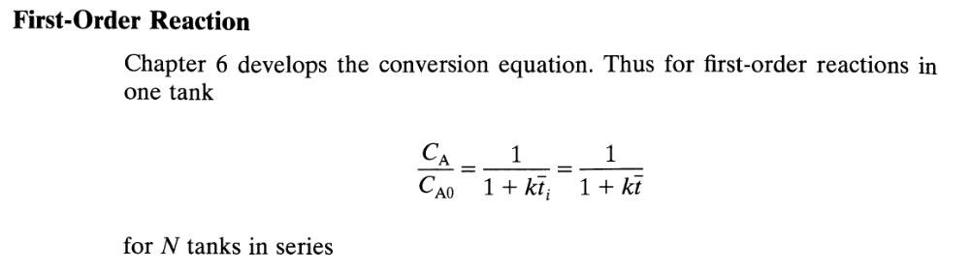
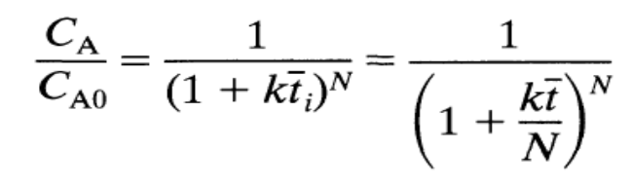
1.5 Continuous Heat Sterilisation
- Continuous sterilization, particularly a high-temperature, short-exposure-time process, can significantly reduce damage to medium ingredients while achieving high levels of cell destruction. Other advantages include improved steam economy and more reliable scale-up. The amount of steam needed for continuous sterilisation is 20-25% that used in batch processes; the time required is also significantly reduced because heating and cooling are virtually instantaneous.
- Typical equipment configurations for continuous sterilization are shown in Figure 1.5.1 In Figure 1.5.1 (a), raw medium entering the system is first pre-heated by hot, sterile medium in a heat exchanger; this economises on steam requirements for heating and cools the sterile medium.
- Steam is then injected directly into the medium as it flows through a pipe; the liquid temperature rises almost instantaneously to the desired sterilisation temperature.
- The time of exposure to this temperature depends on the length of pipe in the holding section of the steriliser. After sterilisation, the medium is cooled instantly by passing it through an expansion valve into a vacuum chamber; further cooling takes place in the heat exchanger where residual heat is used to pre-heat incoming medium. Figure 1.5.1 (b) shows an alternative sterilization scheme based on heat exchange between steam and medium.
- Raw medium is pre-heated withhot, sterile medium in a heat exchanger then brought to the sterilization temperature by further heat exchange with steam.
- The sterilisation temperature is maintained in the holding section before being reduced to the fermentation temperature by heat exchange with incoming medium. Heat-exchange systems are more expensive to construct than injection devices; fouling of the internal surfaces also reduces the efficiency of heat transfer between cleanings.
- On the other hand, a disadvantage associated with steam injection is diludon of the medium by condensate; foaming from direct steam injection can also cause problems with operation of the flash cooler. As indicated in Figure 1.5.2 rates of heating and cooling in continuous sterilization are much more rapid than in batch; accordingly, in design of continuous sterilisers, contributions to cell death outside of the holding period are generally ignored.
- An important variable affecting performance of continuous sterilisers is the nature of fluid flow in the system. Ideally, all fluid entering the equipment at a particular instant should spend the same time in the steriliser and exit the system at the same time; unless this occurs we cannot fully control the time spent in the steriliser by all fluid elements.
- No mixing should occur in the tubes; if fluid nearer the entrance of the pipe mixes with fluid ahead of it, there is a risk that contaminants will be transferred to the outlet of the steriliser. The type of flow in pipes where there is neither mixing nor variation in fluid velocity is called plugflow for plug-flow reactors.
- Plug flow is an ideal flow pattern; in reality, fluid elements in pipes have a range of different velocities. As illustrated in Figure 13.39, flow tends to be faster through the centre of the tube than near the walls. However, plug flow is approached in pipes at turbulent Reynolds numbers) above about 2 X 10⁴; operation at high Reynolds numbers minimises fluid mixing and velocity variation.
- Deviation from plug-flow behaviour is characterised by the degree of axial dispersion in the system, i.e. the degree to which mixing occurs along the length or axis of the pipe. Axial dispersion is a critical factor affecting design of continuous sterilisers. The relative importance of axial dispersion and bulk flow in transfer of material through the pipe is represented by a dimensionless variable called the Peclet number:
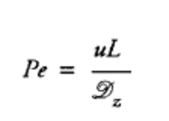
- where Pe is the Peclet number, u is the average linear fluid velocity, L is the pipe length and Dz is the axial-dispersion coefficient. For perfect plug flow, Dz is zero and Pe is infinitel) large; in practice, Peclet numbers between 3 and 600 are typical.
- The value of Dz for a particular system depends on the Reynolds number and pipe geometry; a correlation from the engineering literature for evaluating -~z is shown in Figure 1.5.3. Once the Peclet number has been calculated from Eq.1, the extent of cell destruction in the steriliser can be related to the specific death constant kd using Figure 1.5.4. In Figure 15.4, N ₁ is the number of viable cells entering the system, N ₂ is the number of cells leaving, Pe is the Peclet number as defined by Eq. (1), and Da is another dimensionless number called the Damkiihler number:
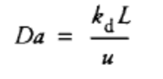
- where k d is the specific death constant, L is the length of the holding pipe and u is the average linear liquid velocity. The lower the value of N₂/N_{l}, the greater is the level of cell destruction.
- Figure 1.5.4 shows that, at any given sterilization temperature defining the value of k d and Da, performance of the steriliser declines significantly as the Peclet number decreases. Design calculations for a continuous sterilizer are illustrated in Example 1
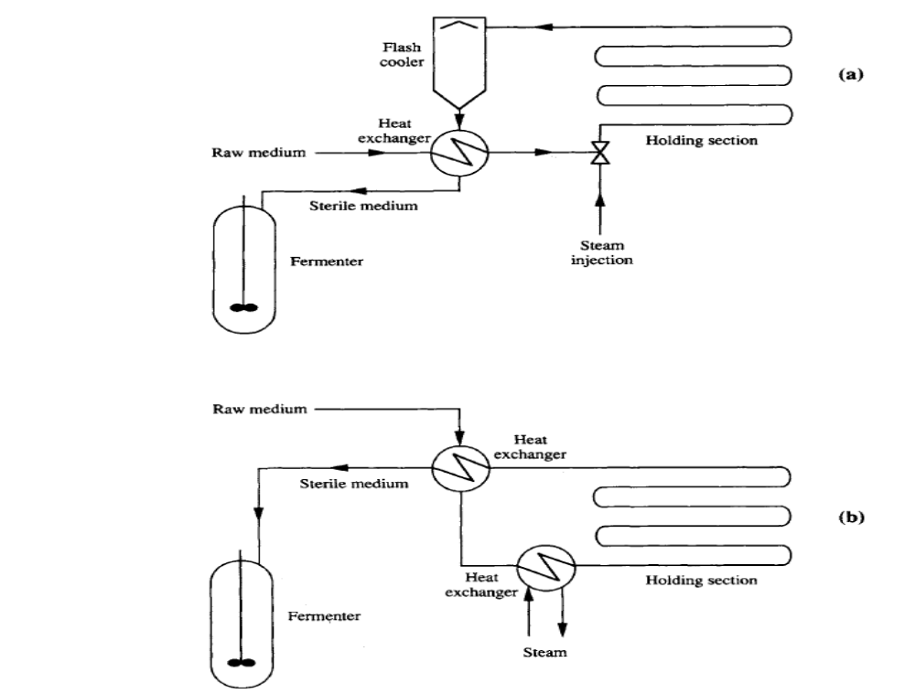
Fig 1.5.1Continuous sterilising equipment: (a) continuous steam injection with flash cooling; (b) heat transfer using heat exchangers.

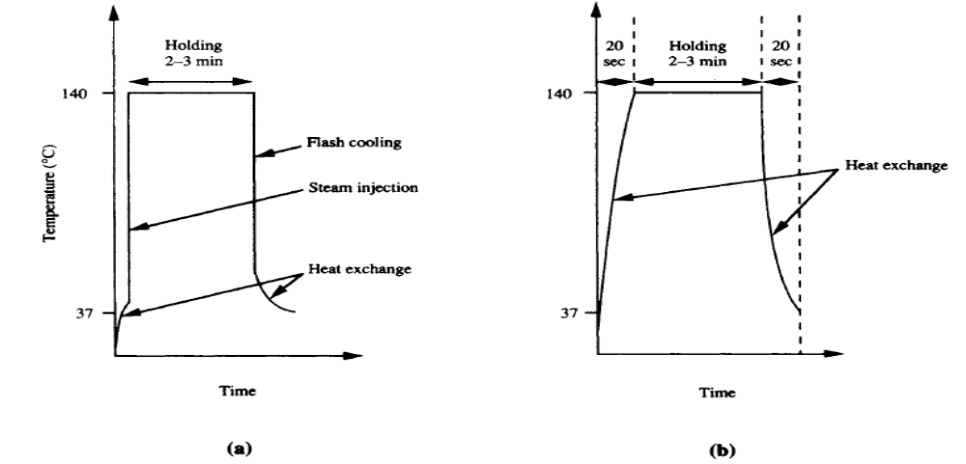
Fig 1.5.2 Variation of temperature with time in the continuous sterilizers

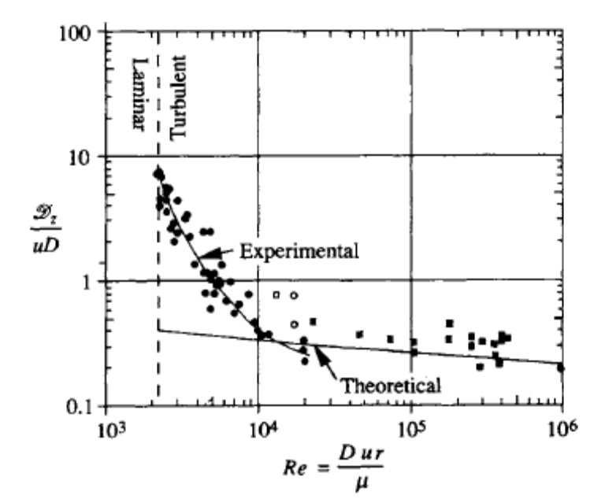
Fig 1.5.3 Correlation for determining the axial dispersion coefficient in turbulent pipe flow. Re is Reynolds number, D is pipe diameter, u is average linear fluid velocity, p is fluid density, μ is fluid viscosity, and Dz is the axial dispersion coefficient.

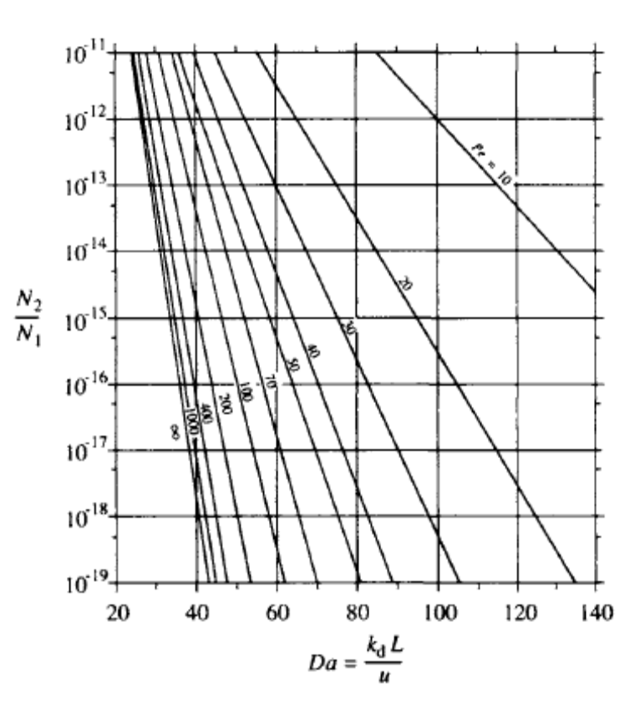

Example1:
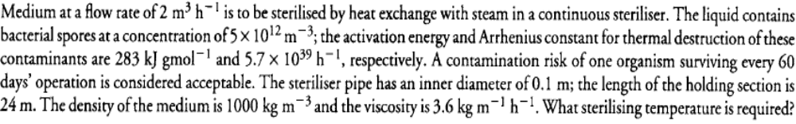
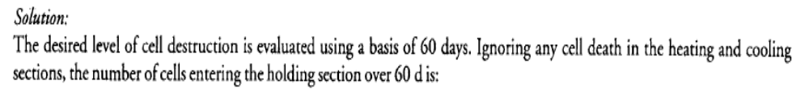
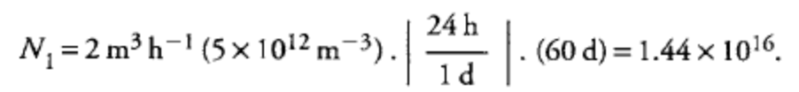
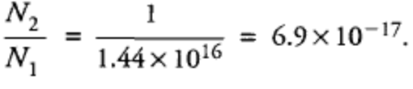
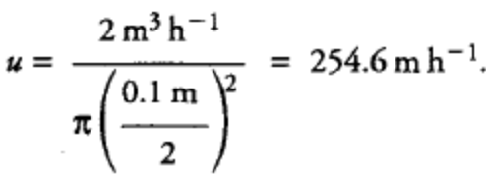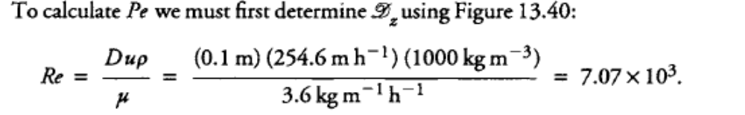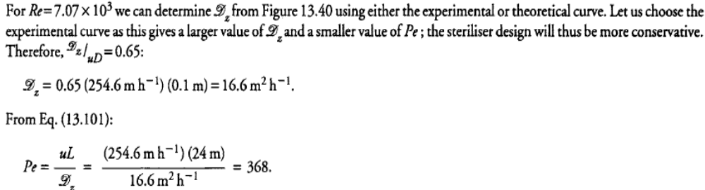

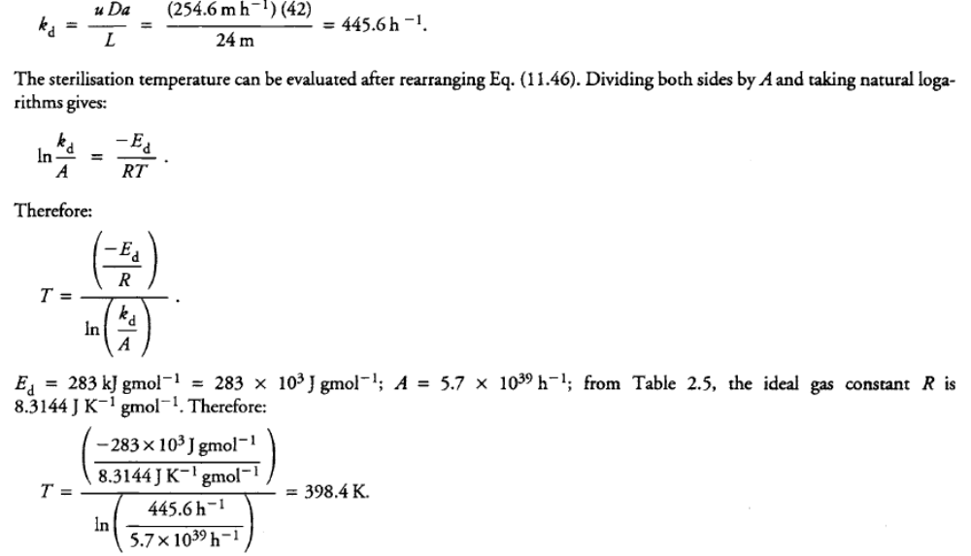

UNIT II
ANALYSIS OF OTHER CONFIGURATIONS
2.1 Packed bed reactor
- Packed-bed reactors are used with immobilised or particulate biocatalysts. The reactor consists of a tube, usually vertical, packed with catalyst particles.
- Medium can be fed either at the top or bottom of the column and forms a continuous liquid phase between the particles. Damage due to particle attrition is minimal in packed beds compared with stirred reactors.
- Packed-bed reactors have been used commercially with immobilised cells and enzymes for production ofaspartate and fumarate, conversion of penicillin to 6-aminopenicillanic acid, and resolution of amino acid isomers. Mass transfer between the liquid medium and solid catalyst is facilitated at high liquid flow rates through the bed; to achieve this, packed beds are often operated with liquid recycle as shown in Figure 2.1.
- The catalyst is prevented from leaving the column by screens at the liquid exit. The particles should be relatively incompressible and able to withstand their own weight in the column without deforming and occluding liquid flow.
- Recirculating medium must also be clean and free of debris to avoid clogging the bed. Aeration is generally accomplished in a separate vessel; if air is sparged directly into the bed, bubble coalescence produces gas pockets and flow channelling or maldistribution. Packed beds are unsuitable for processes which produce large quantities of carbon dioxide or other gases which can become trapped in the packing.

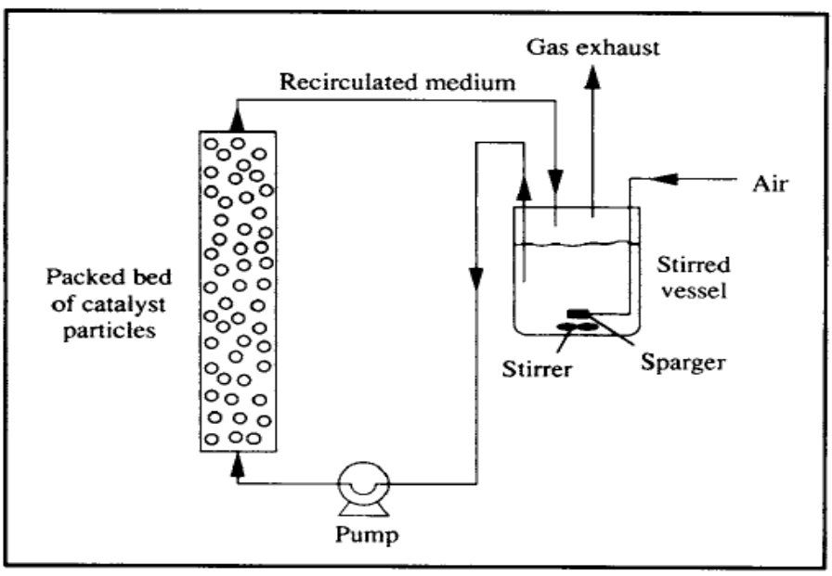

- In the packed bed reactor , the superficial flow velocity through the reactor is equal to the volumetric flow of the feed divided by the cross sectional area which is the total cross sectional area times the void fraction ε.
Void fraction is defined as the ratio of void volume to the total volume.

2.1.1 Modeling of packed bed reactor
Assumption:
- The influence of packed catalyst on flow and kinetic features are considered.
- Flow across the cross sectional area is equal to the cross sectional area times the void fraction.
- The flow rate of liquid = ε x Cross sectional area x ( V/L)
V is interstitial fluid velocity or rate.
Consider a single reaction S → P with intrinsic rate
V= V(S,P) the rate of product formation per crit volume of immobilized biocatalyst pellet at a point in a reactor.
r_{p} = υ overall / Total volume of pellet = η (Ss, Ps) υ(Ss, Ps)
where Ss and Ps are the substrate and product concentrations at the exterior pellet surface at the position inside the reactor and η is the effectiveness factor.
Consider the mass transfer resistance between the bulk phase and pellet surface , a steady state material balance on substrate over a pellet gives for a spherical catalyst pellet of radius R
Rate of substrate diffusion out of bulk liquid= rate of substrate disappearance by reaction within pellet.
4 Π R²Ks( S-Ss) = 4/3 Π R³ η (Ss, Ps) υ(Ss, Ps)
R- Raidus of biocatalyst pellet.
Ks- Mass transfer coefficient.
2.1.2 Advantages
i) Damage due to particles attrition is minimal in packed beds compared with stirred reactors.
ii) The superficial fluid velocity will be larger than in an open plug flow reactor.

2.1.3 Disadvantages
i) Poor temperature control – hot spots
ii) Channeling of gas - leading to ineffective regions
iii) Catalyst loading is difficult
iv) Poor heat transfer to and from the reactor
2.1.4 Applications
i) Isomerization of glucose to fructose for production of high fructose corn sweetener.
iii) Conversion of penicillin to 6 aminopencillin.
2.2 Fluidized bed reactor:
- Fluidized-bed bioreactors are directly linked to the use of biocatalysts (cells or enzymes) for transformations in an immobilized form. The solid particles of the immobilized biocatalyst are maintained in fluidization by means of the circulation of a fluid phase (either liquid, gas, or a mixture of both) that compensates their weight.
- In this way, good liquid mixing and mass transfer between the solid and the liquid phases can be obtained with low attrition. Also, fluidized-bed bioreactors can accommodate a gas phase and can be used to feed solids in suspension.
- High productivities can be achieved in these systems, but their hydrodynamic complexity and operational stability have to be well defined for a proper operation. When packed beds are operated in upflow mode with catalyst beads of appropriate size and density, the bed expands at high liquid flow rates due to upward motion of the particles.
- This is the basis for operation of fluidised-bed reactors as illustrated in Figure 2.2. Because particles in fluidised beds are in constant motion, channelling and clogging of the bed are avoided and air can be introduced directly into the column.
- Fluidised-bed reactors are used in waste treatment with sand or similar material supporting mixed microbial populations. They are also used with flocculating organisms in brewing and for production of vinegar.
2.2.1 The Fluidization concept: General Considerations
- The term fluidized-bed is used to define those physical systems composed of a solid phase in the form of individual particles that move within a fluid phase and are not in continuous contact with each other.
- Fluidization of the solid particles is reached when the flow of fluid through the bed is high enough to compensate their weight. On the other hand, in order to be kept in the fluidized-bed reactor and not be washed out (elutriated), the superficial velocity of the fluid in the bed (that is, the ratio between the flow rate and the bed cross-sectional area) has to be lower than the settling velocity of the particles.
- These two extreme situations are outlined in Figure 2.2.1 When the flow rate of a fluid through a packed bed of solid particles steadily increases, the pressure drop increases proportionally to the flow rate, as long as the bed height remains constant.
- When the drag force of the fluid equilibrates the weight of the particles, the bed starts to expand and, after a transition period, reaches fully developed fluidization. At this point, further increments in the flow rate do not produce an increase in pressure drop, but instead lead to an increase of the height occupied by the solid particles in the reactor.
- If the flow rate is increased significantly, the elutriation of the solid particles occurs when the fluid’s superficial velocity is higher than the solid’s settling velocity.
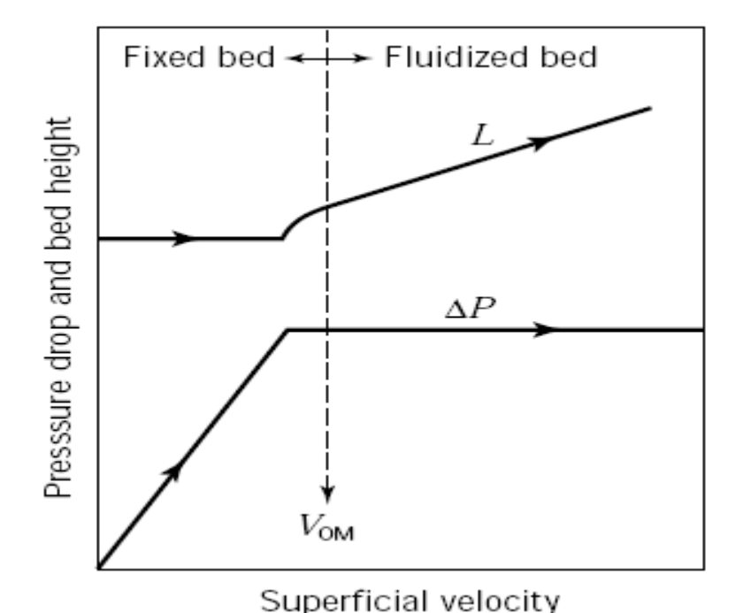
Fig 2.2.1 Fluidization concept

Figure 2.2.2 represents the basic scheme of a fluidized-bed bioreactor.
- Although various configurations are possible , the most extensively used is the gas–liquid cocurrent up-flow reactor. In it, liquid usually comprises the continuous phase and is fed from the reactor bottom. Its flow upward in the reactor promotes fluidization of the solid particles.
- Usually, the reactor will have two or three phases. In addition to the liquid and solid phases, the occurrence of a gas phase is quite common in those systems using cells as biocatalysts, either for aeration requirements (in which case, an air or oxygen stream is fed to the reactor, as shown in Fig. 2.2.2) or because cell metabolism produces a gas product (for example, CO2, CH4).
- In systems using enzymes as biocatalysts, the most common situation is two-phase fluidization, without any gas phase. Very often, due to the low reaction rates of most biological transformations, long liquid residence times are needed for the completion of the reaction, and therefore the drag force created by the low liquid flow rate in a single pass reactor is not enough to promote fluidization of the solid particles.
- Fluidization is obtained either by external liquid recirculation or by the gas loaded to the reactor, as depicted in Figure 2.2.2. In systems where a gas is produced by cell metabolism, the gas can also be an additional factor contributing to solid particle fluidization, although other effects are also observed in this case, such as internal liquid recirculation patterns.
- Fluidization at relatively low liquid flow rates is also favored in tapered fluidized-bed configurations; the liquid superficial velocity at the bottom of the reactor is higher due to the reduced cross-sectional area. In general, one can distinguish three main sections in fluidized-bed bioreactors: (1) the bottom section, where feed (liquid, gas, or both) and recirculation are provided; (2) the central main section, where most of the reaction takes place; (3) and the top section, with a wider diameter that serves to decelerate the movement of the particles by decreasing the superficial velocity of the liquid, thus enhancing the retention of the solid phase and at the same time allowing gas disengagement from the liquid phase.
- It is a common trend for fluidized-bed bioreactors to use biocatalysts, either cells or enzymes, in the form of immobilized preparations. In general, the particles can be of three different types: (1) inert cores on which a biofilm is created by cell attachment, or in the case of enzymes, by adsorption or covalent binding immobilization; (2) porous particles in which the biocatalysts are entrapped; (3) cell aggregates obtained by self-immobilization caused by the ability of some cell strains to form flocs, pellets, or aggregates. Fluidized-bed bioreactors are usually differentiated from air-lift bioreactors by the fact that the latter do not specifically require the use of immobilized biocatalysts. Indeed, they were developed for free cell suspensions. In addition, air-lift bioreactors have different compartments, created by physical internal divisions, with different degrees of aeration.
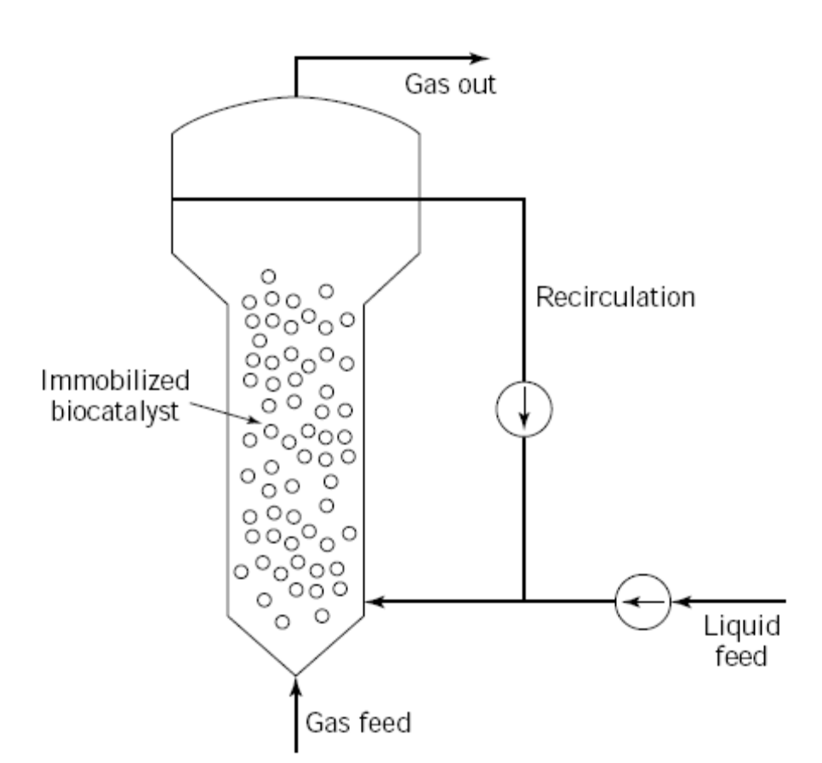
Fig 2.2.2 Fluidized bed reactor

- In a fluidized bed reactor, liquid flows upward through a long vertical cylcinder. Heterogeneous biocatalyst particles( flocculated organisms, pelltes of immobilized enzymes or cells) are suspended by drag exerted by the rising liquid.
- Entrained catalyst pellet are released at the top of the tower by the reduced liquid drag at the expanding cross section and fed back in to the tower. Thus by a careful balance between operating conditions and organisms characteristics, the biocatalyst is retained in the reactor while the medium flows through it continuously.
- Because particles in fluidized beds are in constant motion, channeling and clogging of the bed are avoided and air can be introduced directly into the column.
2.2.1 Design of fluidized bed reactor:
Assumption:
i) The biological catalyst particles are uniform in size.
ii) The fluid phase density is a function of substrate concentration.
iii) The liquid phase move upward through the vessel in plug flow.
iv) Substrate utilization rates are first order in biomass concentration but zero order in substrate concentration.
v) The terminal velocity is small enough to justify stoke’s law.

So, substrate utilization rate,
-r_{A}= dC_{A}/dt = kC_{A} → 1
Substrate conversion
d(SU)/dZ= - kx → 2
U dS/dZ + S dU/dZ = -kx →3
x depends upon terminal setting velocity
x= ρ_{o} [ 1- (U/U_{t} ) ^{1/4.65}] → 4
ρ_{o} – microbial density on a dry weight basis
U_{t} – terminal velocity of a sphere in stoke’s flow
U_{t} = [dp² (ρ_{o} – ρ ) g]/ 18μ →5
Based on assumption 2
d(ρU)/dZ =0
ρ= ρ(S)
ρ(S) dU/dZ +U (dρ/dS) dS/dZ=0 → 6
Where eqn 3 and 6 are simultaneous algebric equation and solving these equation with initial boundary conditions of
S(0) =S_{F}
U(0)= U_{F} = F_{F}/ A_{F}
S_{F} = substrate concentration in feed
F_{F} = Liquid flow rate of the reactor at the bottom.
A_{F} = Cross sectional area of the reactor at the bottom.
Sc= Substrate concentration at the outlet
When Z= L
Sc= S_{F} - k ρ_{o} [ 1- (U/U_{t} ) ^{1/4.65} L/U]
Based on the three phase system reactor, a model developed by kurmi-levenspeil for mass transport and is known as cloud wake model.
N_{sh} =0.81/6 [ (N_{Re}) ^{½} ( N_{sc}) ^{1/3}]
N_{sh} = Sherwood number
N_{Re} = Reynolds number
N_{sc} = Schmid number
N_{sc} = μ/ρdp , N_{sh}= kdp/ Dm
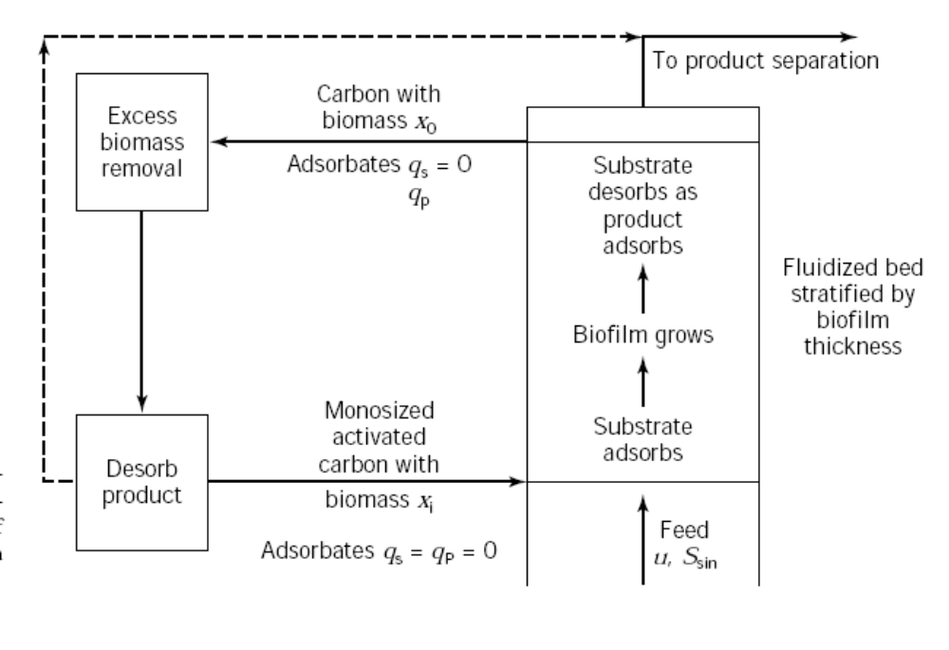
Fig 2.2.3 Operation diagram of a fluidized- bed bioreactor with simultaneous bioconversion
and adsorption/desorption of substrate and product.
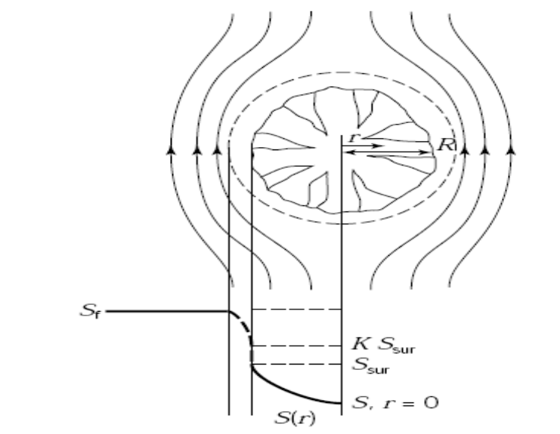
Fig 2.2.4 Inter and intraparticle mass transfer of a single porous spherical bead of radius R. Substrate concentration profiles across the stagnant liquid film and inside the solid particle, S(r). Sf, concentration on the bulk liquid; Ssur, concentration on the solid surface; K, partition coefficient.

2.2.2. Advantages
i) Intimate contact between the solid ,liquid and gas exists.
ii) Mass transfer rate is good.
iii) If mass transfer rate increases the reaction rate is increases.
iv) Also resembles CSTR at a particular velocity.
v) In packed bed the gases produced are trapped but in fluidized bed the gases escapes.
2.2.3 Application
i) It is used in waste water treatment with sand or similar material supporting mixed microbial population.
Eg: UASP- Upward Anaerobic Sludge Plancket reactor.
ii) It is used in brewing and production of vinegar.
2.3 Air lift reactor
- The term airlift reactor (ALR) covers a wide range of gas– liquid or gas–liquid–solid pneumatic contacting devices that are characterized by fluid circulation in a defined cyclic pattern through channels built specifically for this purpose.
- In ALRs, the content is pneumatically agitated by a stream of air or sometimes by other gases. In those cases, the name gas lift reactors has been used. In addition to agitation, the gas stream has the important function of facilitating exchange of material between the gas phase and the medium; oxygen is usually transferred to the liquid, and in some cases reaction products are removed through exchange with the gas phase.
- The main difference between ALRs and bubble columns (which are also pneumatically agitated) lies in the type of fluid flow, which depends on the geometry of the system. The bubble column is a simple vessel into which gas is injected, usually at the bottom, and random mixing is produced by the ascending bubbles. In the ALR, the major patterns of fluid circulation are determined by the design of the reactor, which has a channel for gas–liquid upflow—the riser—and a separate channel for the downflow (Fig.2.3.1).
- The two channels are linked at the bottom and at the top to form a closed loop. The gas is usually injected near the bottom of the riser. The extent to which the gas disengages at the top, in the section termed the gas separator,is determined by the design of this section and the operating conditions. The fraction of the gas that does not disengage, but is entrapped by the descending liquid and taken into the downcomer, has a significant influence on the fluid dynamics in the reactor and hence on the overall reactor performance.
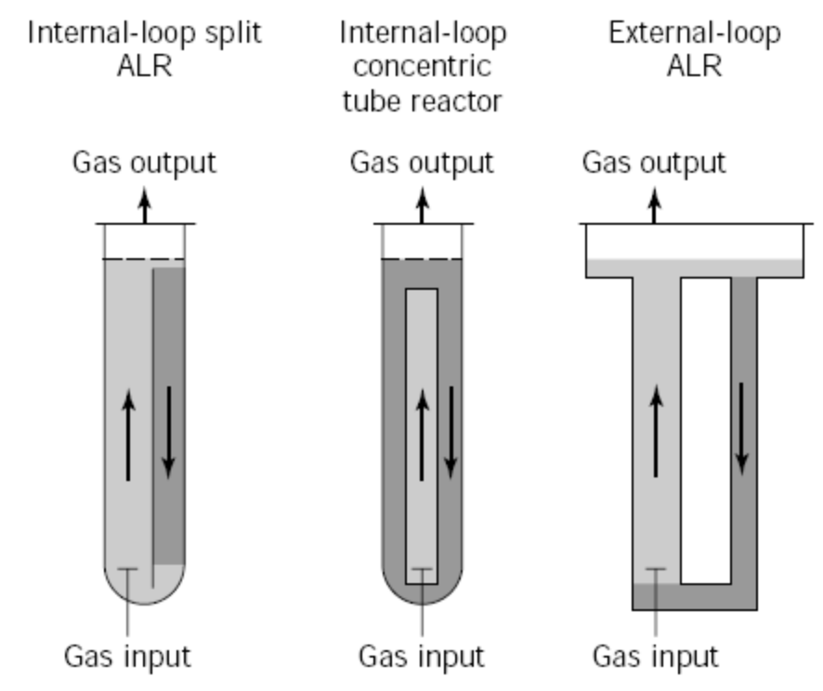
Fig 2.3.1 Airlift Reactor Types
2.3.1 Airlift Reactor Morphology
- Airlift reactors can be divided into two main types of reactors on the basis of their structure (Fig.2.3.1 ): (1) externalloop vessels, in which circulation takes place through separate and distinct conduits; and (2) baffled (or internal-loop) vessels, in which baffles placed strategically in a single vessel create the channels required for the circulation.
- The designs of both types can be modified further, leading to variations in the fluid dynamics, in the extent of bubble disengagement from the fluid, and in the flow rates of the various phases. All ALRs, regardless of the basic configuration (external loop or baffled vessel), comprise four distinct sections with different flow characteristics:
• Riser. The gas is injected at the bottom of this section, and the flow of gas and liquid is predominantly upward.
• Downcomer. This section, which is parallel to the riser, is connected to the riser at the bottom and at the top. The flow of gas and liquid is predominantly downward. The driving force for recirculation is the difference in mean density between the downcomer
and the riser; this difference generates the pressure gradient necessary for liquid recirculation.
• Base. In the vast majority of airlift designs, the bottom connection zone between the riser and downcomer is very simple. It is usually believed that the base does not significantly affect the overall behavior of the reactor, but the design of this section can influence gas holdup, liquid velocity, and solid phase flow
• Gas separator. This section at the top of the reactor connects the riser to the downcomer, facilitating liquid recirculation and gas disengagement. Designs that allow for a gas residence time in the separator that is substantially longer than the time required for the bubbles to disengage will minimize the fraction of gas recirculating through the downcomer
Momentum, mass transfer, and heat transfer will be different in each section, but the design of each section may influence the performance and characteristics of each of the other sections, since the four regions are interconnected.
2.3.2 Flow Configuration
2.3.2.1 Riser.
- In the riser, the gas and liquid flow upward, and the gas velocity is usually larger than that of the liquid. The only exception is homogeneous flow, in which case both phases flow at the same velocity. This can happen only with very small bubbles, in which case the free-rising velocity of the bubbles is negligible with respect to the liquid velocity. Although about a dozen different gas–liquid flow configurations have been developed, only two of them are of interest in ALRs
- Homogeneous bubbly flow regime, in which the bubbles are relatively small and uniform in diameter and turbulence is low
2. Churn-turbulent regime, in which a wide range of bubble sizes coexist within a very turbulent liquid.
The churn-turbulent regime can be produced from homogeneous bubbly flow by increasing the gas flow rate. Another way of obtaining a churn-turbulent flow zone is by starting from slug flow and increasing the liquid turbulence, by increasing either the flow rate or the diameter of the reactor The slug-flow configuration is important only as a situation to be avoided at all costs, because large bubbles bridging the entire tower cross-section offer very poor capacity for mass transfer.
2.3.2.2 Downcomer
- In the downcomer, the liquid flows downward and may carry bubbles down with it. For bubbles to be entrapped and flow downward, the liquid velocity must be greater than the free-rise velocity of the bubbles.
- At very low gas flow input, the liquid superficial velocity is low, practically all the bubbles disengage, and clear liquid circulates in the downcomer. As the gas input is increased, the liquid velocity becomes sufficiently high to entrap the smallest bubbles.
- Upon a further increase in liquid velocity larger bubbles are also entrapped. Under these conditions the presence of bubbles reduces the cross-section available for liquid flow, and the liquid velocity increases in this section.
- Bubbles are thus entrapped and carried downward, until the number of bubbles in the cross-section decreases, the liquid velocity diminishes, and the drag forces are not sufficient to overcome the buoyancy. This feedback loop in the downcomer causes stratification of the bubbles, which is evident as a front of static bubbles, from which smaller bubbles occasionally escape downward and larger bubbles, produced by coalescence, escape upward.
- The bubble front descends, as the gas input to the system is increased, until the bubbles eventually reach the bottom and recirculate to the riser. When this point is reached, the bubble distribution in the downcomer becomes much more uniform.
- This is the most desirable flow configuration in the downcomer, unless a single pass of gas is required. The correct choice of cross-sectional area ratio of the riser to the downcomer will determine the type of flow.
2.3.2.3 Gas Separator
- The gas separator is often overlooked in descriptions of experimental ALR devices, although it has considerable influence on the fluid dynamics of the reactors. The geometric design of the gas separator will determine the extent of disengagement of the bubbles entering from the riser.
- In the case of complete disengagement, clear liquid will be the only phase entering the downcomer. In the general case, a certain fraction of the gas will be entrapped and recirculated.
- Fresh gas may also be entrapped from the headspace if the fluid is very turbulent near the interface. The extent of this entrapment influences strongly gas holdup and liquid velocity in the whole reactor.
- It is quite common to enlarge the separator section to reduce the liquid velocity and to facilitate better disengagement of spent bubbles. Experiments have been reported in which the liquid level in the gas separator was high enough to be represented as two mixed vessels in series. This point will be analyzed further in the section devoted to mixing.

2.3.2.4 Gas Holdup
- Gas holdup is the volumetric fraction of the gas in the total volume of a gas–liquid–solid dispersion:
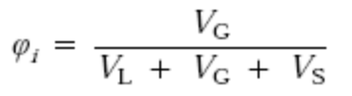
where the subindexes L, G, and S indicate liquid, gas, andsolid, and i indicates the region in which the holdup is considered,that is, gas separator (s) the riser (r), the downcomer (d), or the total reactor (T).
- The importance of the holdup is twofold: (1) the value of the holdup gives an indication of the potential for mass transfer, since for a given system a larger gas holdup indicates a larger gas–liquid interfacial area; and (2) the difference in holdup between the riser and the downcomer generates the driving force for liquid circulation.
- It should be stressed, however, that when referring to gas holdup as the driving force for liquid circulation, only the total volume of the gas is relevant. This is not the case for masstransfer phenomena, in this case, the interfacial area is of paramount importance, and therefore some information on bubble size distribution is required for a complete understanding of the process.
- Because gas holdup values vary within a reactor, average values, referring to the whole volume of the reactor, are usually reported. Values referring to a particular section, such as the riser or the downcomer, are much more valuable, since they provide a basis for determining liquid velocity and mixing. However, such values are less frequently reported.
- The geometric design of the ALR has a significant influence on the gas holdup. Changes in the ratio Ad/Ar, the cross-sectional areas of the downcomer and the riser, respectively, will change the liquid and gas residence time in each part of the reactor and hence their contributions to the overall holdup. Gas holdup increases with decreasing Ad/Ar.
2.3.2.4.1 Gas Holdup in Internal Airlift Reactors.
- Most of the correlations take the form:
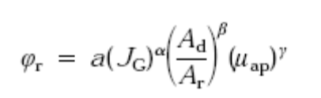
- where φ_{r} is the gas holdup in the riser, J_{G} is the superficial gas velocity (gas volumetric flow rate per unit of crosssectional area), μ_{ap} is the effective viscosity of the liquid, and α,β,γ, and a are constants that depend on the geometry of the reactor and the properties of the liquid.
- The correlation can be used to predict the holdup in a system that is being designed or simulated as a function of the operating variables, the geometry of the system, or the liquid properties. Such correlations are effective for fitting data for the same type of reactor (e.g., a split-vessel reactor) with different area ratios or even different liquid viscosities, but they are mostly reactor-type specific.
- The cyclic flow in the ALR complicates the analysis of the system. The riser gas holdup depends strongly on the geometric configuration of the gas–liquid separator and the water level in the gas separator.
2.3.2.4.2 Gas Hold up in external Airlift Reactors.
- The most important point is that the gas separator of the external-loop ALR is built in such way that gas disengagement is usually much more effective in this type of reactor. In concentric tubes or split vessels, the shortest path that a bubble has to cover from the riser to the downcomer is a straight line across the baffle that separates the two sections.
- In the case of external-loop ALRs, there is usually a minimum horizontal distance to be covered, which increases the chances of disengagement of the bubbles. In this case, it is worth pointing out that if gas does appear in the downcomer, then most of it will be fresh air entrained in the reactor because of interfacial turbulence or vortices that appear in the gas separator above the entrance to the downcomer.
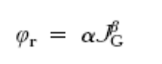
2.3.3 Liquid Velocity Measurement.
- Several different methods can be used for measuring the liquid velocity. The most reliable ones are based on the use of tracers in the liquid. If a tracer is injected and two probes are installed in a section of the tube, the velocity of the liquid traveling the distance between probes can be taken directly from the recorded peaks, as the quotient of the distance between the two electrodes and the time required by the tracer to travel from the one to the other.
- The latter is obtained as the difference of between the first moments of the two peaks. A second method is to calculate the liquid velocity (UL) from the circulation time (tc) and holdup (u) as:
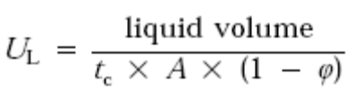
where A is cross-sectional area.
2.3.4 Liquid Mixing
- For the design, modeling, and operation of ALRs, a thorough knowledge of mixing behavior is necessary. This is of particular importance during the process of scale-up from laboratory-scale to industrial-scale reactors.
- The optimum growth rate of a microorganism or the optimum production rate of a specific secondary metabolite usually relates to well-defined environmental conditions, such as pH range, temperature, substrate level, limiting factors, dissolved oxygen, and inhibitor concentration in a specific wellmixed laboratory-scale vessel. Because of the compromises made during scale-up, it is difficult to keep, at different scales of operation, the same hydrodynamic conditions established in the laboratory; mixing on an industrial scale may not be as good as mixing on a laboratory scale (5).
- In smaller-scale reactors it is easier to maintain the optimal conditions of pH, temperature, and substrate concentration required for maximum productivity of metabolites in a fermenter. Furthermore, in fermentation systems efficient mixing is required to keep the pH within the limited range, giving maximum growth rates or maximum production of the microorganism during addition of acid or alkali for pH control.
- Mixing time—or the degree of homogeneity—is also very important in fed-batch fermentation, where a required component, supplied either continuously or intermittently, inhibits the microorganisms or must be kept within a particular concentration range .A large number of commercially important biological systems are operated in batch or fed-batch mode. In this operation mode, fast distribution of the incoming fluid is required, and the necessity for understanding the dynamics of mixing behavior in these vessels is obvious.
- Even for batch systems, good control of the operating conditions, such as pH, temperature, and dissolved oxygen, require prior estimation of mixing so that the addition rates can be suitably adjusted. Deviation of the pH or temperature from the permitted range may cause a damage to the microorganism, in addition to its effect on the growth and production rates.
- Moreover, a knowledge of the mixing characteristics is required for modeling and interpreting mass and heat transfer data. A parameter used frequently to represent mixing in reactors is the mixing time (tm). It has the disadvantage that it is specific to the reactor design and scale, but it is easy to measure and understand. Mixing time is defined as the time required to achieve the desired degree of homogeneity (usually 90–95%) after the injection of an inert tracer pulse into the reactor. The so-called degree of homogeneity (I), is given by:
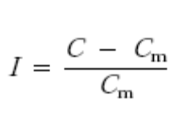
- where C is the maximum local concentration and C_{m} is the mean concentration of tracer at complete mixing.
- A more comprehensive way of analyzing mixing, applicable to continuous systems, is a study of the residence time distribution (RTD). Although ALRs are usually operated in a batch-wise manner, at least in the laboratory, advantage is taken of the fact that the liquid circulates on a definite path to characterize the mixing in the reactor.
- Hence, a single-pass RTD through the whole reactor or through a specific section is usually measured. Based on the observed RTD, several models have been proposed. These models have the advantage of reducing the information of the RTD to a small number of parameters, which can later be used in design and scale-up.
- The axial dispersion model, which has the advantage of having a single parameter, is widely accepted for the representation of tower reactors. This model is based on visualization of the mixing process in the tower reactor as a random, diffusion-like eddy movement superimposed on a plug flow. The axial dispersion coefficient Dz is the only parameter in the formulation:
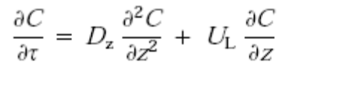
- where C is the concentration of a tracer. The boundary conditions depend on the specific type of tower reactor. This model is attractive, since it has a single parameter, the Bodenstein number (Bo), which is used to describe the mixing in the reactor:
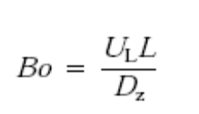
- where L is the characteristic length. When the Bo number tends to infinity, the mixing conditions are similar to those of a plug-flow reactor, and the reactor can be considered as well-mixed for low Bo numbers.
2.3.5 Advantages
i) Draft tubes in airlift bioreactor provide better mass transfer and heat transfer rates.
ii) Small bubble size leads to an increased surface area for oxygen transfer.
2.3.6 Applications
i) Air lift reactor have been applied in the production of single cell protein from methanol and gas oil.
ii) They are also used for plant and animal cell culture
iii) They are also used in waste water treatment.
2.4 Bubble column reactor
- Alternatives to the stirred reactor include vessels with no mechanical agitation. In bubble-column reactors, aeration and mixing are achieved by gas sparging; this requires less energy than mechanical stirring. Bubble columns are applied industrially for production of bakers' yeast, beer and vinegar, and for treatment of wastewater.
- Bubble columns are structurally very simple. As shown in Figure 2.4.1 , they are generally cylindrical vessels with height greater than twice the diameter. Other than a sparger for entry of compressed air, bubble columns typically have no internal structures.
- A height-to-diameter ratio of about 3:1 is common in bakers' yeast production; for other applications, towers with height-to-diameter ratios of 6:1 have been used. Perforated horizontal plates are sometimes installed in tall bubble columns to break up and redistribute coalesced bubbles.
- Advantages of bubble columns include low capital cost, lack of moving parts, and satisfactory heat- and mass-transfer performance. As in stirred vessels, foaming can be a problem requiring mechanical dispersal or addition of antifoam to the medium. Bubble-column hydrodynamics and mass-transfer characteristics depend entirely on the behaviour of the bubbles released from the sparger.
- Different flow regimes occur depending on the gas flow rate, sparger design, column diameter and medium properties such as viscosity. Homogeneous flow occurs only at low gas flow rates and when bubbles leaving the sparger are evenly distributed across the column cross-section.
- In homogeneous flow, all bubbles rise with the same upward velocity and there is no backmixing of the gas phase. Liquid mixing in this flow regime is also limited, arising solely from entrainment in the wakes of the bubbles.
- Under normal operating conditions at higher gas velocities, large chaotic circulatory flow cells develop and heterogeneous flow occurs as illustrated in Figure 2.4.2. In this regime, bubbles and liquid tend to rise up the centre of the column while a corresponding downflow of liquid occurs near the walls.
- Liquid circulation entrains bubbles so that some backmixing of gas occurs. Liquid mixing time in bubble columns depends on the flow regime. For heterogeneous flow, the following equation has been proposed for the upward liquid velocity at the centre of the column for 0.1 < D< 7.5 m and 0 < u G < 0.4 ms-l
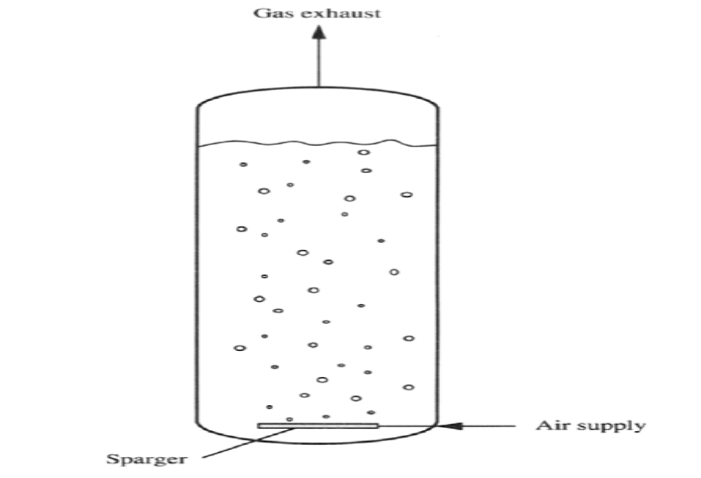

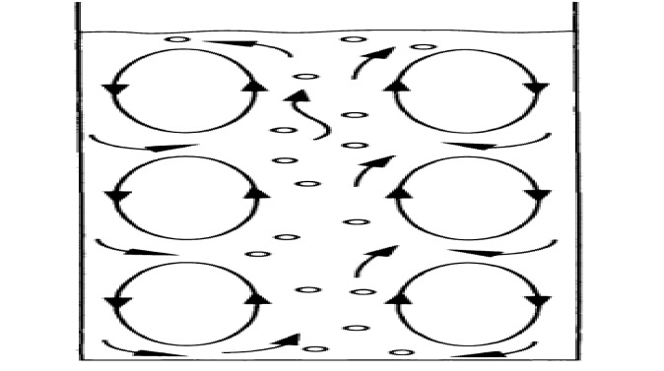

Fig 2.4.2 Heterogeneous flow in bubble column reactor

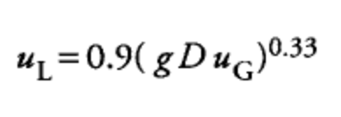
- where u_{L} is linear liquid velocity, g is gravitational acceleration, D is column diameter, and u_{G} is gas superficial velocity, u_{G} is equal to the volumetric gas flow rate at atmospheric pressure divided by the reactor cross-sectional area. From this equation, an expression for the mixing time t_{m} can be obtained
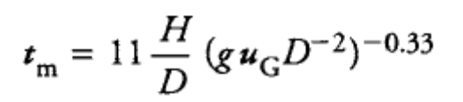
- Values for gas-liquid masstransfer coefficients in reactors depend largely on bubble diameter and gas hold-up. In bubble columns containing nonviscous liquids, these variables depend solely on the gas flow rate.
- However, as exact bubble sizes and liquid circulation patterns are impossible to predict in bubble columns, accurate estimation of the mass-transfer coefficient is difficult. The following correlation has been proposed for non-viscous media in heterogeneous flow
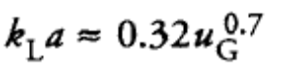
- where k_{L}a is the combined volumetric mass-transfer coefficient and u G is the gas superficial velocity. Above equation is valid for bubbles with mean diameter about 6 mm, 0.08 m < D < 11.6 m, 0.3 m < H< 21 m, and 0 < u G < 0.3 m s -1.
- If smaller bubbles are produced at the sparger and the medium is noncoalescing, kLa will be larger than the value calculated using especially at low values of u G less than about 10 -2 m s ⁻¹
2.4.1 Advantages
i) Low capital cost.
ii) Lack of moving parts.
iii) Satisfactory heat and mass transfer performance.
2.4.2 Application
i) It is used for baker’s yeast , beer and vinegar production.
ii) It is used for waste water treatment.

UNIT-3
BIOREACTOR SCALE UP

3.1 Regime analysis of Bioreactor:
3.1.1 Classification of Fluids
- A fluid is a substance which undergoes continuous deformation when subjected to a shearing force. A simple shearing force is one which causes thin parallel plates to slide over each other, as in a pack of cards. Shear can also occur in other geometries; the effect of shear force in planar and rotational systems is illustrated in Figure. Shear forces in these examples cause deformation, which is a change in the relative positions of parts of a body.
- A shear force must be applied to produce fluid flow. According to the above definition, fluids can be either gases or liquids. Two physical properties, viscosity and density, are used to classify fluids. If the density of a fluid changes with pressure, the fluid is compressible. Gases are generally classed as compressible fluids.
- The density of liquids is practically independent of pressure; liquids are incompressible fluids. Sometimes the distinction between compressible and incompressible fluid is not well defined; for example, a gas may be treated as incompressible if variations of pressure and temperature are small. Fluids are also classified on the basis of viscosity.
- Viscosity is the property of fluids responsible for internal friction during flow. An ideal or perfect fluid is a hypothetical liquid or gas which is incompressible and has zero viscosity. The term inviscid applies to fluids with zero viscosity.
- All real fluids have finite viscosity and are therefore called viscidor viscous fluids. Fluids can be classified further as Newtonian or non- Newtonian.

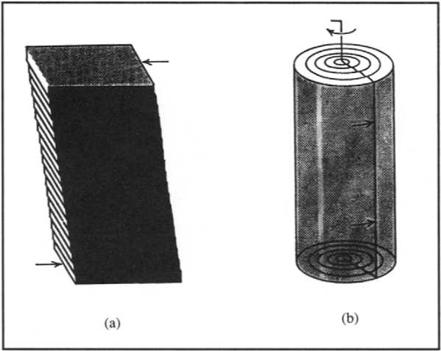

3.1.2 Fluids in Motion
Bioprocesses involve fluids in motion in vessels and pipes. General characteristics of fluid flow are described in the following sections.
3.1.2.1 Streamlines
- When a fluid flows through a pipe or over a solid object, the velocity of the fluid varies depending on position. One way of representing variation in velocity is streamlines, which follow the flow path. Constant velocity is shown by equidistant spacing of parallel streamlines as shown in Figure.
- The velocity profile for slow-moving fluid flowing over a submerged object is shown in Figure ; reduced spacing between the streamlines indicates that the velocity at the top and bottom of the object is greater than at the front and back.
- Streamlines show only the net effect of fluid motion; although streamlines suggest smooth continuous flow, fluid molecules may actually be moving in an erratic fashion. The slower the flow the more closely the streamlines represent actual motion.
- Slow fluid flow is therefore called streamline or laminar flow. In fast motion, fluid particles frequently cross and recross the streamlines. This motion is called turbulent flow and is characterised by formation of eddies.
3.1.2.2 Reynolds Number:
- Transition from laminar to turbulent flow depends not only on the velocity of the fluid, but also on its viscosity and density and the geometry of the flow conduit. A parameter used to characterise fluid flow is the Reynolds number. For full flow in pipes with circular cross-section,
- Reynolds number Re is defined as:
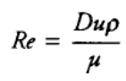
- where D is pipe diameter, u is average linear velocity of the fluid, p is fluid density, and )u is fluid viscosity. For stirred vessels there is another definition of Reynolds number:
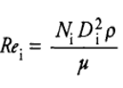
- where Re i is the impeller Reynolds number, N i is stirrer speed, D i is impeller diameter, p is fluid density and/r is fluid viscosity.
- The Reynolds number is a dimensionless variable. Reynolds number is named after Osborne Reynolds, who published in 1883 a classical series of papers on the nature of flow in pipes. One of the most significant outcomes of Reynolds' experiments is that there is a critical Reynolds numberwhich marks the upper boundary for laminar flow in pipes.
- In smooth pipes, laminar flow is encountered at Reynolds numbers less than 2100. Under normal conditions, flow is turbulent at Re above about 4000. Between 2100 and 4000 is the transition region where flow may be either laminar or turbulent depending on conditions at the entrance of the pipe and other variables.
- Flow in stirred tanks may also be laminar or turbulent as a function of the impeller Reynolds number. The value of Re i marking the transition between these flow regimes depends on the geometry of the impeller and tank; for several commonly-used mixing systems, laminar flow is found at Rei ~< 10.
3.1.2.3Viscosity:
- Viscosity is the most important property affecting flow behaviour of a fluid; viscosity is related to the fluid's resistance to motion. Viscosity has a marked effect on pumping, mixing, mass transfer, heat transfer and aeration of fluids; these in turn exert a major influence on bioprocess design and economics.
- Viscosity of fermentation fluids is affected by the presence of cells, substrates, products and air. Viscosity is an important aspect of rheology, the science of deformation and flow. Viscosity is determined by relating the velocity gradient in fluids to the shear force causing flow to occur.
- This relationship can be explained by considering the development of laminar flow between parallel plates, as shownin Figure..
- The plates are a relatively short distance apart and, initially, the fluid between them is stationary. The lower plate is then moved steadily to the right with shear force F, while the upper plate remains fixed. A thin film of fluid adheres to the surface of each plate.
- Therefore as the lower plate moves, fluid moves with it, while at the surface of the stationary plate the fluid velocity is zero. Due to viscous drag, fluid just above the moving plate is set
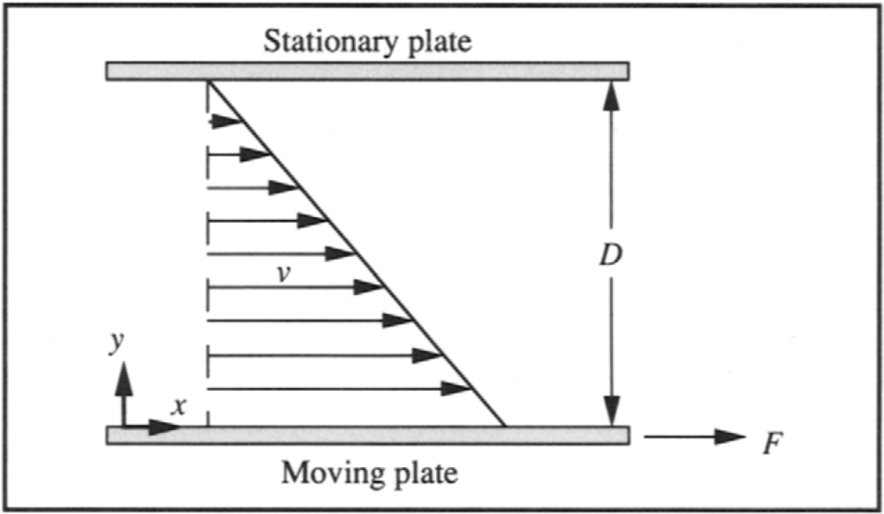

into motion, but with reduced speed.
Moving Plate
- Layers further above also move; however, as we get closer to the top plate, the fluid is affected by viscous drag from the stationary film attached to the upper plate surface.
- As a consequence, fluid velocity between the plates decreases from that of the moving plate at y= O, to zero at y= D. The velocity at different levels between the plates is indicated in Figure 7.5 by the arrows marked v.
- Laminar flow due to a moving surface as shown in Figure is called Couette flow.When steady Couette flow is attained in simple fluids, the velocity profile is as indicated in Figure ; the slope of the line connecting all the velocity arrows is constant and proportional to the shear force Fresponsible for motion of the plate.
- The slope of the line connecting the velocity arrows is the velocity gradient, dV/dy. When the magnitude of the velocity gradient is directly proportional to F, we can write:
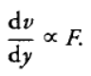 → 1
If we define "r as the shear stress, equal to the shear force per unit area of plate:
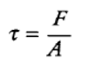 → 2
it follows from Eq. (1) that:
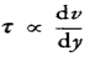 → 3
This proportionality is represented by the equation:

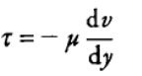 → 4
where/~ is the proportionality constant. Eq. (4) is called Newton's law of viscosity, and ju is the viscosity. The minus sign is necessary in Eq. (4) because the velocity gradient is always negative if the direction of F, and therefore r, is considered positive. -dV/dy is called the shear rate, and is usually denoted by the symbol.γ .

3.1.2.4 Non-Newtonian Fluids
- Most slurries, suspensions and dispersions are non- Newtonian, as are homogeneous solutions of long-chain polymers and other large molecules. Many fermentation processes involve materials which exhibit non-Newtonian behaviour, such as starches, extracellular polysaccharides, and culture broths containing cell suspensions or pellets.
- Examples ofnon-Newtonian fluids are listed in Table .1. Classification of non-Newtonian fluids depends on the relationship between the shear stress imposed on the fluid and the shear rate developed. Common types of non-Newtonian fluid include pseudoplastic, dilatant, Bingham plastic and Casson plastic; flow curves for these materials are shown in Figure 7.7.
- In each case, the ratio between shear stress and shear rate is not constant; nevertheless, this ratio for non- Newtonian fluids is often called the apparent viscosity, t~a.Apparent viscosity is not a physical property of the fluid in the same way as Newtonian viscosity; it is dependent on the shear force exerted on the fluid.
- It is therefore meaningless to specify the apparent viscosity of a non-Newtonian fluid without noting the shear stress or shear rate at which it was measured.
Two-Parameter Models
- Pseudoplastic and dilatant fluids obey the OstwaM-de Waele or power law:
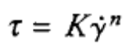
- where z" is shear stress, Kis the consistency index, 4/is shear rate, and n is the flow behaviour index. The parameters Kand n characterize the rheology of power-law fluids. The flow behaviour index n is dimensionless; the dimensions of K, L-IMT n-2, depend on n.
- As indicated in Figure , when n < 1 the fluid exhibits pseudoplastic behaviour; when n > 1 the fluid is dilatant. n = 1 corresponds to Newtonian behaviour. For power-law fluids, apparent viscosity ju a is expressed as:
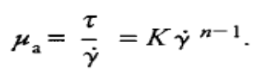
- For pseudoplastic fluids n < 1 and the apparent viscosity decreases with increasing shear rate; these fluids are said to exhibit shear thinning. On the other hand, apparent viscosity increases with shear rate for dilatant or shear thickeningfluids.Also included in Figure 7.7 are flow curves for plastic flow.
- Some fluids do not produce motion until some finite yield stress has been applied. For Binghamplastic fluids:
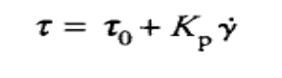
- where T O is the yield stress. Once the yield stress is exceeded and flow initiated, Bingham plastics behave like Newtonian fluids; a constant ratio Kp exists between change in shear stress
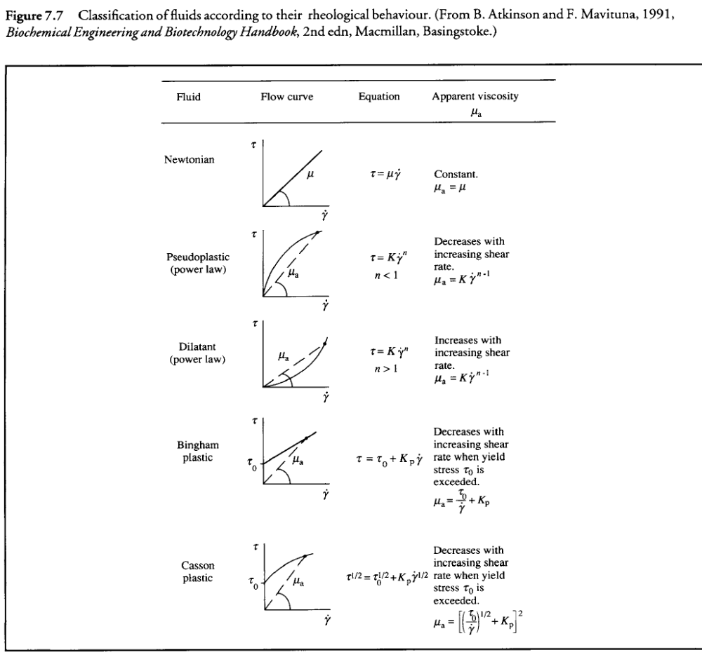

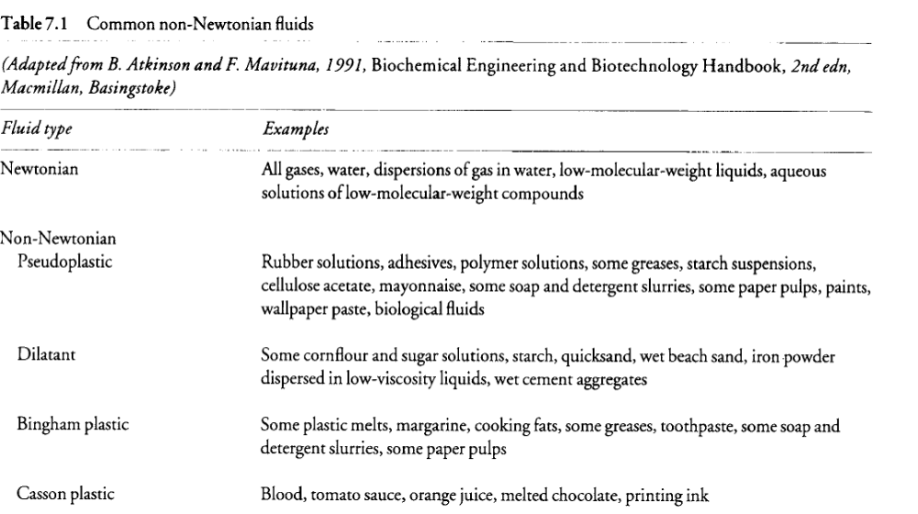

Three flow regimes can be identified
(i) Laminar regime. The laminar regime corresponds to Re i < 10 for many impellers; for stirrers with very small wall-clearance such as the anchor and helical-ribbon mixer, laminar flow persists until Re i - 1 O0 or greater. In
the laminar regime:
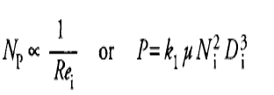
where k 1 is a proportionality constant. Power required for laminar flow is independent of the density of the fluid but directly proportional to fluid viscosity.

(ii) Turbulent regime. Power number is independent of Reynolds number in turbulent flow. Therefore:
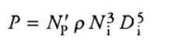
where NI~ is the constant value of the power number in the turbulent regime.
(iii) Transition regime. Between laminar and turbulent flow lies the transition regime. Both density and viscosity affect power requirements in this regime. There is usually a gradual transition from laminar to fully-developed turbulent flow in stirred tanks; the flow pattern and Reynolds-number range for transition depend on system geometry.
3.2 Gas-Liquid Mass Transfer
Gas-liquid mass transfer is of paramount importance in bioprocessing because of the requirement for oxygen in aerobic fermentations. Transfer of a solute such as oxygen from gas to liquid is analysed in a similar way to liquid-liquid and liquid-solid mass transfer. Below Figure shows the situation at an interface between gas and liquid phases containing component A. Let us assume that A is transferred from the gas phase into the liquid. The concentration of A in the liquid is CAt, in the bulk and CAL i at the interface. In the gas, the concentration is C_{AG} in the bulk and C_{AG i} at the interface. the rate of mass transfer of A through the gas boundary layer is:
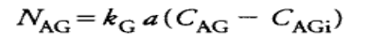→ 1
and the rate of mass transfer of A through the liquid boundary layer is:
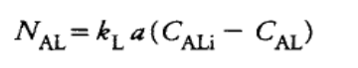→ 2
where k G is the gas-phase mass-transfer coefficient and k L is the liquid-phase mass-transfer coefficient. assume that equilibrium exists at the interface, C_{AG I} and C_{ALi} can be related. For dilute concentrations of most gases and for a wide range of concentration for some gases, equilibrium concentration in the gas phase is a linear functionof liquid concentration. Therefore, we can write:
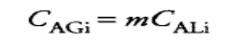 → 3
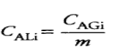→ 4
where m is the distribution factor. These equilibrium relationships can be incorporated into Eqs (1)and (2) at steady state using procedures which parallel those already used for liquid-liquid mass transfer. The results are also similar:
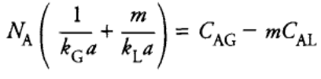→ 5
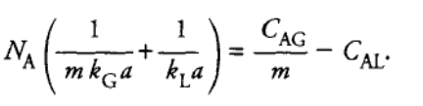→ 6

The combined mass-transfer coefficients in Eqs (5) and (6) can be used to define overall mass-transfer coefficients.
The overall gas-phase mass-transfer coefficient K G is defined by the equation:
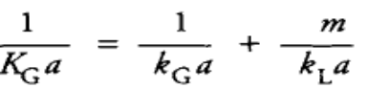→ 7
and the overall liquid-phase mass-transfer coefficient K_{L} is defined as
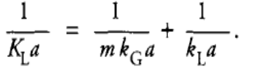→ 8
Or
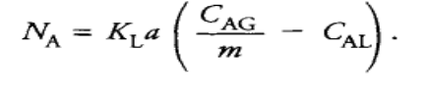→9
Eqs (8) and (9) are usually expressed using equilibrium concentrations, mCaL is equal to C~t G , the gas-phase concentration of A in equilibrium with CAt ., and (cA6/,) is equal to C~L, the liquid-phase concentration of A in quilibrium with CaG. Eqs (8) and (9) become:
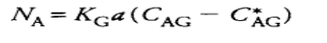→ 10
and
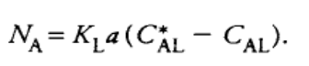→ 11
When solute A is very soluble in the liquid, for example in transfer of ammonia to water, the liquid-side resistance is small compared with that posed by the gas interfacial film. Therefore eqn 10
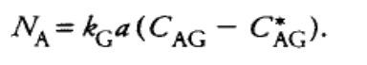→ 12
Conversely, if A is poorly soluble in the liquid, e.g. oxygen in aqueous solution, the liquid-phase mass-transfer resistance dominates and k G a is much larger than k L a. From Eq. ( 8), this means that K La is approximately equal to kLa, and Eq.(11) can be simplified to:
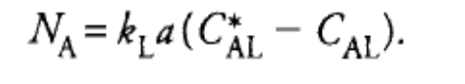→ 13
3.2.1 Oxygen Transfer Rate: (OTR)
OTR =

3.2.2 Oxygen Uptake Rate: (OUR)
The rate at which oxygen is consumed by cells in fermenters determined the rate at which it must be transferred from gas to liquid.
OUR= Q₀= q₀x - where q₀ is the specific oxygen uptake rate x is cell concentration.
3.3 Oxygen Transfer from Gas Bubble to Cell
In aerobic fermentation, oxygen molecules must overcome a series of transport resistances before being utilised by the cells. Eight mass-transfer steps involved in transport of oxygen from the interior of gas bubbles to the site of intracellular reaction are represented diagrammatically in Figure. They are:
(i). transfer from the interior of the bubble to the gas-liquid interface;
(ii) Movement across the gas-liquid interface;
(iii) Diffusion through the relatively stagnant liquid film surrounding the bubble;
(iv) Transport through the bulk liquid;
(v) Diffusion through the relatively stagnant liquid film surrounding the cells;
(vi) Movement across the liquid-cell interface;
(vii) if the cells are in a floc, clump or solid particle, diffusion through the solid to the individual cell; and
(viii) Transport through the cytoplasm to the site of reaction.
Note that resistance due to the gas boundary layer on the inside of the bubble has been neglected; because of the low solubility of oxygen: in aqueous solutions, we can assume that the liquid-film resistance dominates gas-liquid mass transfer (see
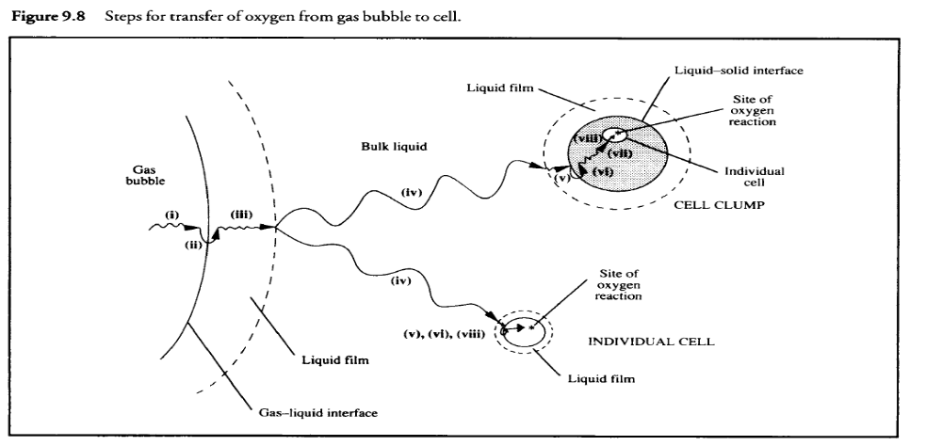

If the cells are individually suspended in liquidrather than in a clump, step (vii) disappears.
The relative magnitudes of the various mass-transfer resistancesdepend on the composition and rheological properties of the liquid, mixing intensity, bubble size, cell-clump size,interfacial adsorption characteristics and other factors. For most bioreactors the following analysis is valid.
i) Transfer through the bulk gas phase in the bubble is relatively fast.
ii) The gas-liquid interface itself contributes negligible resistance.
iii) The liquid film around the bubbles is a major resistance to oxygen transfer.
iv) In a well-mixed fermenter, concentration gradients in the bulk liquid are minimised and mass-transfer resistance in this region is small. However, rapid mixing can be difficult to achieve in viscous fermentation broths; if this is the case, oxygen-transfer resistance in the bulk liquid may be important.
Because single cells are much smaller than gas bubbles,
v) the liquid film surrounding each cell is much thinner than that around the bubbles and its effect on mass transfer can generally be neglected. On the other hand,if the cells form large clumps, liquid-film resistance can be significant.
(vi) Resistance at the cell-liquid interface is generally neglected.
(vii) When the cells are in clumps, intraparticle resistance is likely to be significant as oxygen has to diffuse through the solid pellet to reach the interior cells. The magnitude of this resistance depends on the size of the clumps.
(viii) Intracellular oxygen-transfer resistance is negligible because of the small distances involved.
When cells are dispersed in the liquid and the bulk fermentation broth is well mixed, the major resistance to oxygen transfer is the liquid fllm surrounding the gas bubbles. Transport through this film becomes the rate-limiting step in the complete process,and controls the overall mass-transfer rate. Consequently,the rate of oxygen transfer from the bubble all the way to the cell is dominated by the rate of step (iii). The mass-transfer rate for this step can be calculated using Eq. (13). At steady state there can be no accumulation of oxygen at any location in the fermenter; therefore, the rate of oxygen transfer from the bubbles must be equal to the rate of oxygen consumption by the cells. If we make N_{A} in Eq. (14) equal to Qo in Eq. (15) we obtain the following equation:
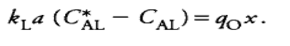→ 16
We can use Eq. (16) to deduce some important relationships for fermenters. First, let us estimate the maximum cell concentration that can be supported by the fermenter's oxygen-transfer system. For a given set of operating conditions, the maximum rate of oxygen transfer occurs when the concentration- difference driving force (C*_{AL} - C_{AL}) is highest, i.e.when the concentration of dissolved oxygen CAL is zero.
Therefore from Eq. (16), the maximum cell concentration that can be supported by the mass-transfer functions of the reactor is:
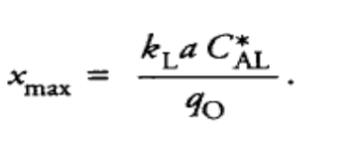→ 17
If Xmax estimated using Eq. (9.40) is lower than the cell concentration required in the fermentation process, kLa must be improved. It is generally undesirable for cell density to be limited by rate of mass transfer. Comparison of Xma x values evaluated using Eqs (8.52) and (9.40) can be used to gauge the relative effectiveness of heat and mass transfer in aerobic fermentation.
For example, if Xmax from Eq. (17) were small while Xma x calculated from heat-transfer considerations were large, we would know that mass-transfer operations are more likely to limit biomass growth. If both Xm~ x values are greater than that desired for the process, heat and mass transfer are adequate.
Another important parameter is the minimum kLarequired to maintain CaL > Ccrit in the fermenter. This can be determined from Eq. (16) as:
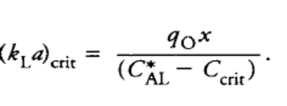→ 18
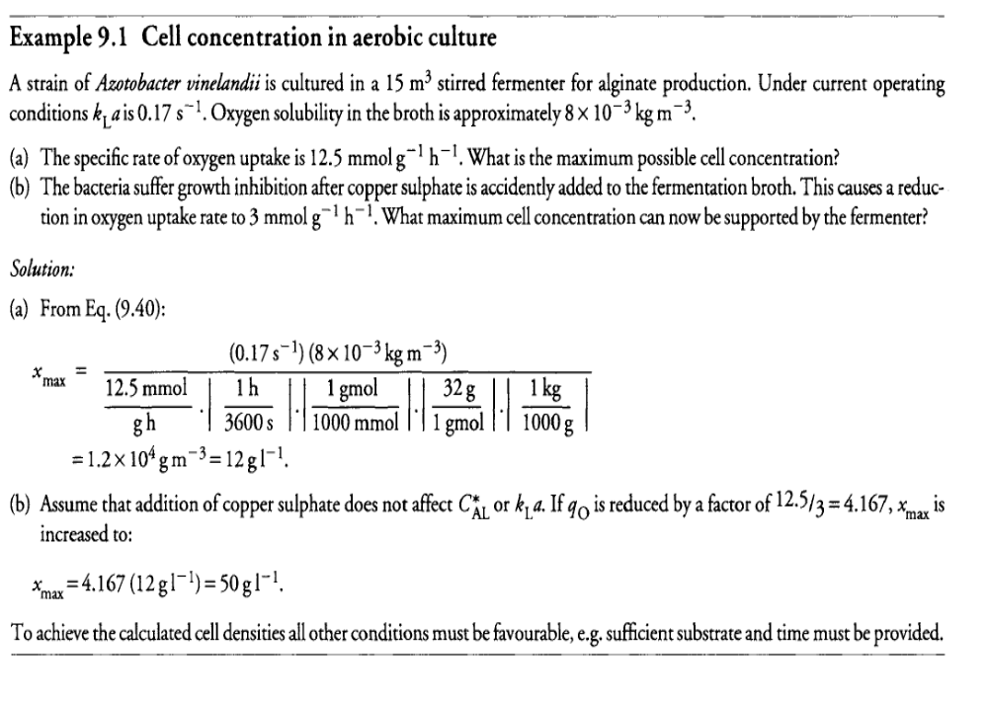

3.4 Microbial Oxygen Demand:
- Many factors influence oxygen demand, the most important of these are cell species, culture growth phase and nature of carbon source in the medium. In batch culture, rate of oxygen uptake varies with time. The reasons for this are two fold.
- First the concentration of cells increases during the course of batch culture and the total rate of oxygen uptake is proportional to the number of cells present. The inherent demand of an organism for oxygen (q₀) depends primarily on the biochemical nature of the cell and its nutritional environment.
- When the level of dissolved oxygen in the medium falls below a certain point, the specific rate of oxygen uptake is also dependent on the oxygen concentration in the liquid.
3.5 Methods for determination of mass transfer coefficients:
3.5.1 Oxygen –Balance method:
- This technique is based on the equation for gas-liquid mass transfer. In the experiment, the oxygen content of gas streams flowing to and from the fermenter are measured. From a mass balance at steady state, the difference in oxygen flow between inlet and outlet must be equal to the rate of oxygen transfer from gas to liquid

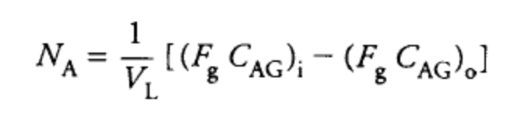
- 1
- where V _{L} is the volume of liquid in the fermenter, Fg is the volumetric gas flow rate, C_{AG} is the gas-phase concentration of oxygen, and subscripts i and o refer to inlet and outlet gas streams, respectively.
- The first term on the right-hand side of Eq. (1) represents the rate at which oxygen enters the fermenter in the inlet-gas stream; the second term is the rate at which oxygen leaves. The difference between them is the rate at which oxygen is transferred out of the gas into the liquid, N_{A}.
- Because gas concentrations are generally measured as partial pressures, the ideal gas law equation can be incorporated into Eq. (1) to obtain an alternative expression.
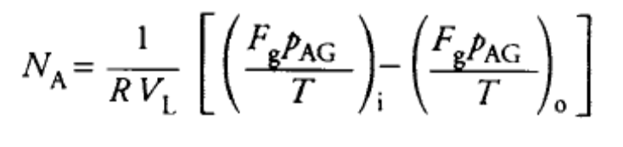
- 2
- where R is the universal gas constant P_{AG} is the oxygen partial pressure in the gas and T is absolute temperature. Because oxygen partial pressures in the inlet and exit gas streams are usually not very different during operation of fermenters, they must be measured very accurately, e.g.using mass spectrometry.
- The temperature and flow rate of the gases must also be measured carefully to ensure an accurate value of N_{A} is determined. Once N_{A} is known and C_{AL} and C*_{AL} found using the methods described in Sections 3.2.12 and 3.2.13, k_{L}a can be calculated from Eq. (3.2.14).The steady-state oxygen-balance method is the most reliable procedure for measuring kLa, and allows determination from a single-point measurement.
- An important advantage is that the method can be applied to fermenters during normal operation. It depends, however, on accurate measurement of gas composition, flow rate, pressure and temperature; large errors as high as + 100% can be introduced if measurement techniques are inadequate.
3.5.2 Dynamic Method
- This method for measuring kLa is based on an unsteady-state mass balance for oxygen. The main advantage of the dynamic method over the steady-state technique is the low cost of the equipment needed.
- There are several different versions of the dynamic method;only one will be described here. Initially, the fermenter containscells in batch culture. As shown in Figure 3.5.1 , at some time t_{o}the broth is de-oxygenated either by sparging nitrogen into the vessel or by stopping the air flow if the culture is oxygen-consuming.
- Dissolved-oxygen concentration CAL drops during this period. Air is then pumped into the broth at a constant flow-rate and the increase in CAL monitored as a function of time. It is important that the oxygen concentration remains above Ccrit so that the rate of oxygen uptake by the cells is independent of oxygen level.
- Assuming re-oxygenation of the broth is fast relative to cell growth, the dissolved-oxygen level will soon reach a steadystate value C'ALwhich reflects a balance between oxygen supply and oxygen consumption in the system. CAL 1 and CAL 2 are two oxygen concentrations measured during re-oxygenation at times t I and t 2, respectively.
- We can develop an equation for k_{L}a in terms of these experimental data. During the re-oxygenation step, the system is not at steady state. The rate of change in dissolved-oxygen concentration during this period is equal to the rate of oxygen transfer from gas to liquid, minus the rate of oxygen uptake by the cells:
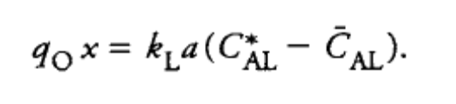
- 1
- where q_{o}x is the rate of oxygen consumption. We can determine an expression for q_{o}x by considering the final steady dissolved-oxygen concentration, C'AL. When C_{AL} = C'AL,- dC_{AL}/d t = 0 because there is no change in C_{AL} with time.Therefore, from Eq. (1)
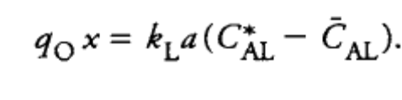
- 2
- Substituting this result into Eq. (1) and cancelling the k_{L}aC*_{AL} terms gives
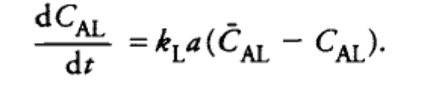
- 3
- Assuming kLa is constant with time, we can integrate Eq.(3) between t₁ and t₂ using the integration rules .The resulting equation for kLa is:
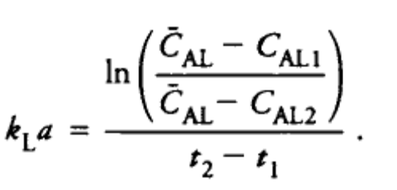
- 4
- kLa can be estimated using two points from Figure 3.5.2 or, more accurately, from several values of (CAL l, t 1) and(CAL 2, t2). When
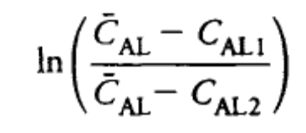
- 5
- is plotted against (t₂ - t_{l} ) as shown in Figure 3.5.2, the slope is kLa. Eq. (5) can be applied to actively respiring cultures, or to systems without oxygen uptake. In the latter case, 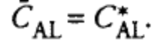

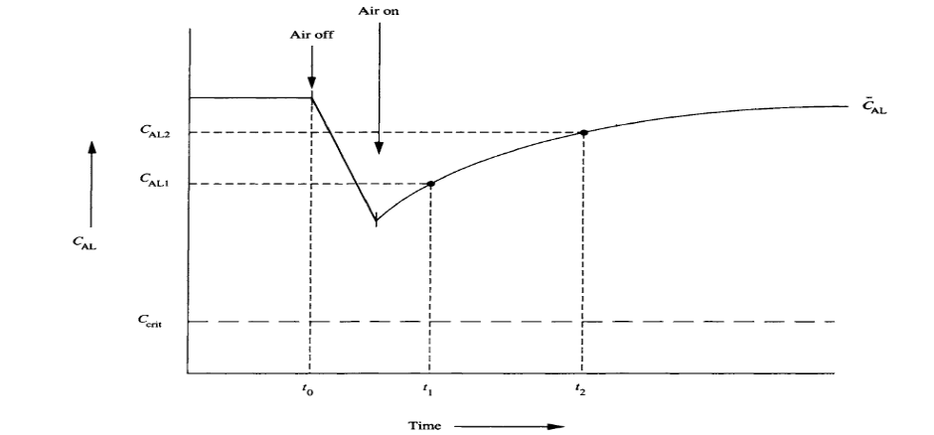
Fig 3.5.1Variation of oxygen tension for dynamic measurement of kLa.

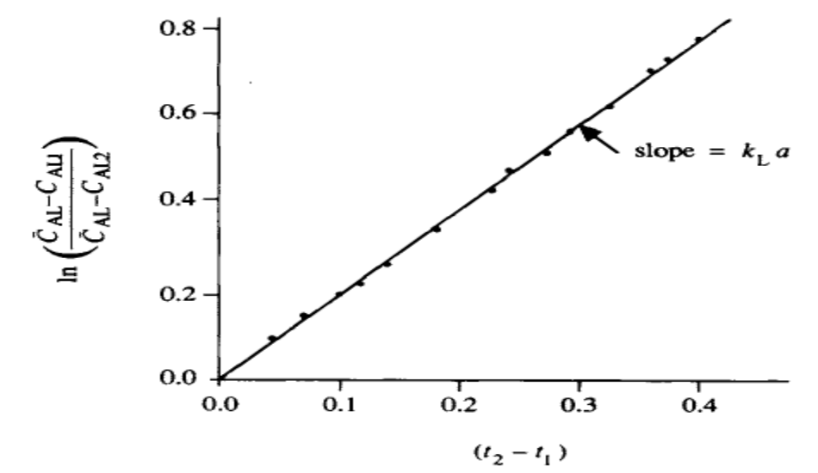
Fig 3.5.2 Evaluating kLa using the dynamic method.
3.5.3 Sulphite oxidation method

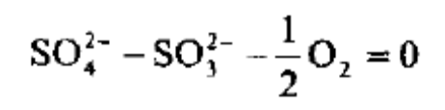
→1
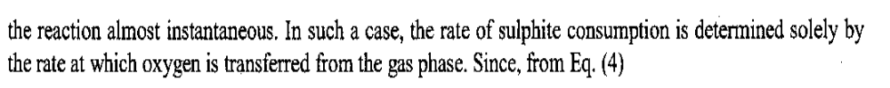
Eqn 1
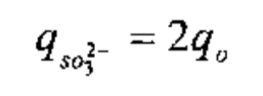
→2
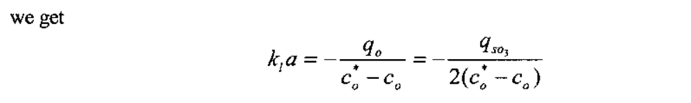
→3
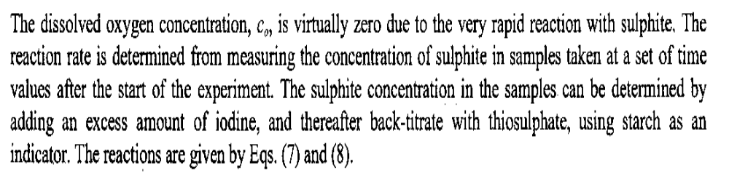

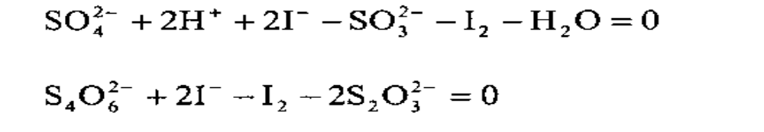
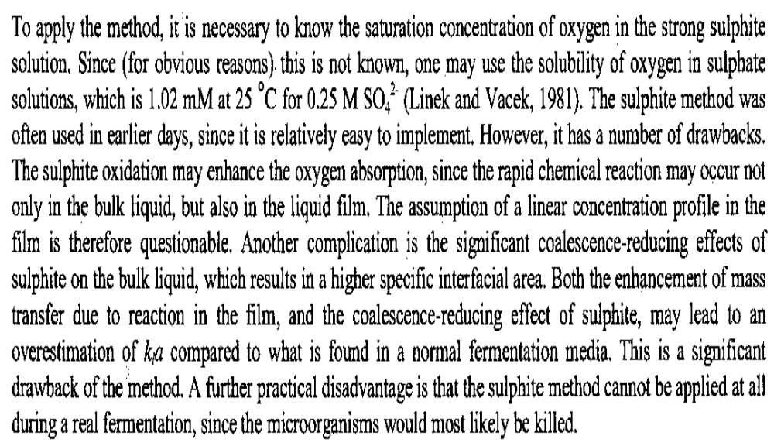
3.6 Mass transfer correlation
- Mass-transfer coefficient is a function of physical properties and vessel geometry. Because of the complexity of hydrodynamics in multiphase mixing, it is difficult, if not impossible, to derive a useful correlation based on a purely theoretical basis.
- It is common to obtain an empirical correlation for the mass-transfer coefficient by fitting experimental data. The correlations are usually expressed by dimensionless groups since they are dimensionally consistent and also useful for scale-up processes. Since kLa is the combination of two experimental parameters, mass-transfer coefficient and interfacial area, it is difficult to identify which parameter is responsible for the change of kLa when we change the operating condition of a fermenter.
- Calderbank and Moo-Young (1961) separated kLa by measuring interfacial area and correlated mass-transfer coefficients in gas-liquid dispersions in mixing vessels, and sieve and sintered plate column, as follows:
1. For small bubbles less than 2.5 mm in diameter,
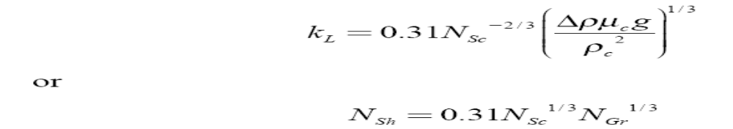
where NGr is known as Grashof number and defined as
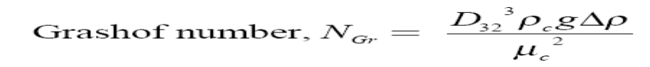
The more general forms which can be applied for both small rigid sphere bubble and suspended solid particle are
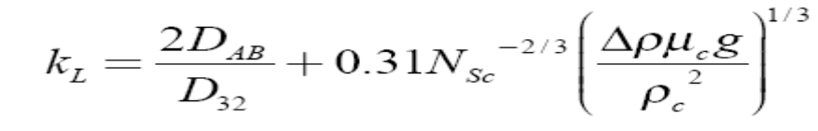
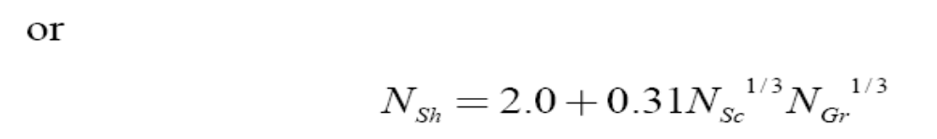
Eqs. (4) and (5) were confirmed by Calderbank and Jones (1961), for mass transfer to and from dispersions of low-density solid particles in agitated liquids which were designed to simulate mass transfer to microorganisms in fermenters.
2. For bubbles larger than 2.5 mm in diameter,
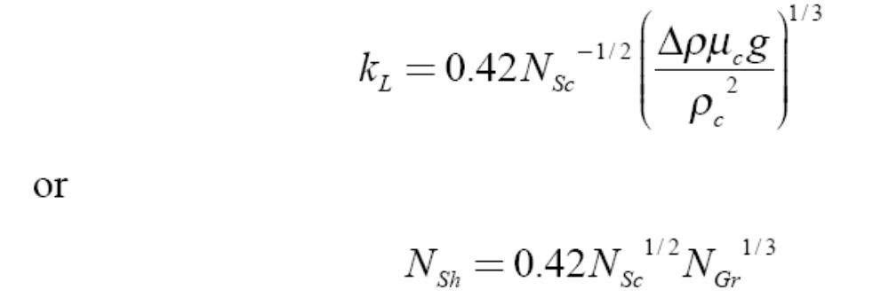
3.7 Scale up criteria for bioreactors based on oxygen transfer, power consumption and impeller tip speed.
3.7.1 Scale up criteria for bioreactors based on oxygen transfer
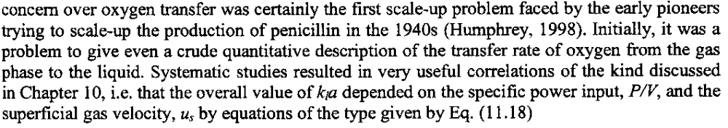

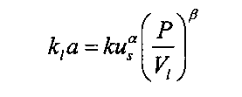

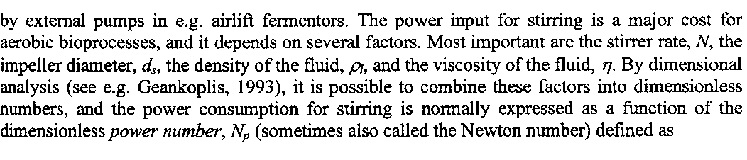
3.7.2 Scale up criteria for bioreactors based on power consumption and impeller tip speed.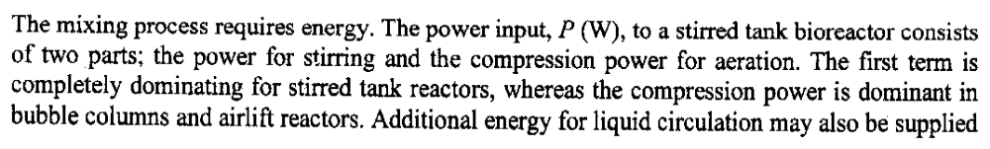
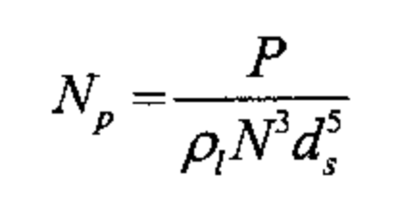
→1

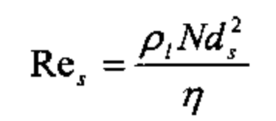
→2

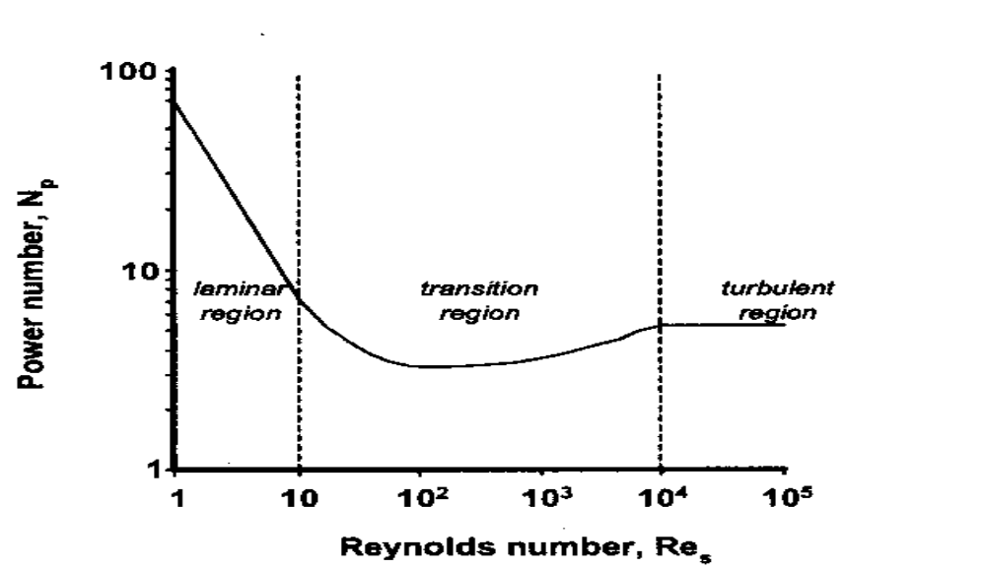
Fig 3.7.2 N_{P} Vs Re
For laminar flow
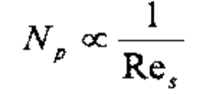
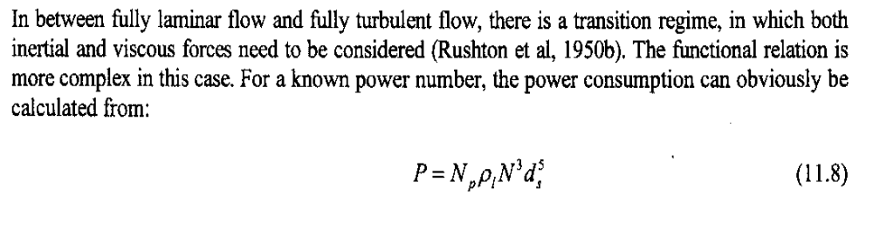

Most often, power consumption per unit volume Pmo/v is employed as a criterion for scale-up. In this case, to satisfy the equality of power numbers of a model and a prototype,
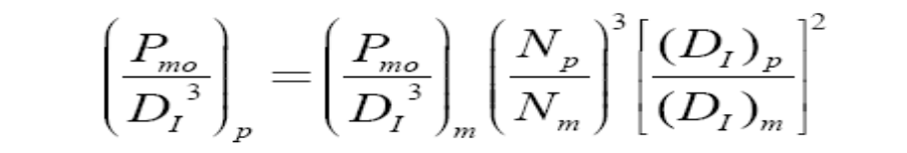
Note that Pmo/D_{I}3 represents the power per volume because the liquid volume is proportional to D_{I}3 for the geometrically similar vessels. For the constant Pmo/D_{I}3,
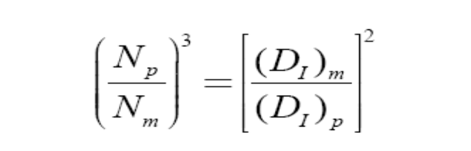
As a result, if we consider scale-up from a 20-gallon to a 2,500-gallon agitated vessel, the scale ratio is equal to 5, and the impeller speed of the prototype will be
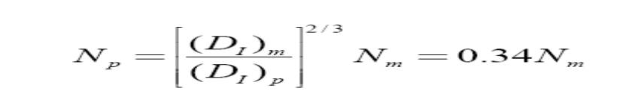
which shows that the impeller speed in a prototype vessel is about one third of that in a model. For constant Pmo/v, the Reynolds number and the impeller tipspeed cannot be the same. For the scale ratio of 5,

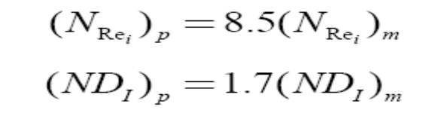

Unit-4
MODELLING AND SIMULATION OF BIOPROCESSES
4.1 Study of structured models for analysis of various bioprocesses
- Unstructured models do not recognize the complex set of metabolic reactions occurring within the cell. Unstructured models can predict intracellular concentrations only if there is a constant fraction of the particular metabolite in the cell, for example that the fraction RNA or DNA within a cell is constant.
- They thus have limited utility in guiding research aimed at understanding cellular regulation and dynamics. Models which incorporate the details of intracellular metabolism are referred to as structured models. Such models attempt to account for unbalanced growth of microorganism i.e., when the composition of the major cellular constituents, such as RNA, enzyme concentrations etc vary as a result of changing external conditions. Such conditions apply in batch growth, in fed batch growth and in transient situations in well –stirred tank reactors.
- The transient responses of cells to these changing external conditions can be modeled by analogy with classical reactor modeling using transfer function approach. By using an appropriate forcing function and determining the transient response of the cells, the behavior of various cellular constituents can be modeled as first order or higher order. This approach has some advantages in developing and analyzing strategies for process control, but does not provide much insight into the factors that regulate metabolism.
4.1.1 Compartmental models
The earliest attempts to include structure in models of cell growth and metabolism generally subdivided the cell mass into various components on the basis of the function of parts of the cell’s internal machinery.
4.1.1.1 The Model of Williams
The model of Williams divides the cell in two compartment, a synthetic one(k-compartment) that consider as consisting of RNA and pools of small metabolites, and a genetic one (g-compartment) consisting of DNA and protein. The third component is external substrate concentration. A simple model based on these compartments can be developed as follows. If K and G are the concentrations of the components in the k and g compartments, as mass per unit cell volume (V_{c})
Mass balance for a constant reactor volume (V_{R}) as follows

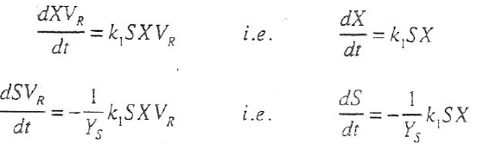
→1
→2

The rate of substrate uptake is assumed to be first order in substrate concentration S and in total cell concentration X ( both S and X being expressed as mass/reactor volume).Assuming that the structural- genetic compartment material is produced from the synthetic compartment at a rate that depends directly on the concentration of species in each compartment. The mass balances are based on the reactor volume, thus the concentration per cell must be multiplied by the total cell volume per unit reactor volume, X/ρ_{c} , where ρ_{c} cell density( cell mass per unit cell volume).
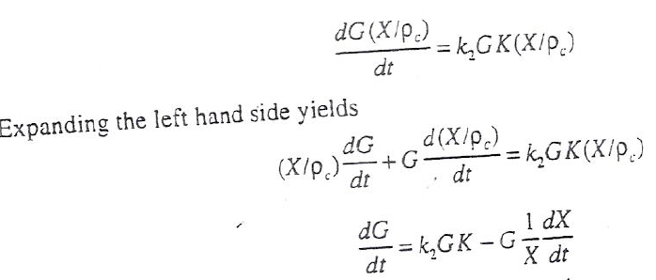
→3

Combining this result with eqn 1
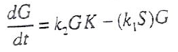

Assuming that the density of the cell, ρ_{c,} is constant. The synthetic portion of the biomass is produced at the rate that is first order in substrate concentration and depends on the cell density ρ_{c}( equal to the sum of K and G)

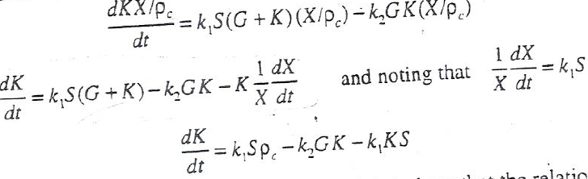
→4

Equations 3 and 4 can be added to get
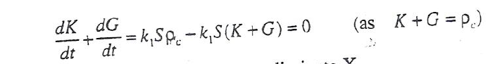

Equations 1 and 2
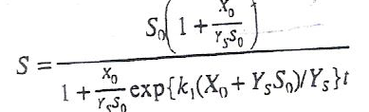
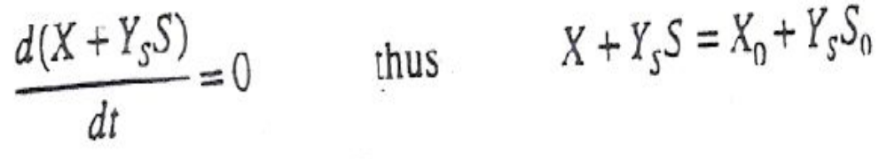
Equation 1 can be solved for S

The cell number depends only on the amount of genetic component present, then the cell number will be proportional to GX/ ρ_{c} cells/ reactor volume. The cell volume will change as a reflection of the changing amounts in the genetic and synthetic compartments, hence the cell size will be proportional to (K + G)/G i.e ρ_{c/}G. The behavior of the model is shown in fig 4.1.1.1

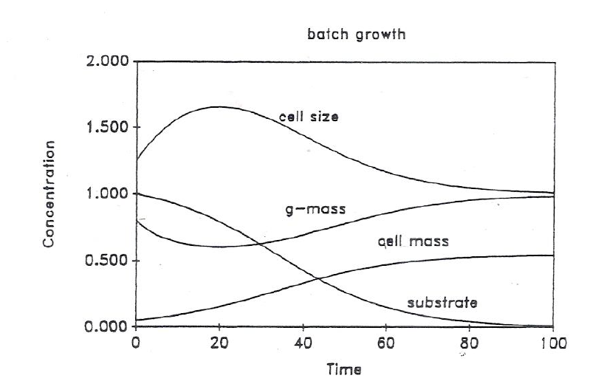
Fig 4.1.1.1 Simulation of the two compartment model of Willaims

The compartment model of Williams illustrates some important properties of cell growth. It predicts the existence of a initial lag phase and if the inoculums is not fully adapted, cell mass will increase, while the cell number will not change initially. The model can be refined by changing the linear dependence of the rate of substrate uptake and growth from first order to a Monod type in equation. The inclusion of maintenance in the formulation of the model would change this inconsistent result and improve the model.

4.1.1.2 The Model of Ramkrishna et.al
An analogous compartment model to that of Williams has been developed by Ramkrishna et.al. The cell is divided into two compartments. G-Mass, comprising RNA and DNA and D-Mass, which mostly consists of proteins. An inhibitor (T) is produced during growth which converts both G and D mass to inactive forms of biomass. The reactions assumed are the following
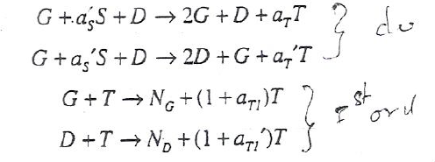

In the first reaction, D-mass catalyses the formation of G-mass, consuming a_{s} units of substrate and producing a_{T} units of an unidentified inhibitor. In the second reaction G mass catalyzes the formation of D-mass are deactivated by inhibitor .The rate expressions assumed in the model for production of G and D mass are of the double substrate form of equation, while those for the deactivation reactions are assumed to be first order in each reactant. This model can predict oscillatory behavior about a steady state.
4.1.2 Models of cellular energetic and Metabolism
- Metabolic pathways can be distinguished as catabolic and anabolic. In catabolism, energy containing molecules, such as carbohydrates, hydrocarbons and other reduced carbon containing compounds are degraded to CO₂ or other oxidized end products and the energy is stored in ATP,GTP and other energy-rich compounds.
- In anabolism, intermediates and end products formed from catabolism are incorporated into cell constituents and their intermediate precursors.
- Anabolic reactions generally require energy which is supplied via ATP is rapidly turned over. This implies that energy producing and energy consuming processes must be tightly regulated within the cell. It is thus necessary to consider both carbon and energy flows within the cell in developing these more complex models. An example of such a model is given in the following section.
- A model for Aerobic growth of the yeast Saccharomyces cerevisiae
- Hall and co workers have formulated a model of the rather complex metabolism exhibited by S.cerevisiae when grown on glucose. This yeast can use either the respiratory pathway, in which glucose is converted to CO₂ and cell mass, or the fermentative pathway, resulting in the formation of ethanol, CO₂ and cell mass. At low growth rates, metabolism is fully oxidative i.e the respiratory quotient ( RQ) , defined as the ratio of the rates of CO₂ production to O₂ consumption is unity and Yx/s is 0.50 gm cells/ gm glucose.
- This situation is maintained up to a critical growth rate, beyond which the metabolism becomes increasingly fermentative. In the fermentative pathway, the yield coefficient decreases and there is an increase in the specific carbon dioxide production rate and ethanol production. This critical growth rate is slightly higher than the value of µ_{max} on ethanol.
- There is a change in the enzyme pattern that reflects this switch from respiration to fermentation: typical respiratory enzymes, such as isocitrate lyase, malate dehydrogenous and the cytochromes are repressed at high growth rates, and glycolysis provides the main source of energy. At low growth rates, reduced levels of glycolytic enzymes are found.
- As the growth rate increases, the percentage of budding yeast cells increase almost linearly. Using this linear relationship and the mean generation time (ln2/µ), the length of the budding period can be calculated.
- There is little variation in the duration of the budding period at different growth rates. At low growth rates, the generation time increases due to lengthening of the gap- phase following cell division. Thus referring to the cell cycle, the time periods for DNA replication(S), mitosis(G₂) and the cell division (M) phases are all constant.
- The duration of the G₁ phase appears to be variable. During the single cell G₁ phase, substrate is accumulated and there is a buildup of reserve carbohydrates within the cell that are then depleted energy and carbon during the period of budding.
- The model is based on this two stage breakdown of the cell cycle. The length of the G₁ phase depends on the availability of the limiting substrate, the length of the division phase is assumed to be independent of substrate. The cell mass is considered to be comprised of two parts: A mass, which carries out substrate uptake energy and energy production and B Mass, which carries out reproduction and division. B mass is converted to A mass at a constant rate, whereas A mass consumes substrate and produces B mass at a variable rate.
- The repression of respiratory enzymes by glucose was initially thought to result from glucose acting as a catabolic repressor. More recent evidence suggest that a high catabolic flux is the direct cause of respiratory inhibition and that glucose concentration plays a secondary role. Thus the model proposes that both glycolsis and respiration are carried out by A mass and both provide energy for growth. The following reactions were proposed to describe respiration and glcolysis
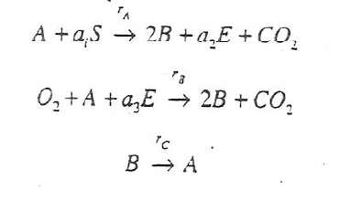

(A + B) is the total cell mass (X) and E is the ethanol concentration.
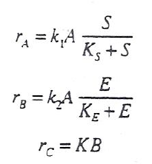
The following rate expressions are assumed:

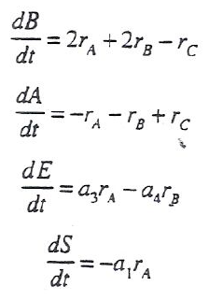
The budding process (B →A) is assumed to occur at a constant rate whereas respiration and fermentation follow Monod type kinetics. Mass balances can now be written for each of the species( assuming constant cell volume)

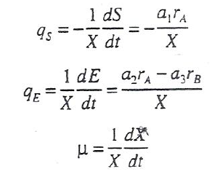
Estimates of the yield coefficients can now be made to evaluate the contants a₁ and a₃. The specific uptake and production rates can be calculated.

4.1.3 Single Cell Models
- By considering reactions occurring in a single cell as being representative of the behavior of the whole microbial population, more sophisticated models of cell behavior can be developed. Such models are certainly less complex than models which consider both the chemical structure of the cell and variations from cell to cell (i.e, segregation).
- Single cell models have the advantages that they can incorporate cell geometry (surface to volume ratios) and its influence on metabolite transport; they can predict temporal events during the cell cycle (e.g, changes in the size); they can incorporate details of the spatial arrangements within the cell (e.g, mitochondrial concentrations may be distinct from those in the cytosol); and they can include details of the metabolic pathways.
- The price for this increasing sophistication is that determination of rate expressions for the large number of reactions is difficult and estimates must be made for many of the constants involved. An example of this approach is provided by the model of E.coli growth and cell division formulated by shuler and coworkers.
- In this approach, the cell is treated as an expanding reactor,i.e., mass balance are written which include the effect of the changing cell volume resulting in a dilution of intracellular concentration. A representation of the model by shuler and co-workers is shown in the figure.
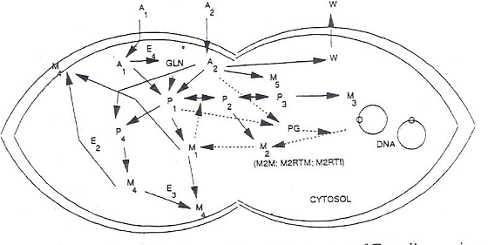
- Figure: A representation of the key metabolic reactions of E.coli growing on glucose and ammonium salts, on which the model of shuler and coworkers is based. In the figure above, the cell has completed a round of DNA replication and initiated cross-wall formation. The solid lines indicate reaction pathways, while the dashed lines represent regulatory steps.

The metabolic components indicated above are:
A₁= ammonium ion
A₂= glucose
W= waste products (e,g. CO₂, acetate and water)
P₁= amino acids
P₂= ribonucleotides
P₃= deoxyribonucleotides
P₄= cell envelope precursors
M₁= protein (cytosolic and envelope)
M_{2.RTI}= immature, stable RNA
M₂._{RTM}= mature, stable RNA(t-RNA &r-RNA)
M₂._{M}= messenger RNA
M₃= DNA
M₄= non-protein part of cell envelope
M₅= glucogen
PD= ppGpp
E₁= enzymes in conversion of P₂ to P₃
E₂, E₃= enzymes involved in directing cross wall formation and cell envelope synthesis
GLN= glutamine
E₄= glutamine synthetase
- Equations can be developed for each of the species listed above in terms of total mass of each metabolite (rather than in terms of concentration). In the figure above, the dashed lines indicate the structure of the metabolic regulatory processes.
- In addition, stoichiometric relations are required for the lumped energy, mass and reductant consumption processes in the cell. In the case of anaerobic growth, electron balances must be added so that the amount of ATP and reducing power generated meet the demands of energy consumption. As an example of the model formulation, consider the mass balance for DNA synthesis:
- Where M₃ is the mass of DNA, P3 is the mass of deoxynucleotides, etc. The constitutive rate expression is ad hoc; DNA formation is assumed to depend to the intracellular concentration of nucleotide precursors and on the intracellular glucose concentration, which we might consider to reflect the availability of energy to the cell. The rate expression are formulated in concentrations expressed as mass per cell volume, noting that the cell volume (V(t)) changes with time.
- F is the number of replication forks; µ₃ is a rate constant for the maximum rate of DNA formation per fork, in units of DNA mass per fork per time; the K’s are saturation constants. µ₃ can be determined from data on the size of the E.coli chromosome, the number of replication forks and the time required for a fork to traverse the chromosome under conditions of maximum growth.
- To determine the number of replication forks, F , a separate set of equations describing the control of chromosome replication must be solved. Clearly an enormous amount of metabolic information is required in formulating single cell models. However, these models can provide information on the transient response of cells to environmental changes and are capable of predicting measureable quantities, such as cell size and nucleic acid content.
- These can be used to test the assumptions inherent in the rate expressions. Models such as these involve a very large number of equations and parameters; thus they are not described in detail here. It may be interesting however to examine the wide range of predictive responses such models can generate.
4.1.4 Plasmid Expression and Replication
- Two of the difficulties associated with the use of recombinant organisms for production of plasmid-encoded proteins are their more complex growth patterns and the stability of the plasmid within the host cell, particularly for high copy number plasmids. In this section, we shall examine models describing the replication of plasmids within the cell and more complex models describing the expression of the encoded plasmid product.
- The number of plasmids within a cell may vary depending on the nature of the plasmid and the growth rate of the host. The amount of plasmid DNA in the cell is an important determinant of the host plasmid system. When plasmid expression occurs, an additional metabolic burden is imposed on the cell and a deterioration in cellular growth occurs.
- When there is a large amount of plasmid DNA present, this metabolic burden may become quite high. Plasmids may be lost from the host by several mechanisms. These are a result of segregational effects, where plasmids may partition unevenly between mother and daughter cells at the point of cell division, and structural effects, where loss occurs due to a reduction in the rate of growth of plasmid containing cells. Partitioning of plasmids at cell division from the mother cell to the daughter cell is generally regulated in low and intermediate copy number plasmids(e,g,.RP1 plasmids) by genetic information contained on the plasmid at the par locus (from partition).
- These plasmids are thus desirable for their stability characteristics. High copy number plasmids (typically used for their high levels of expression of encoded protein) do not contain a par locus. Segregational instability in the absence of this type of genetic regulation can be related to the number of plasmids in the cell.
- The probability (Ѳ) that a plasmid-free daughter cell may arise from a plasmid-containing mother cell in the absence of specific partitioning effects described above is
Ѳ = 2^{1-N}
- Where N is the number of plasmids in the mother cell. When there are relatively few non-par-containing plasmids in the host cell, the probability of appearance of a plasmid-free segregant is high. On this basis, high copy number plasmids might not be expected to show significant segregational instability.
- However, plasmids may from multimers within the cell and reduce the apparent copy number. Thus, even a high copy number plasmid may show segregational instability.
- We shall now examine an unstructured model for plasmid replication which describes the interplay of plasmid properties and the growth characteristics of the host cell.
Example: A Generalized Model of Plasmid Replication
- We consider that plasmid replication, resulting in a doubling of plasmid number within the cell, is governed by two separable factors: the host cell and plasmid itself. Thus for the reaction
p→2p
- a rate expression for plasmid replication r_{p}(p.h) can be written
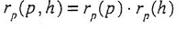
- Where r_{p}(p) and r_{p}(h) are the plasmid- and host-cell regulated reaction rates, respectively. The host cell regulates the host cell rate factor r_{p}(h) through the availability of enzymes for plasmid synthesis and through components involved in the reactions of synthesis. The plasmid-regulated component of the above rate expression r_{p} (p) is governed by the amount of plasmid present. Because it is an enzyme-regulated replication, we expect this rate expression to follow michaelis- menten kinetics.
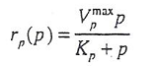
- Where p is the plasmid number, V_{p}^{max} is the maximum rate of plasmid synthesis, and K_{p} is a saturation constant. Both constants are characteristic of the host-plasmid system, and V_{p}^{max} can be through of as the maximum rate in the presence of a surplus of all host-required components for plasmid synthesis.
- We now turn to the expression for r_{o}(h). the host cell, and the conditions under which it is growing, influence the plasmid synthesis rate. It is assumed that these conditions limit synthesis when growth activity is low and that host functions saturate at high levels of cellular activity. The general metabolic activities that influence r_{p}(h) can be assumed to be linearly proportional to the specific growth rate of the cell, µ. An expression that shows the appropriate limiting behavior is
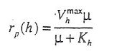
- Shows that at high rates of cellular activity ( and thus growth rate), plasmid synthesis reaches a saturation rate. At low cellular growth rates, plasmid synthesis depends on the cellular growth rate. K_{h} can be througt of as a measure of the dependence of the plasmid on the host for replication. The equations for r_{p}(h) and _{rp(}p) can be combined as follows:
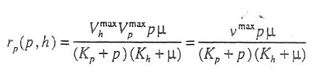
- Thus the rate of plasmid synthesis has the same from as that for double-substrate limiting kinetics. A mass balance over the cell (noting that the volume may change during growth) gives the following expression for the plasmid number:
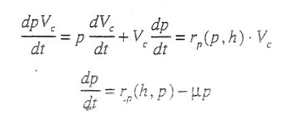
- When the cell is in a state of balance growth, (e,g. cells grown in a continuous well-mixed reactor or in the expoential growth phase), the value of the intercellular components will tend to a constant value. Thus we can set dp/dt to zero and calculated the steady-state plasmid number (p_{s}) from
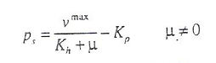
- An estimate of the steady-state concentration of plasmid p_{so} can be made from
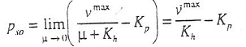
- Equation implies that at low growth rates, the host cell, through K_{h}, influences the plasmid number. A low value of K_{h} would give the case of runaway replication, where extremely high copy numbers are found. If K_{h} is large the plasmid number remains small.
- A specific growth rate where the steady-stste number of plasmids falls to zero can be found by setting p_{s}(µ) equal to zero. This defines a plasmid “washout” growh rate, µ_{pwo}.
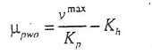
- Using the definition of pso and the expression for p_{s}(µ), we can eliminate K_{p} and rearrange the resulting equation to provide a linear relationship for determiniing the parameters K_{h} and V_{max}.
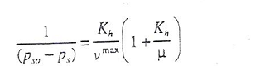
- Alternatively, we can use the definition of µ_{pwo} and p_{s}(µ) to eliminate K_{h} and obtain

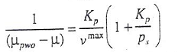
- Predictions from this model can now be compared with the expermental data of seo and Bailey44 for E.coli HB 101 containing pDM247 plasmids. This is a low molecular weight plasmid which is present in high copy number, but the plasmid number decreasea with increasing growth rates.
- The experimental data is show in figure3.34. the cure through data has been extrapolated to determine µ_{pwo}, and a value of 2.0hr⁻¹ is obtained. This is clearly greater then µ max for E.coli (usually around 1.0 hr⁻¹). This value of µ_{pwo} is used to transform the data and 1/( µ_{pwo}-µ) is then plotted against 1/p_{s}. As can be seen in figure 3.35, be 1.08 (mg/gm cell-hr) and 0.53 (mg/gm), respectively.

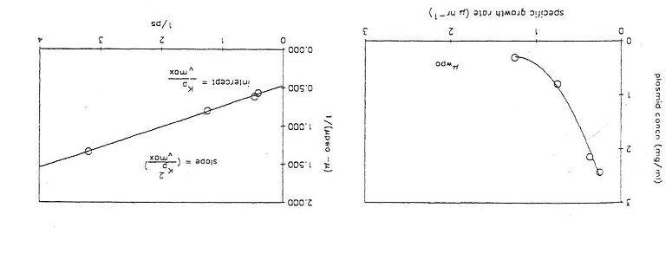
Figure4.14.1 Plasmid concentration within E.coli as a function of the specific growth rate (µ_{pwo} is estimated as 2.0hr⁻¹).
Figure 4.1.4.2 Linearized representation of the data according to the model equations.Thus this model provodes a simple representation of the essential features of plasmid replication. Like the monod model for microbial growth, it is a simplication that cannot be expected to be valid under transient conditons. In the next section, we will examine a structured model that is based on the approach described in this section that might be expected to be more generally applicable.
Example: A Simple Structure Model for Plasmid Replication:
- The equation employed in the preceding model describing the effect of plasmid itself on its rate of replication (r_{p}(p)) was a purely constitutive one. We shall now develop a mechanistic model which incorporates our understanding of the nature of Col E1 plasmid replication and show that the simplification employed in the above constitutive model is reasonable. The model is that of satyagal and Agrawal.
- Replication of Col E1 plasmid is controlled by a replicon, which consists of an origin of replication, a gene for initiator synthesis and a gene for repressor synthesis. The initiator and the repressor are assumed to be produced constitutively.
- The repressor controls the replication rate by complexing with and inactivating the initiator. The formation of this complex is a second order reaction. A schematic of replication control is shown below. The initiator and repressor molecules are RNA in Col E1 plasmids. We can now write mass balances around the cell, denoting the intracellular concentration of initiator and repressor molecules as I and R respectively.
- The plasmid concentration is given by p. we need to note that the cell volume V_{c} will change with the growth rate of the cell and this must be included in our mass balances. For both I and R formation (assumed in both cases to be first order in plasmid concentration), degradation (first order) and reaction terms are included.
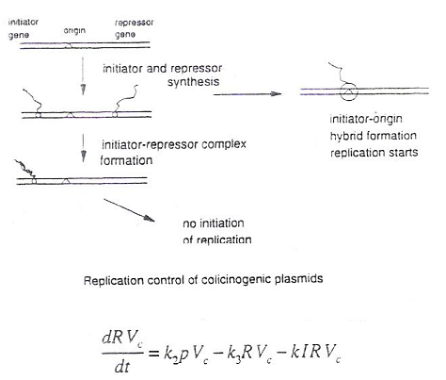
If the density of the cell is constant, then
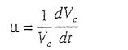
Above equation can now be simplified:
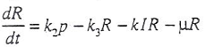
Similarly, the mass balance for I becomes
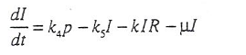
And that for plasmid concentration is
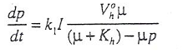
- Where the same form for r_{p}(h) as used in the simplified model above has been retained and the rate of plasmid replication is assumed to be first order in initiator I. the case of balanced growth can now be considered. The time derivatives are equated to zero and the following assumptions made: (a) the rate of deactivation of R is much greater than its rate of dilution due to cell growth I,e., K₃»µ; and (b) (K₅+µ)µ« k₁k₃.
The concentration under balanced growth then become
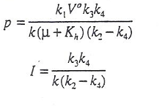
Nomenclature
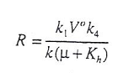
- The initiator concentration is a constant, independent of the cell growth rate. Whereas the repressor and plasmid concentrations decline with increasing cell growth rates. Equation shows that a positive I requires k₂>k₄. This implies that the rate of repressor synthesis must be greater than the rate of initiator synthesis on a unit plasmid basis.
- We can further examine the model equations by considering that the changes in repressor and initiator concentration are rapid with repect to changes in plasmid concentration, I,e,. the quasi-steady state assumption that dR/dt = 0 and dI/dt = 0. Further, let us assume that the dilution terms due to cell growth are negligible for I and R (I,e,. µI and µR) and that he initiator degradation rate is small. The equations for I and R then become
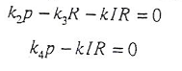
Solving for I we obtain
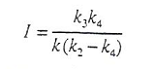
The dynamic behavior of plasmid concentration can now be described by employing this expression for I;
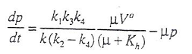
- This expression is analogous to that for r_{p}(p,h) employed in the simple model examined earlier with Kp equated to zero. Thus this more complex model shows the validity of the earlier simple constitutive model under these limiting conditions.
4.2 Dynamic simulation of batch, fed batch, steady and transient culture metabolism.
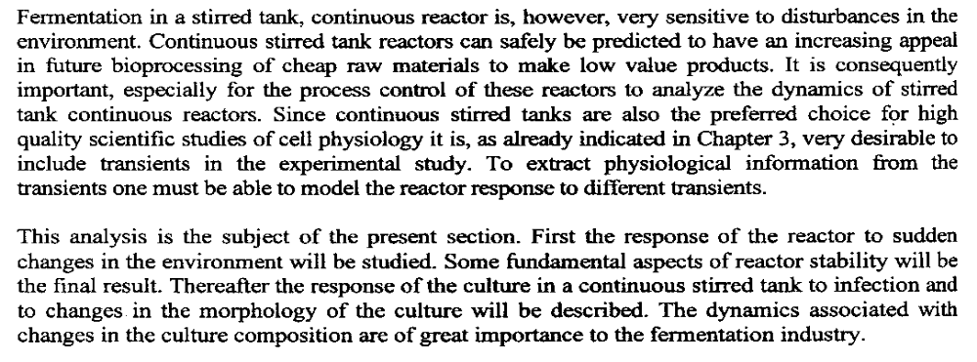
4.2.1

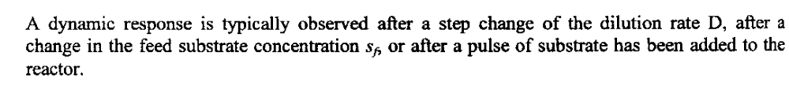
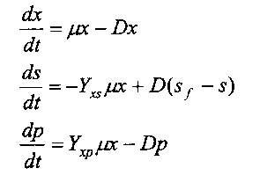
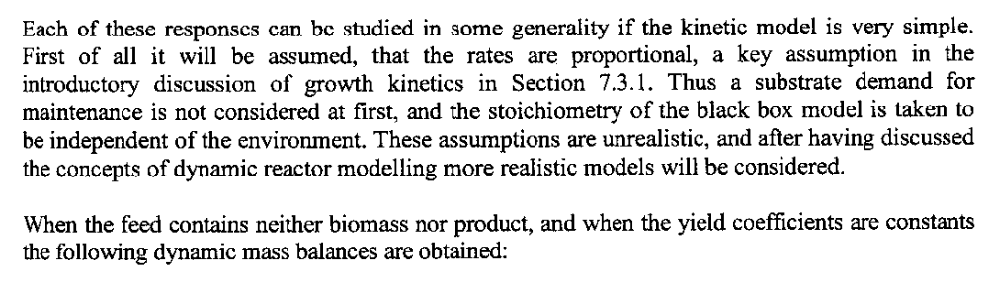

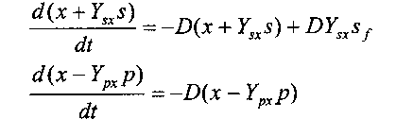

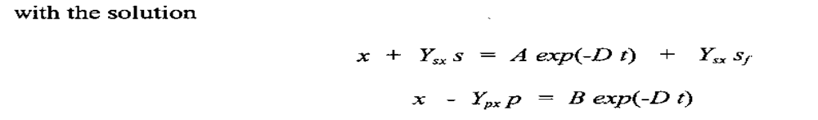
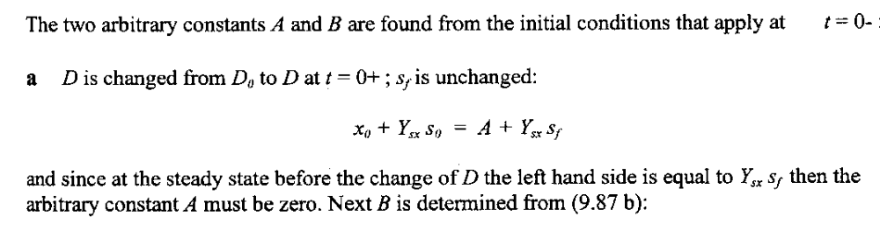
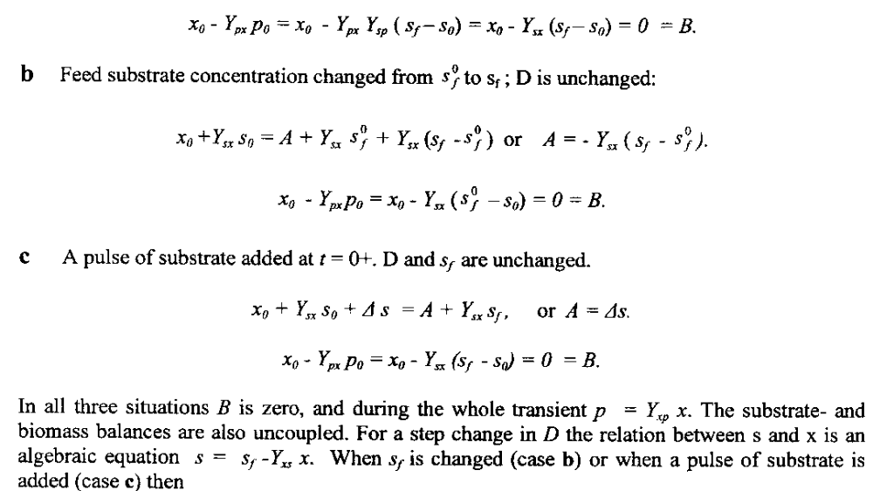
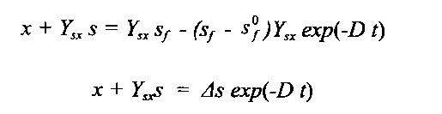

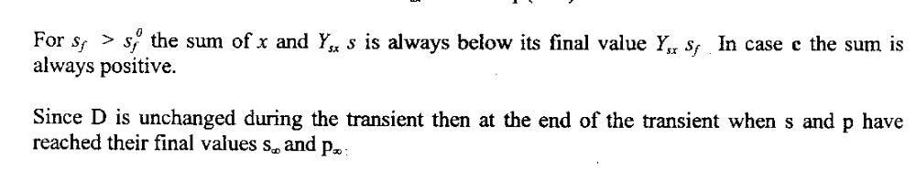
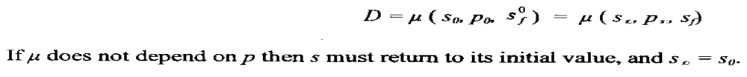
4.2.2
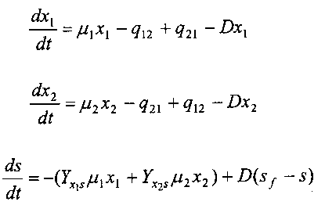
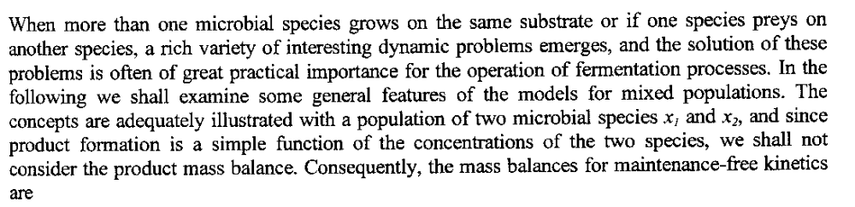

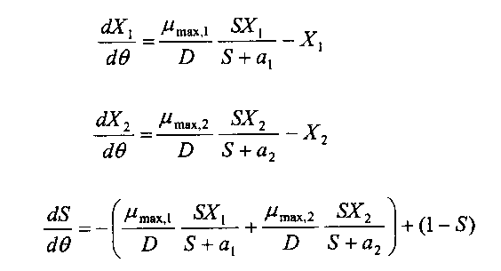
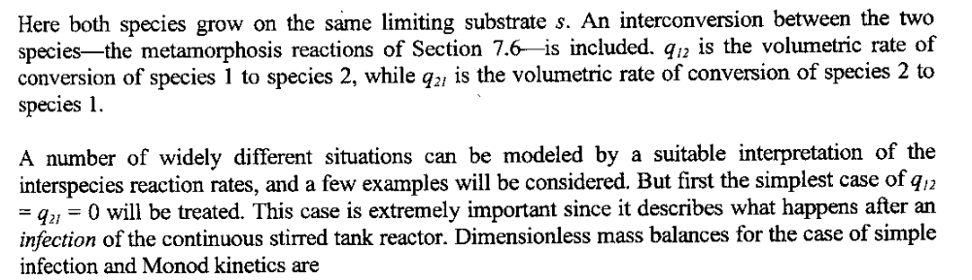

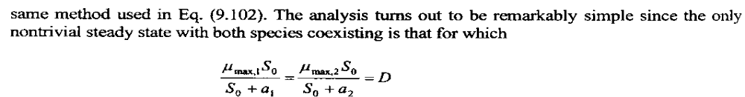
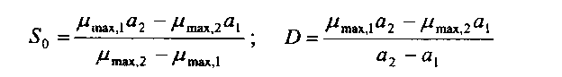

UNIT 5
BIOREACTOR CONSIDERATION IN ENZYME SYSTEMS
5.1 Analysis of film and pore diffusion effects on kinetics of immobilized enzyme reactions
5.1.1 Analysis of film diffusion effects on kinetics of immobilized enzyme reactions or external mass transfer resistance
- If an enzyme is immobilized on the surface of an insoluble particle, the path is only composed of the first and second steps, external mass-transfer resistance. The rate of mass transfer is proportional to the driving force, the concentration difference, as
→1

- where C_{Sb} and C_{S} are substrate concentration in the bulk of the solution and at the immobilized enzyme surface, respectively (Figure 5.1.1). The term k_{S} is the mass-transfer coefficient (length/time) and A is the surface area of one immobilized enzyme particle.
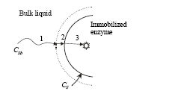

Fig 5.1.1 Schematic diagram of the path of the substrate to the reaction site in an immobilized enzyme

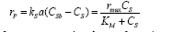
- During the enzymatic reaction of an immobilized enzyme, the rate of substrate transfer is equal to that of substrate consumption. Therefore, if the enzyme reaction can be described by the Michaelis-Menten equation,
→2

- where a is the total surface area per unit volume of reaction solution. This equation shows the relationship between the substrate concentration in thebulk of the solution and that at the surface of an immobilized enzyme. Eq. (2) can be expressed in dimensionless form as:
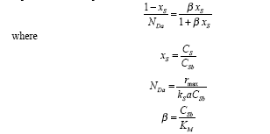
→ 3

→ 4
N_{Da} is known as Damköhler number, which is the ratio of the maximum reaction rate over the maximum mass-transfer rate. Depending upon the magnitude of N_{Da}, Eq. (2) can be simplified, as follows:
- If NDa< 1, the mass-transfer rate is much greater than the reaction rate and the overall reaction is controlled by the enzyme reaction,
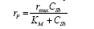
→ 5

- If NDa " 1, the reaction rate is much greater than the mass-transfer rate and the overall rate of reaction is controlled by the rate of mass transfer that is a first-order reaction,
→ 6

To measure the extent which the reaction rate is lowered because of resistance to mass transfer, we can define the effectiveness factor of an immobilized enzyme, η, as
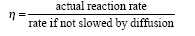
→7

The actual reaction rate, according to the external mass-transfer limitation model, is as given in Eq. (2). The rate that would be obtained with no mass-transfer resistance at the interface is the same as Eq. (5) except that C_{S} is replaced by C_{Sb}. Therefore, the effectiveness factor is
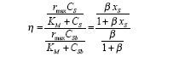
→8

- where the effectiveness factor is a function of x_{S} and β. If x_{S} is equal to 1, the concentration at the surface C_{S} is equal to the bulk concentration C_{Sb}. Substituting 1 for x_{S} in the preceding equation yields η = 1, which indicates that there is no mass-transfer limitation.
- On the other hand, if x_{S} approaches zero, η also approaches zero, which is the case when the rate of mass transfer is very slow compared to the reaction rate.
5.1.2 Analysis of pore diffusion effects on kinetics of immobilized enzyme reactions or internal mass transfer resistance.
- If enzymes are immobilized by copolymerization or microencapsulation, the intraparticle mass-transfer resistance can affect the rate of enzyme reaction. In order to derive an equation that shows how the mass-transfer resistance affects the effectiveness of an immobilized enzyme, let’s make a series of assumptions as follows:
1. The reaction occurs at every position within the immobilized enzyme, and the kinetics of the reaction are of the same form as observed for free enzyme.
2. Mass transfer through the immobilized enzyme occurs via molecular diffusion.
3. There is no mass-transfer limitation at the outside surface of the immobilized enzyme.
4. The immobilized enzyme is spherical.
The model developed by these assumptions is known as the distributedmodel.
First we derive a differential equation which describes the relationship between the substrate concentration and the radial distance in an immobilized enzyme. The material balance for the spherical shell with thickness dr as shown in Figure 5.1.2 is
Input . Output + Generation = Accumulation
→1
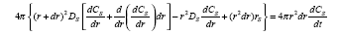
→2

where D_{S} is diffusivity of the substrate in an immobilization matrix.
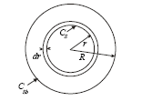

Fig 5.1.2-Shell balance for a substrate in an immobilized enzyme.

For a steady-state condition, the change of substrate concentration, dC_{S} /dt,is equal to zero. After opening up the brackets and simplifying by eliminating all terms containing dr2 or dr3, we obtain the second order differential equation:
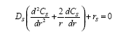
→3

Eq. (3) can be solved by substituting a suitable expression for r_{S.} Let’s solve the equation first for the simple cases of zero-order and first-order reactions, and for the Michaelis-Menten equation.
Zero-order Kinetics: Let’s assume that the rate of substrate consumption is constant (zero order) with respect to substrate concentration as
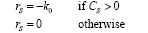
→4
This is a good approximation when KM << CS for Michaelis-Menten kinetics, in which case k0 = rmax.
By substituting Eq. (3.4) into Eq. (3.3), we obtain
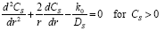
→5

The boundary conditions for the solution of the preceding equation are
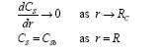
→6

Eq. (5) becomes
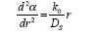
→7

Integrating Eq. (7) twice with respect to r, we obtain
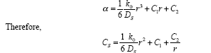
→8

→9

Applying the boundary conditions (Eq. (6) on Eq. (7) yields
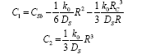
→10

→11

Therefore, the solution of Eq. (5) is
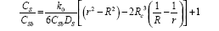
→12

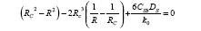
Eq. (12) is only valid when C_{S} > 0. The critical radius, below which C_{S} is zero, can be obtained by solving
→13

The actual reaction rate according to the distribution model with zero order is (4/3)π(R³- R_{C}³)k₀. The rate without the diffusion limitation is (4/3)π R³k₀.Therefore, the effectiveness factor, the ratio of the actual reaction rate to the rate if not slowed down by diffusion, is
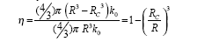
→14

First-order Kinetics: If the rate of substrate consumption is a first-order reaction with respect to the substrate concentration,
→1
→2
By substituting Eq. (1) into Eq.

and converting it to dimensionless form, we obtain
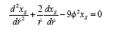
→3

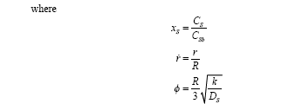

→4

and φ is known as Thiele’s modulus, which is a measure of the reaction rate relative to the diffusion rate. Eq. (3) together with the boundary conditions
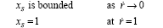
→5

determines the function C’S(r’).
In order to convert Eq. (3) to a form which can be easily solved, we set α= rx_{s} , so that the differential equation becomes
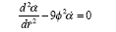
→6

Now the general solution of this differential equation is
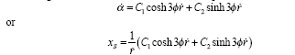
→7

→8

Since x_{S} must be bounded as r approaches zero according to the firstboundary condition, we must choose C₁ = 0. The second boundary condition requires that C₂ = 1/sinh3φ, leaving
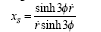
→9

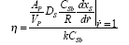
The actual reaction rate with the diffusion limitation would be equal to the rate of mass transfer at the surface of an immobilized enzyme, while the rate if not slowed down by pore diffusion is kC_{Sb}. Therefore,
→10
5.2 Design of Packed bed and Fluidized bed reactor
5.2.1 Packed bed reactor
- Packed-bed reactors are used with immobilised or particulate biocatalysts. The reactor consists of a tube, usually vertical, packed with catalyst particles. Medium can be fed either at the top or bottom of the column and forms a continuous liquid phase between the particles.
- Damage due to particle attrition is minimal in packed beds compared with stirred reactors. Packed-bed reactors have been used commercially with immobilised cells and enzymes for production ofaspartate and fumarate, conversion of penicillin to 6-aminopenicillanic acid, and resolution of amino acid isomers. Mass transfer between the liquid medium and solid catalyst is facilitated at high liquid flow rates through the bed; to achieve this, packed beds are often operated with liquid recycle as shown in Figure 2.1.
- The catalyst is prevented from leaving the column by screens at the liquid exit. The particles should be relatively incompressible and able to withstand their own weight in the column without deforming and occluding liquid flow.
- Recirculating medium must also be clean and free of debris to avoid clogging the bed. Aeration is generally accomplished in a separate vessel; if air is sparged directly into the bed, bubble coalescence produces gas pockets and flow channelling or maldistribution. Packed beds are unsuitable for processes which produce large quantities of carbon dioxide or other gases which can become trapped in the packing.
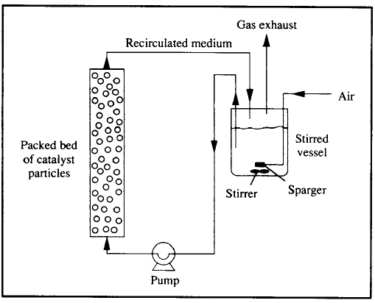

Fig 5.2.1 Packed bed reactor

- In the packed bed reactor, the superficial flow velocity through the reactor is equal to the volumetric flow of the feed divided by the cross sectional area which is the total cross sectional area times the void fraction ε.
Void fraction is defined as the ratio of void volume to the total volume.
5.2.1.1 Modeling of packed bed reactor
Assumption:
- The influence of packed catalyst on flow and kinetic features are considered.
- Flow across the cross sectional area is equal to the cross sectional area times the void fraction.
- The flow rate of liquid = ε x Cross sectional area x ( V/L)
V is interstitial fluid velocity or rate.
Consider a single reaction S → P with intrinsic rate
V= V(S,P) the rate of product formation per crit volume of immobilized biocatalyst pellet at a point in a reactor.
r_{p} = υ overall / Total volume of pellet = η (Ss, Ps) υ(Ss, Ps)
where Ss and Ps are the substrate and product concentrations at the exterior pellet surface at the position inside the reactor and η is the effectiveness factor.
Consider the mass transfer resistance between the bulk phase and pellet surface , a steady state material balance on substrate over a pellet gives for a spherical catalyst pellet of radius R
Rate of substrate diffusion out of bulk liquid= rate of substrate disappearance by reaction within pellet.
4 Π R²Ks( S-Ss) = 4/3 Π R³ η (Ss, Ps) υ(Ss, Ps)
R- Raidus of biocatalyst pellet.
Ks- Mass transfer coefficient.
5.2.1.2 Advantages
i) Damage due to particles attrition is minimal in packed beds compared with stirred reactors.
ii) The superficial fluid velocity will be larger than in an open plug flow reactor.
5.2.1.3 Disadvantages
i) Poor temperature control – hot spots
ii) Channeling of gas - leading to ineffective regions
iii) Catalyst loading is difficult
iv) Poor heat transfer to and from the reactor
5.2.1.4 Applications
i) Isomerization of glucose to fructose for production of high fructose corn sweetener.
iii) Conversion of penicillin to 6 aminopencillin.
5.2.2 Fluidized bed reactor:
- Fluidized-bed bioreactors are directly linked to the use of biocatalysts (cells or enzymes) for transformations in an immobilized form. The solid particles of the immobilized biocatalyst are maintained in fluidization by means of the circulation of a fluid phase (either liquid, gas, or a mixture of both) that compensates their weight.
- In this way, good liquid mixing and mass transfer between the solid and the liquid phases can be obtained with low attrition. Also, fluidized-bed bioreactors can accommodate a gas phase and can be used to feed solids in suspension.
- High productivities can be achieved in these systems, but their hydrodynamic complexity and operational stability have to be well defined for a proper operation. When packed beds are operated in upflow mode with catalyst beads of appropriate size and density, the bed expands at high liquid flow rates due to upward motion of the particles. This is the basis for operation of fluidised-bed reactors as illustrated in Figure 2.2.
- Because particles in fluidised beds are in constant motion, channelling and clogging of the bed are avoided and air can be introduced directly into the column. Fluidised-bed reactors are used in waste treatment with sand or similar material supporting mixed microbial populations. They are also used with flocculating organisms in brewing and for production of vinegar.
5.2.2.1 The Fluidization concept: General Considerations
- The term fluidized-bed is used to define those physical systems composed of a solid phase in the form of individual particles that move within a fluid phase and are not in continuous contact with each other. Fluidization of the solid particles is reached when the flow of fluid through the bed is high enough to compensate their weight.
- On the other hand, in order to be kept in the fluidized-bed reactor and not be washed out (elutriated), the superficial velocity of the fluid in the bed (that is, the ratio between the flow rate and the bed cross-sectional area) has to be lower than the settling velocity of the particles. These two extreme situations are outlined in Figure 5.2.2.1
- When the flow rate of a fluid through a packed bed of solid particles steadily increases, the pressure drop increases proportionally to the flow rate, as long as the bed height remains constant. When the drag force of the fluid equilibrates the weight of the particles, the bed starts to expand and, after a transition period, reaches fully developed fluidization.
- At this point, further increments in the flow rate do not produce an increase in pressure drop, but instead lead to an increase of the height occupied by the solid particles in the reactor. If the flow rate is increased significantly, the elutriation of the solid particles occurs when the fluid’s superficial velocity is higher than the solid’s settling velocity.
Fig 5.2.2.1 Fluidization concept

- Figure 5.2.2.2 represents the basic scheme of a fluidized-bed bioreactor. Although various configurations are possible , the most extensively used is the gas–liquid cocurrent up-flow reactor. In it, liquid usually comprises the continuous phase and is fed from the reactor bottom. Its flow upward in the reactor promotes fluidization of the solid particles.
- Usually, the reactor will have two or three phases. In addition to the liquid and solid phases, the occurrence of a gas phase is quite common in those systems using cells as biocatalysts, either for aeration requirements (in which case, an air or oxygen stream is fed to the reactor, as shown in Fig. 2.2.2) or because cell metabolism produces a gas product (for example, CO2, CH4). In systems using enzymes as biocatalysts, the most common situation is two-phase fluidization, without any gas phase.
- Very often, due to the low reaction rates of most biological transformations, long liquid residence times are needed for the completion of the reaction, and therefore the drag force created by the low liquid flow rate in a single pass reactor is not enough to promote fluidization of the solid particles. Fluidization is obtained either by external liquid recirculation or by the gas loaded to the reactor, as depicted in Figure 2.2.2.
- In systems where a gas is produced by cell metabolism, the gas can also be an additional factor contributing to solid particle fluidization, although other effects are also observed in this case, such as internal liquid recirculation patterns.
- Fluidization at relatively low liquid flow rates is also favored in tapered fluidized-bed configurations; the liquid superficial velocity at the bottom of the reactor is higher due to the reduced cross-sectional area. In general, one can distinguish three main sections in fluidized-bed bioreactors: (1) the bottom section, where feed (liquid, gas, or both) and recirculation are provided; (2) the central main section, where most of the reaction takes place; (3) and the top section, with a wider diameter that serves to decelerate the movement of the particles by decreasing the superficial velocity of the liquid, thus enhancing the retention of the solid phase and at the same time allowing gas disengagement from the liquid phase.
- It is a common trend for fluidized-bed bioreactors to use biocatalysts, either cells or enzymes, in the form of immobilized preparations. In general, the particles can be of three different types: (1) inert cores on which a biofilm is created by cell attachment, or in the case of enzymes, by adsorption or covalent binding immobilization; (2) porous particles in which the biocatalysts are entrapped; (3) cell aggregates obtained by self-immobilization caused by the ability of some cell strains to form flocs, pellets, or aggregates.
- Fluidized-bed bioreactors are usually differentiated from air-lift bioreactors by the fact that the latter do not specifically require the use of immobilized biocatalysts. Indeed, they were developed for free cell suspensions. In addition, air-lift bioreactors have different compartments, created by physical internal divisions, with different degrees of aeration.
Fig 5. 2.2.2 Fluidized bed reactor

In a fluidized bed reactor, liquid flows upward through a long vertical cylcinder. Heterogeneous biocatalyst particles( flocculated organisms, pelltes of immobilized enzymes or cells) are suspended by drag exerted by the rising liquid. Entrained catalyst pellet are released at the top of the tower by the reduced liquid drag at the expanding cross section and fed back in to the tower. Thus by a careful balance between operating conditions and organisms characteristics, the biocatalyst is retained in the reactor while the medium flows through it continuously.
Because particles in fluidized beds are in constant motion, channeling and clogging of the bed are avoided and air can be introduced directly into the column.
5.2.2.2 Design of fluidized bed reactor:
Assumption:
i) The biological catalyst particles are uniform in size.
ii) The fluid phase density is a function of substrate concentration.
iii) The liquid phase move upward through the vessel in plug flow.
iv) Substrate utilization rates are first order in biomass concentration but zero order in substrate concentration.
v) The terminal velocity is small enough to justify stoke’s law.
So, substrate utilization rate,
-r_{A}= dC_{A}/dt = kC_{A} → 1
Substrate conversion
d(SU)/dZ= - kx → 2
U dS/dZ + S dU/dZ = -kx →3
x depends upon terminal setting velocity
x= ρ_{o} [ 1- (U/U_{t} ) ^{1/4.65}] → 4
ρ_{o} – microbial density on a dry weight basis
U_{t} – terminal velocity of a sphere in stoke’s flow
U_{t} = [dp² (ρ_{o} – ρ ) g]/ 18μ →5
Based on assumption 2
d(ρU)/dZ =0
ρ= ρ(S)
ρ(S) dU/dZ +U (dρ/dS) dS/dZ=0 → 6
Where eqn 3 and 6 are simultaneous algebric equation and solving these equation with initial boundary conditions of
S(0) =S_{F}
U(0)= U_{F} = F_{F}/ A_{F}
S_{F} = substrate concentration in feed
F_{F} = Liquid flow rate of the reactor at the bottom.
A_{F} = Cross sectional area of the reactor at the bottom.
Sc= Substrate concentration at the outlet
When Z= L
Sc= S_{F} - k ρ_{o} [ 1- (U/U_{t} ) ^{1/4.65} L/U]
Based on the three phase system reactor, a model developed by kurmi-levenspeil for mass transport and is known as cloud wake model.
N_{sh} =0.81/6 [ (N_{Re}) ^{½} ( N_{sc}) ^{1/3}]
N_{sh} = Sherwood number
N_{Re} = Reynolds number
N_{sc} = Schmid number
N_{sc} = μ/ρdp , N_{sh}= kdp/ Dm
Fig 5.2.2.3Operation diagram of a fluidized- bed bioreactor with simultaneous bioconversion
and adsorption/desorption of substrate and product.

Fig 5.2.2.4 Inter and intraparticle mass transfer of a single porous spherical bead of radius R. Substrate concentration profiles across the stagnant liquid film and inside the solid particle, S(r). Sf, concentration on the bulk liquid; Ssur, concentration on the solid surface; K, partition coefficient.

5.2.2.3. Advantages
i) Intimate contact between the solid ,liquid and gas exists.
ii) Mass transfer rate is good.
iii) If mass transfer rate increases the reaction rate is increases.
iv) Also resembles CSTR at a particular velocity.
v) In packed bed the gases produced are trapped but in fluidized bed the gases escapes.
5.2.2.4 Application
i) It is used in waste water treatment with sand or similar material supporting mixed microbial population.
Eg: UASP- Upward Anaerobic Sludge Plancket reactor.
ii) It is used in brewing and production of vinegar.

5.3 Membrane reactors
Membrane bioreactor (MBR) is the combination of a membrane process like microfiltration or ultrafiltration with a suspended growth bioreactor, and is now widely used for municipal and industrial wastewater treatment with plant sizes up to 80,000 population equivalent (i.e. 48 MLD)

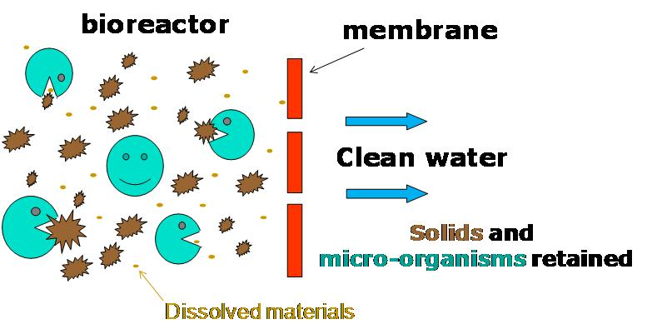
- When used with domestic wastewater, MBR processes could produce effluent of high quality enough to be discharged to coastal, surface or brackish waterways or to be reclaimed for urban irrigation. Other advantages of MBRs over conventional processes include small footprint, easy retrofit and upgrade of old wastewater treatment plants.
- Two MBR configurations exist: internal, where the membranes are immersed in and integral to the biological reactor; and external/sidestream, where membranes are a separate unit process requiring an intermediate pumping step.
- The MBR process was introduced by the late 1960s, as soon as commercial scale ultra filtration (UF) and microfiltration (MF) membranes were available. The original process was introduced by Dorr-Olivier Inc. and combined the use of an activated sludge bioreactor with a crossflow membrane filtration loop.
- The flat sheet membranes used in this process were polymeric and featured pore sizes ranging from 0.003 to 0.01 μm. Although the idea of replacing the settling tank of the conventional activated sludge process was attractive, it was difficult to justify the use of such a process because of the high cost of membranes, low economic value of the product (tertiary effluent) and the potential rapid loss of performance due to membrane fouling.
- As a result, the focus was on the attainment of high fluxes, and it was therefore necessary to pump the mixed liquor suspended solids (MLSS) at high crossflow velocity at significant energy penalty (of the order 10 kWh/m3 product) to reduce fouling. Due to the poor economics of the first generation MBRs, they only found applications in niche areas with special needs like isolated trailer parks or ski resorts for example.
- The breakthrough for the MBR came in 1989 with the idea of Yamamoto and co-workers to submerge the membranes in the bioreactor. Until then, MBRs were designed with the separation device located external to the reactor (sidestream MBR) and relied on high transmembrane pressure (TMP) to maintain filtration.
- With the membrane directly immersed into the bioreactor, submerged MBR systems are usually preferred to sidestream configuration, especially for domestic wastewater treatment. The submerged configuration relies on coarse bubble aeration to produce mixing and limit fouling. The energy demand of the submerged system can be up to 2 orders of magnitude lower than that of the sidestream systems and submerged systems operate at a lower flux, demanding more membrane area. In submerged configurations, aeration is considered as one of the major parameter on process performances both hydraulic and biological.
- Aeration maintains solids in suspension, scours the membrane surface and provides oxygen to the biomass, leading to a better biodegradability and cell synthesis.
- The other key steps in the recent MBR development were the acceptance of modest fluxes (25% or less of those in the first generation), and the idea to use two-phase bubbly flow to control fouling. The lower operating cost obtained with the submerged configuration along with the steady decrease in the membrane cost encouraged an exponential increase in MBR plant installations from the mid 90s. Since then, further improvements in the MBR design and operation have been introduced and incorporated into larger plants.
- While early MBRs were operated at solid retention times (SRT) as high as 100 days with mixed liquor suspended solids up to 30 g/L, the recent trend is to apply lower solid retention times (around 10–20 days), resulting in more manageable mixed liquor suspended solids (MLSS) levels (10-15 g/L).
- Thanks to these new operating conditions, the oxygen transfer and the pumping cost in the MBR have tended to decrease and overall maintenance has been simplified. There is now a range of MBR systems commercially available, most of which use submerged membranes although some external modules are available; these external systems also use two-phase flow for fouling control.
- Typical hydraulic retention times (HRT) range between 3 and 10 hours. In terms of membrane configurations, mainly hollow fibre and flat sheet membranes are applied for MBR applications .
5.3.1 Major considerations in MBR
Fouling and fouling control
- The MBR filtration performance inevitably decreases with filtration time. This is due to the deposition of soluble and particulate materials onto and into the membrane, attributed to the interactions between activated sludge components and the membrane.
- This major drawback and process limitation has been under investigation since the early MBRs, and remains one of the most challenging issues facing further MBR development
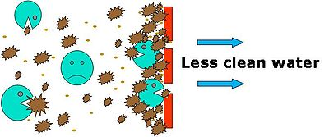
Illustration of membrane fouling
- In recent reviews covering membrane applications to bioreactors, it has been shown that, as with other membrane separation processes, membrane fouling is the most serious problem affecting system performance.
- Fouling leads to a significant increase in hydraulic resistance, manifested as permeate flux decline or transmembrane pressure (TMP) increase when the process is operated under constant-TMP or constant-flux conditions respectively. Frequent membrane cleaning and replacement is therefore required, increasing significantly the operating costs.
- Membrane fouling results from interaction between the membrane material and the components of the activated sludge liquor, which include biological flocs formed by a large range of living or dead microorganisms along with soluble and colloidal compounds.
- The suspended biomass has no fixed composition and varies both with feed water composition and MBR operating conditions employed.
- Thus though many investigations of membrane fouling have been published, the diverse range of operating conditions and feedwater matrices employed, the different analytical methods used and the limited information reported in most studies on the suspended biomass composition, has made it difficult to establish any generic behaviour pertaining to membrane fouling in MBRs specifically.
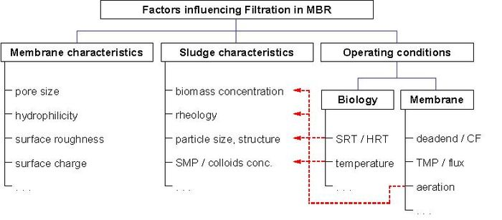
Factors influencing fouling (interactions in red)
The air-induced cross flow obtained in submerged MBR can efficiently remove or at least reduce the fouling layer on the membrane surface. A recent review reports the latest findings on applications of aeration in submerged membrane configuration and describes the enhancement of performances offered by gas bubbling ^{[5]}. As an optimal air flow-rate has been identified behind which further increases in aeration have no effect on fouling removal, the choice of aeration rate is a key parameter in MBR design.
Many other anti-fouling strategies can be applied to MBR applications. They comprise, for example:
- Intermittent permeation, where the filtration is stopped at regular time interval for a couple of minutes before being resumed. Particles deposited on the membrane surface tend to diffuse back to the reactor; this phenomena being increased by the continuous aeration applied during this resting period.
- Membrane backwashing, where permeate water is pumped back to the membrane, and flow through the pores to the feed channel, dislodging internal and external foulants.
- Air backwashing, where pressurized air in the permeate side of the membrane build up and release a significant pressure within a very short period of time. Membrane modules therefore need to be in a pressurised vessel coupled to a vent system. Air usually does not go through the membrane. If it did, the air would dry the membrane and a rewet step would be necessary, by pressurizing the feed side of the membrane.
- Proprietary anti-fouling products, such as Nalco's Membrane Performance Enhancer Technology.
In addition, different types/intensities of chemical cleaning may also be recommended:
- Chemically enhanced backwash (daily);
- Maintenance cleaning with higher chemical concentration (weekly);
- Intensive chemical cleaning (once or twice a year).
Intensive cleaning is also carried out when further filtration cannot be sustained because of an elevated transmembrane pressure (TMP). Each of the four main MBR suppliers (Kubota, Memcor, Mitsubishi and Zenon) have their own chemical cleaning recipes, which differ mainly in terms of concentration and methods .Under normal conditions, the prevalent cleaning agents remain NaOCl (Sodium Hypochlorite) and citric acid. It is common for MBR suppliers to adapt specific protocols for chemical cleanings (i.e. chemical concentrations and cleaning frequencies) for individual facilities .

5.3.2 Biological performances/kinetics
5.3.2.1 COD removal and sludge yield
- Simply due to the high number of microorganism in MBRs, the pollutants uptake rate can be increased. This leads to better degradation in a given time span or to smaller required reactor volumes. In comparison to the conventional activated sludge process (ASP) which typically achieves 95%, COD removal can be increased to 96-99% in MBRs (see table, COD and BOD5 removal are found to increase with MLSS concentration.
- Above 15g/L COD removal becomes almost independent of biomass concentration at >96% .Arbitrary high MLSS concentrations are not employed, however, as oxygen transfer is impeded due to higher and Non-Newtonian fluid viscosity. Kinetics may also differ due to easier substrate access. In ASP, flocs may reach several 100 μm in size.
- This means that the substrate can reach the active sites only by diffusion which causes an additional resistance and limits the overall reaction rate (diffusion controlled). Hydrodynamic stress in MBRs reduces floc size (to 3.5 μm in sidestream MBRs) and thereby increases the apparent reaction rate. Like in the conventional ASP, sludge yield is decreased at higher SRT or biomass concentration. Little or no sludge is produced at sludge loading rates of 0.01 kgCOD/(kgMLSS d). Due to the biomass concentration limit imposed, such low loading rates would result in enormous tank sizes or long HRTs in conventional ASP.
5.3.2.2 Nutrient removal
- Nutrient removal is one of the main concerns in modern wastewater treatment especially in areas that are sensitive to eutrophication. Like in the conventional ASP, currently, the most widely applied technology for N-removal from municipal wastewater is nitrification combined with denitrification.
- Besides phosphorus precipitation, enhanced biological phosphorus removal (EBPR) can be implemented which requires an additional anaerobic process step. Some characteristics of MBR technology render EBPR in combination with post-denitrification an attractive alternative that achieves very low nutrient effluent concentrations .
5.3.3 ADVANTAGES
1) The effluent is of very high quality, very low in BOD (less than 5 mg/l), very low in turbidity and suspended solids. The technology produces some of the most predictable water quality known. It is fairly easy to operate as long as the operation has been properly trained, pays strict attention to the proper operation, corrective maintenance, and preventative maintenance tasks.
2) The “simple filtering action” of the membranes creates a physical disinfection barrier, which significantly reduces the disinfection requirements.
3) The capitol cost is usually less than for comparable treatment trains.
4) The treatment process also allows for a smaller “footprint” as there are no secondary clarifiers nor tertiary filters which would be required to achieve similar water quality results. It also eliminates the need for a tertiary backwash surge tank, a backwash water storage tank, and for the treatment of the backwash water.
5) Generally speaking it produces less waste activated sludge than a simple conventional system.
6) If re-use is a major water quality goal, the MBR process will be a major consideration. This process produces a consistent, high water quality discharge. When followed by a disinfection process, it allows for a wide range of water re-use applications including landscape irrigation, non-root edible crops, highway median strip and golf course irrigation, and cooling water re-charge. When Reverse Osmosis (RO) water quality is required, the MBR process is an excellent candidate for preparing the water for RO treatment.
5.3.4 DISADVANTAGES
1) The membrane modules will need to be replaced somewhere between five (5) and ten (10) years with the current technology. While the costs have decreased over the past several years, these modules can still be classified as expensive. (The membranes “dry out” due to the flexible polymers leaching out, the closing/plugging of the pores, and the membranes becoming somewhat hard or brittle.) These costs are often offset somewhat when life-cycle costs for comparable technologies are examined. If the costs for the membrane replacement task continue to decrease then over time, then this process is even more financially viable.
2) In most sales pitches the MBR technology is stated as an option of replacing the secondary clarifier. Usually these clarifiers are operated with a single, very low horsepower motor, usually less than 2 HP. The electrical cost for this simple motor is significantly less than the filtrate pumps, chemical feed pumps, compressors, etc., of the MBR system. While this energy cost is significantly higher, the MBR system produces a significantly higher quality effluent that most clarifiers could never achieve.
3) Fouling is troublesome, and its prevention is costly. Several papers and research endeavors have concluded that up to two-thirds of the chemical and energy costs in an MBR facility are directly attributable to reducing membrane fouling. While this is costly to be sure, future advances into this area will continue to reduce these costs.
4) There may be cleaning solutions that require special handling, treatment, and disposal activities depending on the manufacturer. These cleaning solutions may be classified as hazardous waste depending on local and state regulations.

